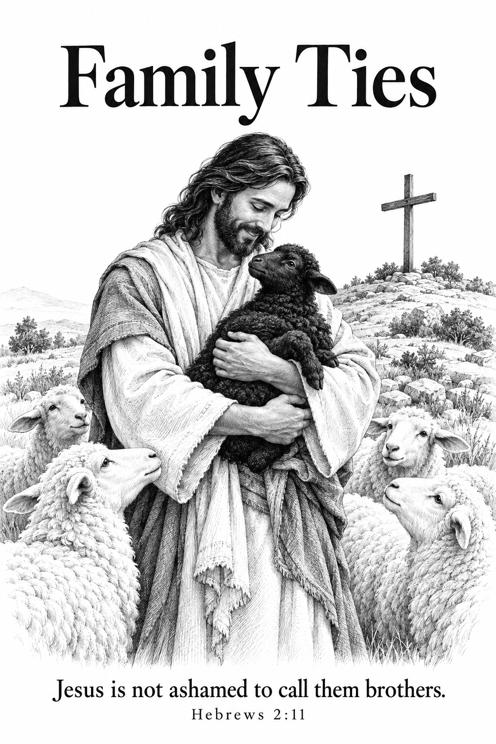

THE COMMON SERVICE
This liturgy is adapted from the Common Service Book of the Lutheran Church (1917-1918), Evangelical Lutheran Hymn-book (1912), and Music for the Liturgy: in Conformity with the Evangelical Lutheran Hymn book which are in the public domain.

OPENING HYMN 538
Leader : (The congregation rises.) In the name of the Father, and of the Son, and of the Holy Spirit.



THE CONFESSION OF SINS
L: Beloved in the Lord! Let us draw near with a true heart and confess our sins to God our Father, asking Him, in the name of our Lord Jesus Christ, to grant us forgiveness.
L: Our help is in the name of the Lord.

L: I said, I will confess my transgressions to the Lord.


L : Almighty God, our Maker and Redeemer, we poor sinners confess to You that we are by nature sinful and unclean, and that we have sinned against You by thought, word, and deed. Therefore we flee for refuge to Your infinite mercy, seeking and imploring Your grace for the sake of our Lord Jesus Christ.
C: O most merciful God, who has given Your only-begotten Son to die for us, have mercy upon us, and for His sake grant us remission of all our sins; and by Your Holy Spirit increase in us true knowledge of You and of Your will, and true obedience to Your Word, so that by Your grace we may come to everlasting life; through Jesus Christ our Lord. Amen.

THE ABSOLUTION
L : Almighty God, our heavenly Father, has had mercy upon us and has given His only Son to die for us, and for His sake forgives us all our sins. To those who believe in His name He gives power to become the children of God and bestows upon them His Holy Spirit. Whoever believes and is baptized will be saved. Grant this, O Lord, to us all.
C: Amen.

PSALM OF THE DAY
L: O Lord, our Lord, How excellent is Your name in all the earth,
C: Who have set Your glory above the heavens!
L: Out of the mouth of babes and nursing infants You have ordained strength,
C: Because of Your enemies, That You may silence the enemy and the avenger.
L: When I consider Your heavens, the work of Your fingers,
C: The moon and the stars, which You have ordained,
L: What is man that You are mindful of him,
C: And the son of man that You visit him?
L: For You have made him a little lower than the angels,
C: And You have crowned him with glory and honor.
L: You have made him to have dominion over the works of Your hands;
C: You have put all things under his feet, (Psalm 8)

GLORIA PATRI

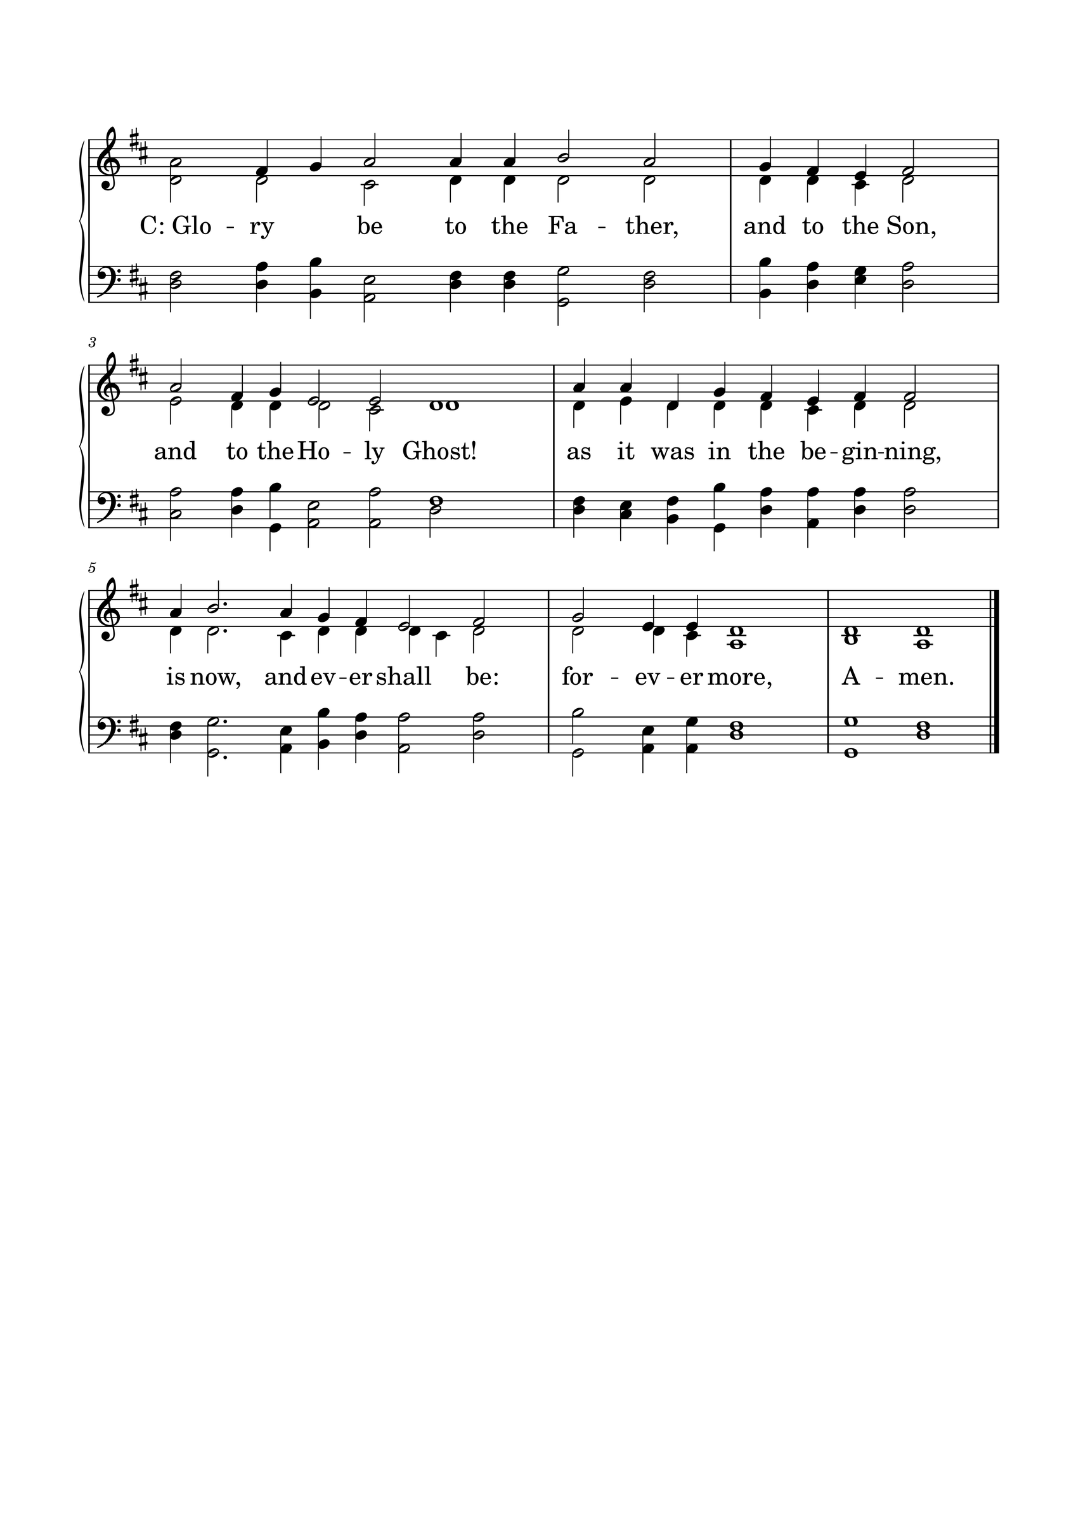

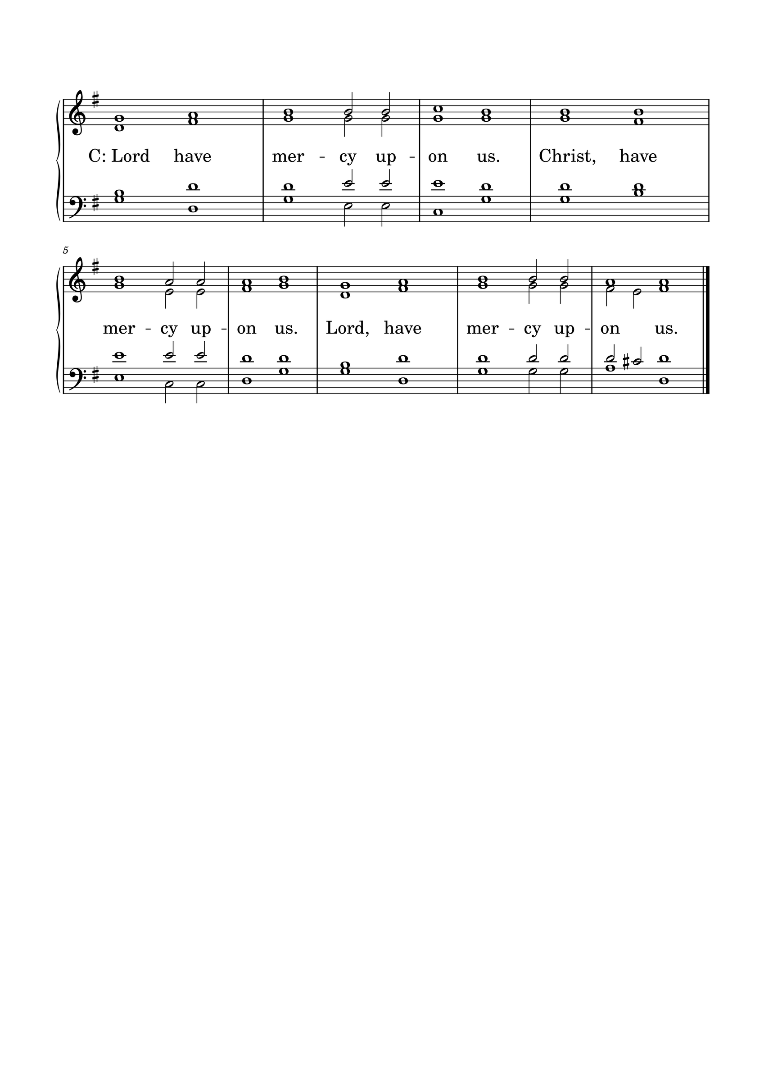KYRIE

GLORIA
The Lutheran Hymnal hymn 244 Verses 1 & 2
C: 1. Glory be to God the Father,
Glory be to God the Son,
Glory be to God the Spirit:
Great Jehovah, Three in One!
Glory, glory,
While eternal ages run!

2. Glory be to Him who loved us,
Washed us from each spot and stain;
Glory be to Him who bought us,
Made us kings with Him to reign!
Glory, glory,
To the Lamb that once was slain!

THE COLLECT
L : Let us pray.
L :
O God, the protector of all who trust in You, have mercy on us that with You as our ruler and guide we may so pass through things temporal that we lose not the things eternal. We pray this through Jesus Christ, our Lord and Savior, who lives and reigns with You and the Holy Spirit, one God, now and forever.
C: Amen.

FIRST SCRIPTURE READING
L: (The congregation may be seated.) The First Scripture Reading for 21st Sunday after Trinity is written in the 2nd chapter of Hebrews, beginning at verse 1.
[1] Therefore we must give the more earnest heed to the things we have heard, lest we drift away. [2] For if the word spoken through angels proved steadfast, and every transgression and disobedience received a just reward, [3] how shall we escape if we neglect so great a salvation, which at the first began to be spoken by the Lord, and was confirmed to us by those who heard Him, [4] God also bearing witness both with signs and wonders, with various miracles, and gifts of the Holy Spirit, according to His own will?
[5] For He has not put the world to come, of which we speak, in subjection to angels. [6] But one testified in a certain place, saying:
“What is man that You are mindful of him,
Or the son of man that You take care of him?
[7] You have made him a little lower than the angels;
You have crowned him with glory and honor,
And set him over the works of Your hands.
[8] You have put all things in subjection under his feet.”
For in that He put all in subjection under him, He left nothing that is not put under him. But now we do not yet see all things put under him.
L: Here ends the First Scripture Reading.

SECOND SCRIPTURE READING
L: The Second Scripture Reading is written in the 10th chapter of Mark, beginning at verse 35.


[35] Then James and John, the sons of Zebedee, came to Him, saying, “Teacher, we want You to do for us whatever we ask.”
[36] And He said to them, “What do you want Me to do for you?”
[37] They said to Him, “Grant us that we may sit, one on Your right hand and the other on Your left, in Your glory.”
[38] But Jesus said to them, “You do not know what you ask. Are you able to drink the cup that I drink, and be baptized with the baptism that I am baptized with?”
[39] They said to Him, “We are able.”
So Jesus said to them, “You will indeed drink the cup that I drink, and with the baptism I am baptized with you will be baptized; [40] but to sit on My right hand and on My left is not Mine to give, but it is for those for whom it is prepared.”
[41] And when the ten heard it, they began to be greatly displeased with James and John. [42] But Jesus called them to Himself and said to them, “You know that those who are considered rulers over the Gentiles lord it over them, and their great ones exercise authority over them. [43] Yet it shall not be so among you; but whoever desires to become great among you shall be your servant. [44] And whoever of you desires to be first shall be slave of all. [45] For even the Son of Man did not come to be served, but to serve, and to give His life a ransom for many.”

L: Here ends the Second Scripture Reading.



THE APOSTLES' CREED
C: I believe in God the Father almighty, maker of heaven and earth. And in Jesus Christ, His only Son, our Lord, who was conceived by the Holy Spirit, born of the Virgin Mary; suffered under Pontius Pilate, was crucified, died, and was buried. He descended into hell. The third day He rose again from the dead. He ascended into heaven and is seated at the right hand of God the Father almighty. From there He will come to judge the living and the dead. I believe in the Holy Spirit; the holy Christian Church, the communion of saints; the forgiveness of sins; the resurrection of the body; and the life everlasting. Amen.

HYMN 219

THE SERMON
Sermon Text: Hebrews 2:9-11 EHV
"But we look to Jesus (the one who was made lower than the angels for a little while, so that by God’s grace he might taste death for everyone), now crowned with glory and honor, because he suffered death. 10 Certainly it was fitting for God (the one for whom and through whom everything exists), in leading many sons to glory, to bring the author of their salvation to his goal through sufferings. 11 For he who sanctifies and those who are being sanctified all have one Father. For that reason, he is not ashamed to call them brothers."

Sermon Theme: Family Ties

L: (The congregation rises.) And may the peace of God, which surpasses all understanding, guard your hearts and minds through Christ Jesus, amen.

THE OFFERTORY
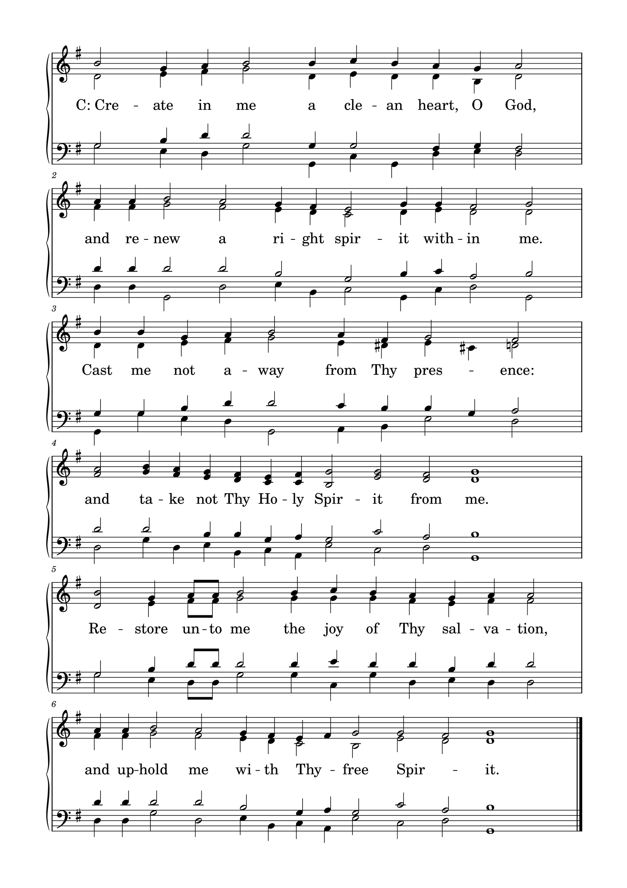

L: Please be seated.

(An offering may be collected at this time, or the congregation may be informed that the offering plate is located at the back of the church.)

HYMN 464

GENERAL PRAYER

THE LORD'S PRAYER
C: Our Father, who art in heaven, hallowed be Your name; Your kingdom come; Your will be done on earth as it is in heaven. Give us this day our daily bread; and forgive us our trespasses, as we forgive those who trespass against us; and lead us not into temptation; but deliver us from evil. For Yours is the kingdom and the power and the glory forever and ever. Amen.

(If Communion is celebrated, refer to the order of Holy Communion.)

FINAL HYMN 241

THE BENEDICTION
L : (The congregation rises.) The Lord bless you and keep you. The Lord make His face shine upon you and be gracious to you. The Lord lift up His countenance upon you and give you peace.


ANNOUNCEMENTS
• CALL NEWS Pastor Zachary Sippert of Grace Ev. Lutheran Church, Sleepy Eye, MN, has returned the call to Holy Cross Ev. Lutheran Church, Phoenix, AZ. <> Missionary Todd Ohlmann has received the call to Messiah Lutheran Church, Eau Claire, WI. <> Pastor Timothy Daub of Prince of Peace Lutheran Church, Hecla, SD, Zion Ev. Lutheran Church, Aberdeen, SD, and Redeemer Lutheran Church, Bowdle, SD, has received the call from the CLC Board of Missions to serve as Part-Time Missionary to Mexico. <> Pastor Rob Sauers of Immanuel Lutheran Church, Winter Haven, FL, has received the call from the CLC Board of Missions to serve as Part-Time Missionary to India. <> Pastor Frank Gantt of Zion Ev. Lutheran Church, Loganville, GA, and Faith Lutheran Church, Manchester, MO, has received the call to St. Luke’s Ev. Lutheran Church, Lemmon, SD. <> Pastor Paul Krause of Trinity Lutheran Church, Watertown, SD, and Zion Lutheran Church, Hidewood Township, SD, has received the call to Mt. Zion Lutheran Church, Madison Heights, MI. <> Pastor Matthew Hanel of St. Matthew Ev. Lutheran Church, Dallas, TX, has returned the call to Gift of God Lutheran Church, Mapleton, ND, and to St. Paul’s Lutheran Church, Ponsford, MN. <> Pastor Aaron Ude of Good Shepherd Lutheran Church, Rapid City, SD, has returned the call to St. Paul’s Ev. Lutheran Church, Austin, MN.
• ANNIVERSARIES Ascension Lutheran Church, Batavia, IL, will be celebrating its 60th anniversary on October 11, 2026. Pastor Emeritus David Schierenbeck will be the guest speaker.

“Scripture taken from the New King James Version®. Copyright © 1982 by Thomas Nelson. Used by permission. All rights reserved.”

