

THE COMMON SERVICE
This liturgy is adapted from the Common Service Book of the Lutheran Church (1917-1918), Evangelical Lutheran Hymn-book (1912), and Music for the Liturgy: in Conformity with the Evangelical Lutheran Hymn book which are in the public domain.

OPENING HYMN 625
Leader : (The congregation rises.) In the name of the Father, and of the Son, and of the Holy Spirit.



THE CONFESSION OF SINS
L: Beloved in the Lord! Let us draw near with a true heart and confess our sins to God our Father, asking Him, in the name of our Lord Jesus Christ, to grant us forgiveness.
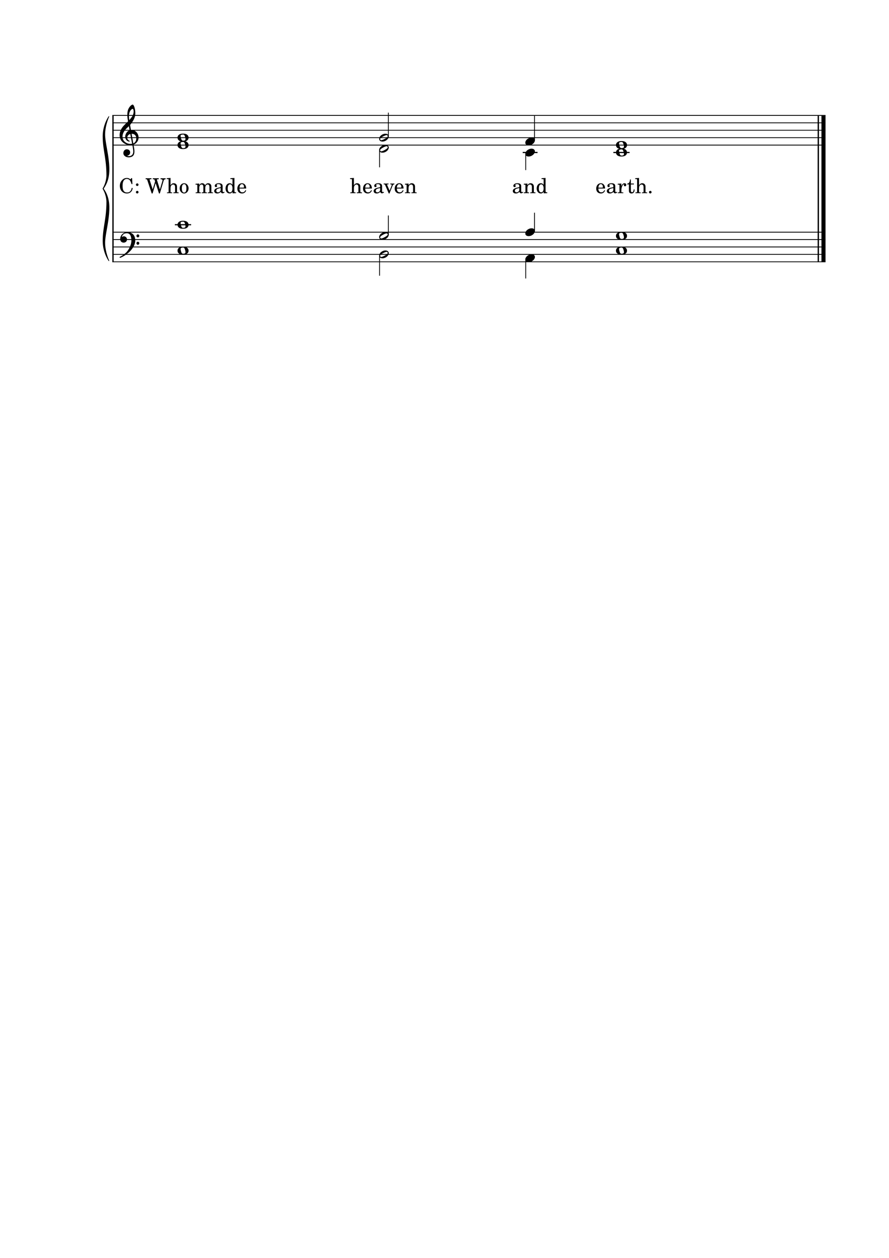L: Our help is in the name of the Lord.

L: I said, I will confess my transgressions to the Lord.
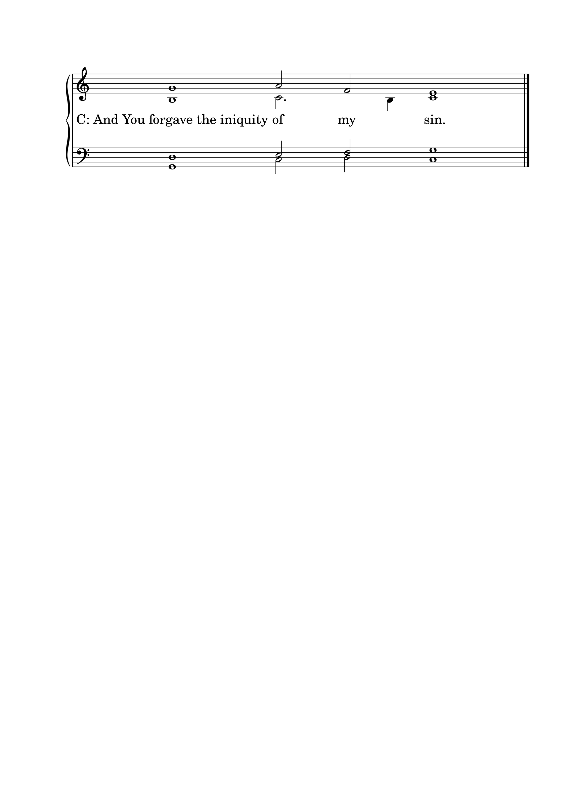

L : Almighty God, our Maker and Redeemer, we poor sinners confess to You that we are by nature sinful and unclean, and that we have sinned against You by thought, word, and deed. Therefore we flee for refuge to Your infinite mercy, seeking and imploring Your grace for the sake of our Lord Jesus Christ.
C: O most merciful God, who has given Your only-begotten Son to die for us, have mercy upon us, and for His sake grant us remission of all our sins; and by Your Holy Spirit increase in us true knowledge of You and of Your will, and true obedience to Your Word, so that by Your grace we may come to everlasting life; through Jesus Christ our Lord. Amen.

THE ABSOLUTION
L : Almighty God, our heavenly Father, has had mercy upon us and has given His only Son to die for us, and for His sake forgives us all our sins. To those who believe in His name He gives power to become the children of God and bestows upon them His Holy Spirit. Whoever believes and is baptized will be saved. Grant this, O Lord, to us all.
C: Amen.

PSALM OF THE DAY
L: Blessed is every one who fears the Lord,
C: Who walks in His ways.
L: When you eat the labor of your hands,
C: You shall be happy, and it shall be well with you.
L: Your wife shall be like a fruitful vine In the very heart of your house,
C: Your children like olive plants All around your table.
L: Behold, thus shall the man
C: be blessed Who fears the Lord.
L: The Lord bless you out of Zion,
C: And may you see the good of Jerusalem All the days of your life.
L: Yes, may you see your children’s children.
C: Peace be upon Israel! (Psalm 128)

GLORIA PATRI

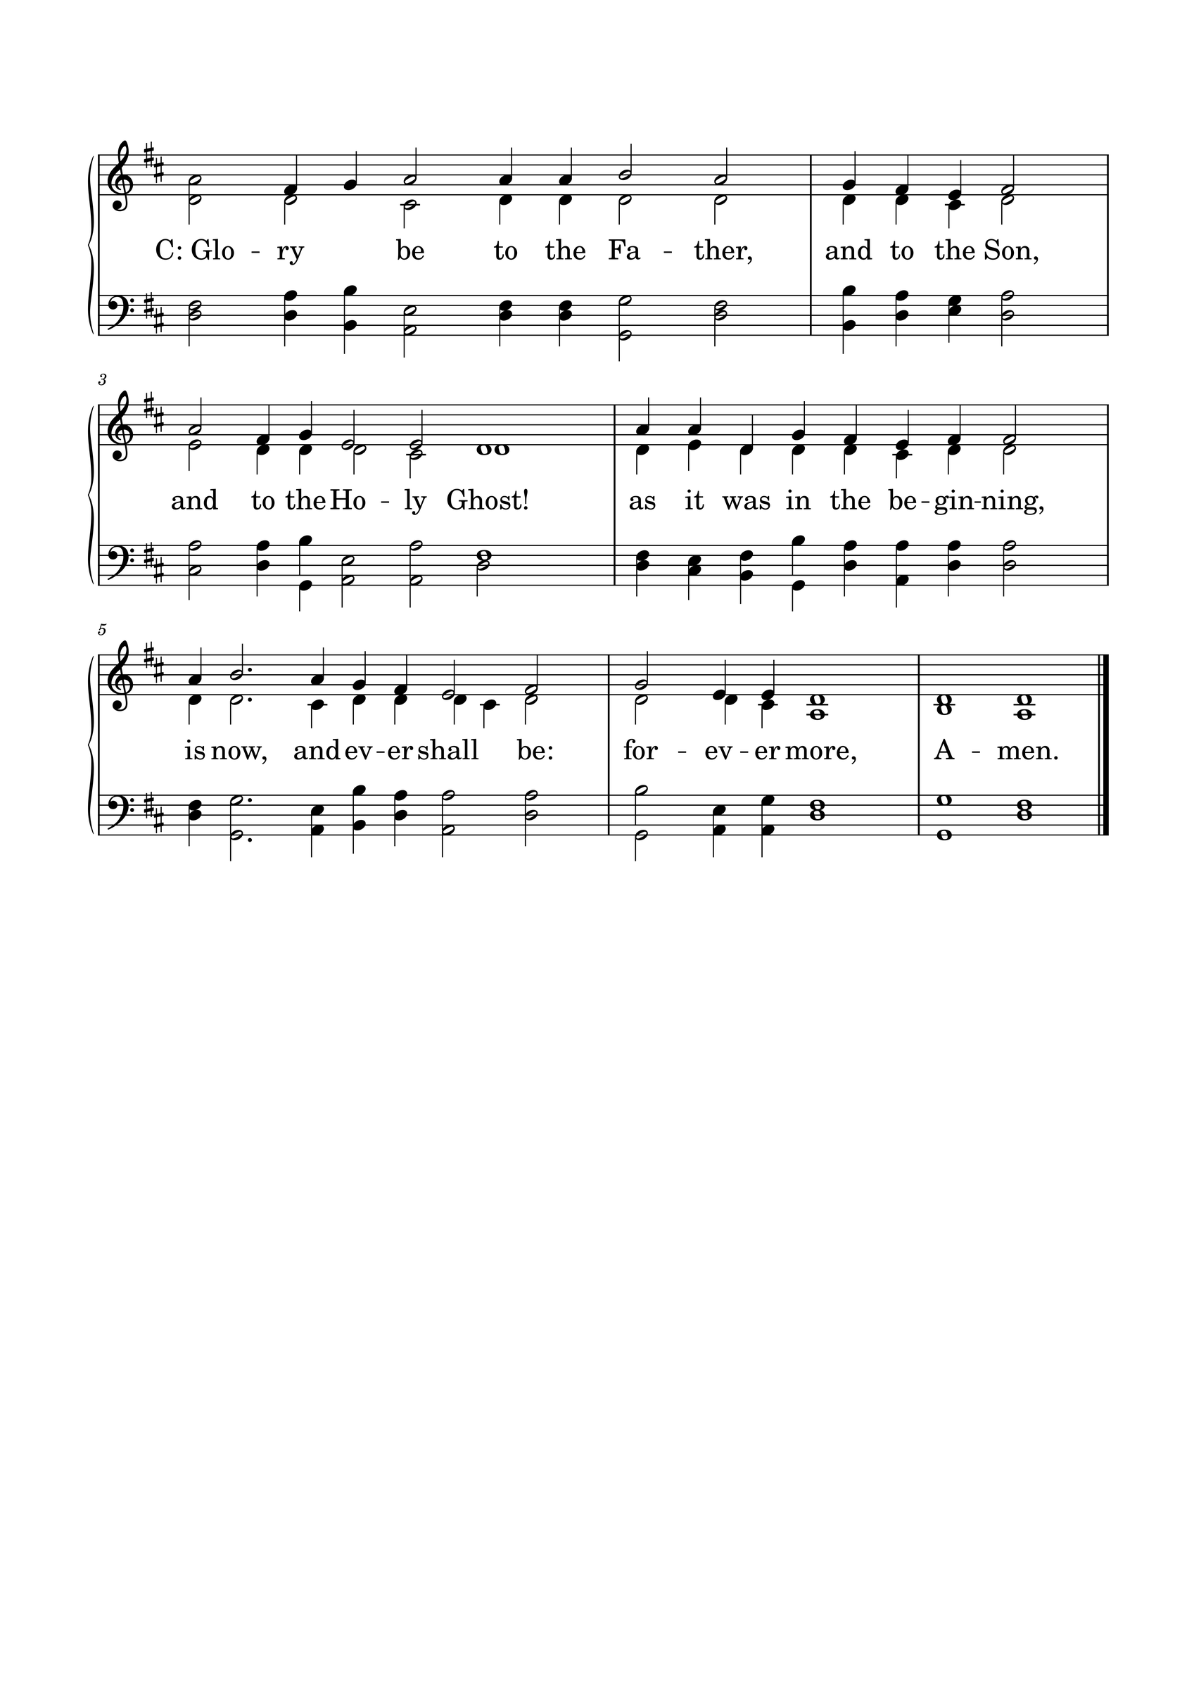

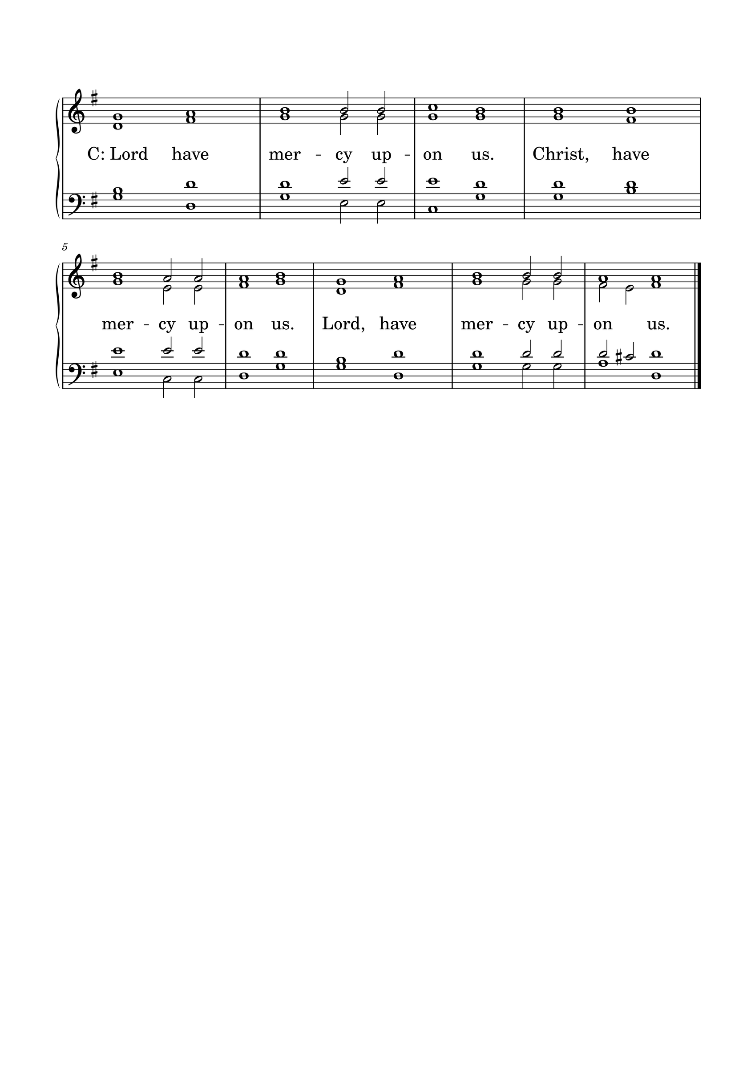KYRIE

GLORIA
The Lutheran Hymnal hymn 244 Verses 1 & 2
C: 1. Glory be to God the Father,
Glory be to God the Son,
Glory be to God the Spirit:
Great Jehovah, Three in One!
Glory, glory,
While eternal ages run!

2. Glory be to Him who loved us,
Washed us from each spot and stain;
Glory be to Him who bought us,
Made us kings with Him to reign!
Glory, glory,
To the Lamb that once was slain!

THE COLLECT
L : Let us pray.
L :
Almighty God, our heavenly Father, You established marriage as a good and gracious gift and revealed Your faithful love in Jesus Christ, who gave Himself for His church: Forgive our selfishness, and renew us through Your Word, that husbands may love and serve their wives, wives may respect and support their husbands, and all Your people may find comfort in the love of their Savior; through Jesus Christ, Your Son, our Lord, who lives and reigns with You and the Holy Spirit, one God, now and forever. Amen.
C: Amen.

FIRST SCRIPTURE READING
L: (The congregation may be seated.) The First Scripture Reading for 20th Sunday of Trinity is written in the 2nd chapter of Genesis, beginning at verse 18.
[18] And the Lord God said, “It is not good that man should be alone; I will make him a helper comparable to him.” [19] Out of the ground the Lord God formed every beast of the field and every bird of the air, and brought them to Adam to see what he would call them. And whatever Adam called each living creature, that was its name. [20] So Adam gave names to all cattle, to the birds of the air, and to every beast of the field. But for Adam there was not found a helper comparable to him.
[21] And the Lord God caused a deep sleep to fall on Adam, and he slept; and He took one of his ribs, and closed up the flesh in its place. [22] Then the rib which the Lord God had taken from man He made into a woman, and He brought her to the man.
[23] And Adam said: “This is now bone of my bones And flesh of my flesh;
She shall be called Woman, Because she was taken out of Man.”
[24] Therefore a man shall leave his father and mother and be joined to his wife, and they shall become one flesh.
[25] And they were both naked, the man and his wife, and were not ashamed.
L: Here ends the First Scripture Reading.

SECOND SCRIPTURE READING
L: The Second Scripture Reading is written in the 10th chapter of Mark, beginning at verse 2.
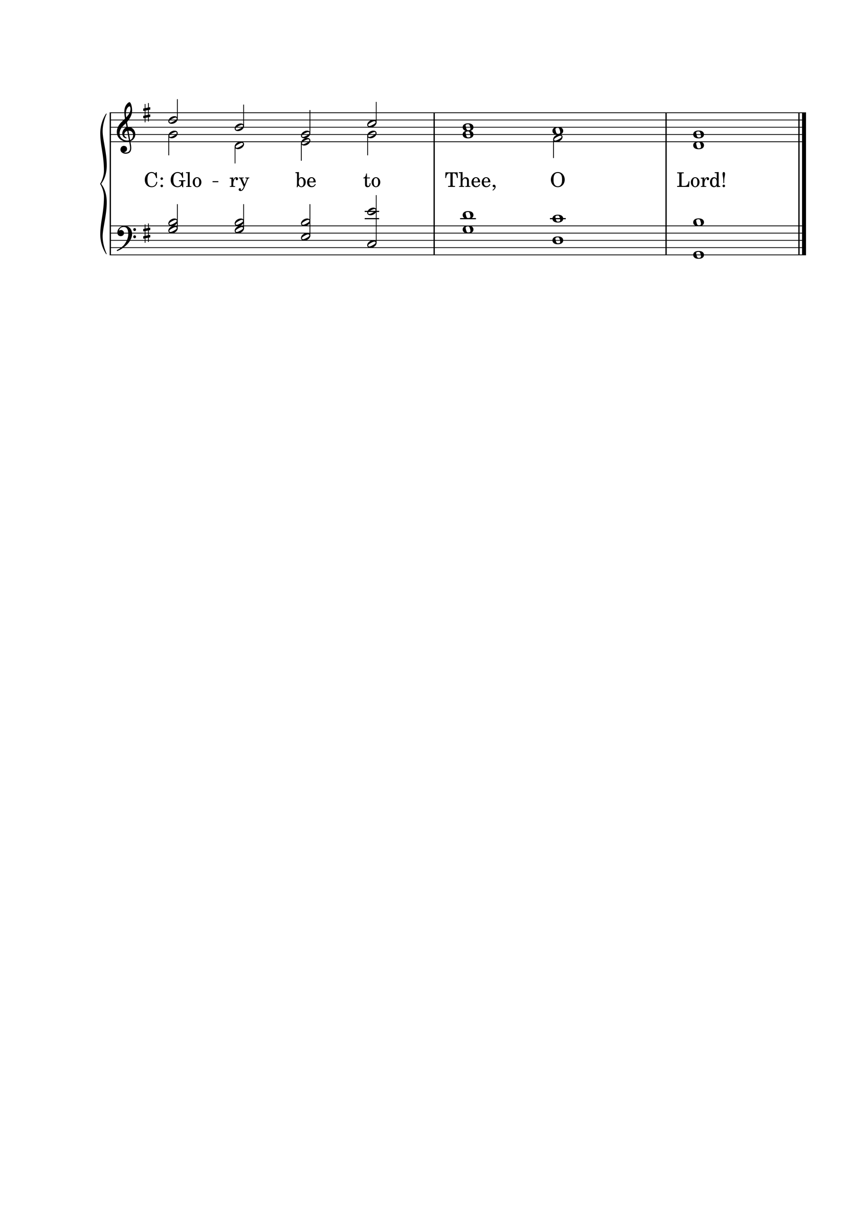

[2] The Pharisees came and asked Him, “Is it lawful for a man to divorce his wife?” testing Him.
[3] And He answered and said to them, “What did Moses command you?”
[4] They said, “Moses permitted a man to write a certificate of divorce, and to dismiss her.”
[5] And Jesus answered and said to them, “Because of the hardness of your heart he wrote you this precept. [6] But from the beginning of the creation, God ‘made them male and female.’ [7] ‘For this reason a man shall leave his father and mother and be joined to his wife, [8] and the two shall become one flesh’ ; so then they are no longer two, but one flesh. [9] Therefore what God has joined together, let not man separate.”
[10] In the house His disciples also asked Him again about the same matter. [11] So He said to them, “Whoever divorces his wife and marries another commits adultery against her. [12] And if a woman divorces her husband and marries another, she commits adultery.”
[13] Then they brought little children to Him, that He might touch them; but the disciples rebuked those who brought them. [14] But when Jesus saw it, He was greatly displeased and said to them, “Let the little children come to Me, and do not forbid them; for of such is the kingdom of God. [15] Assuredly, I say to you, whoever does not receive the kingdom of God as a little child will by no means enter it.” [16] And He took them up in His arms, laid His hands on them, and blessed them.

L: Here ends the Second Scripture Reading.

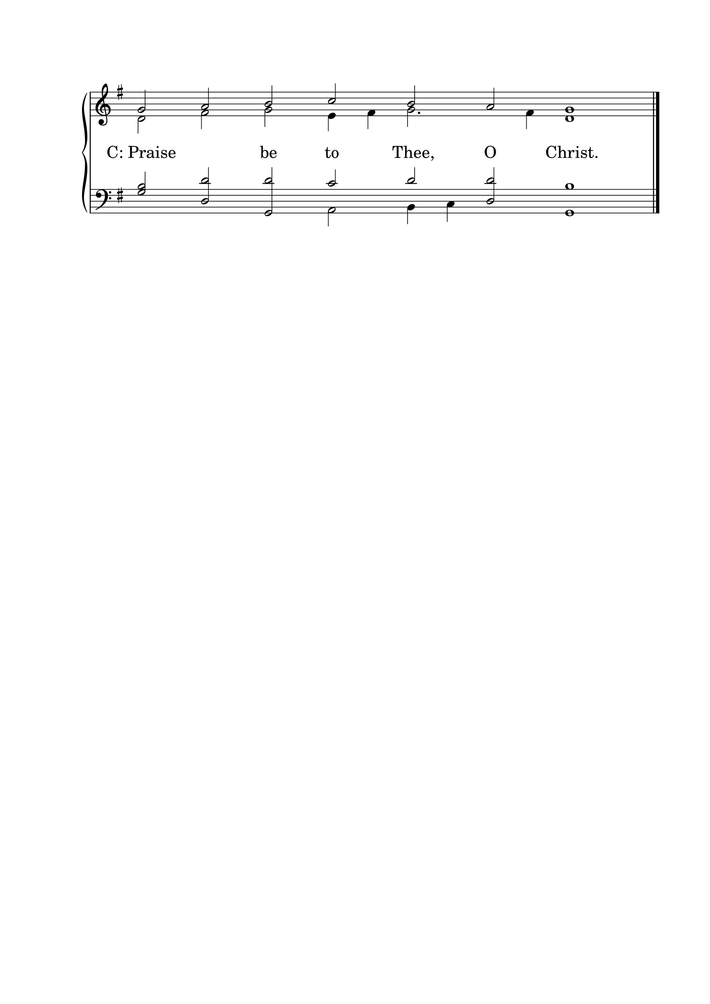

THE APOSTLES' CREED
C: I believe in God the Father almighty, maker of heaven and earth. And in Jesus Christ, His only Son, our Lord, who was conceived by the Holy Spirit, born of the Virgin Mary; suffered under Pontius Pilate, was crucified, died, and was buried. He descended into hell. The third day He rose again from the dead. He ascended into heaven and is seated at the right hand of God the Father almighty. From there He will come to judge the living and the dead. I believe in the Holy Spirit; the holy Christian Church, the communion of saints; the forgiveness of sins; the resurrection of the body; and the life everlasting. Amen.

HYMN 624
THE SERMON
Sermon Text: Ephesians 5:22-33 NKJ
"Wives, submit to your own husbands, as to the Lord. 23 For the husband is head of the wife, as also Christ is head of the church; and He is the Savior of the body. 24 Therefore, just as the church is subject to Christ, so let the wives be to their own husbands in everything. 25 Husbands, love your wives, just as Christ also loved the church and gave Himself for her, 26 that He might sanctify and cleanse her with the washing of water by the word, 27 that He might present her to Himself a glorious church, not having spot or wrinkle or any such thing, but that she should be holy and without blemish. 28 So husbands ought to love their own wives as their own bodies; he who loves his wife loves himself. 29 For no one ever hated his own flesh, but nourishes and cherishes it, just as the Lord does the church. 30 For we are members of His body, of His flesh and of His bones. 31 "For this reason a man shall leave his father and mother and be joined to his wife, and the two shall become one flesh." 32 This is a great mystery, but I speak concerning Christ and the church. 33 Nevertheless let each one of you in particular so love his own wife as himself, and let the wife see that she respects her husband."

Sermon Theme: Christ and the Church: God’s Pattern for Marriage

L: (The congregation rises.) And may the peace of God, which surpasses all understanding, guard your hearts and minds through Christ Jesus, amen.

THE OFFERTORY
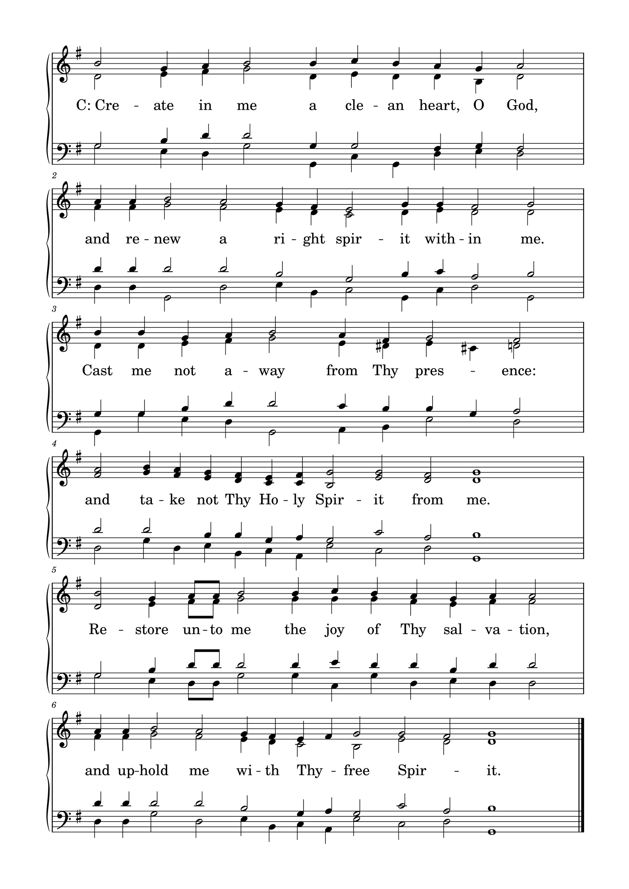

L: Please be seated.

(An offering may be collected at this time, or the congregation may be informed that the offering plate is located at the back of the church.)

HYMN 340

GENERAL PRAYER

THE LORD'S PRAYER
C: Our Father, who art in heaven, hallowed be Your name; Your kingdom come; Your will be done on earth as it is in heaven. Give us this day our daily bread; and forgive us our trespasses, as we forgive those who trespass against us; and lead us not into temptation; but deliver us from evil. For Yours is the kingdom and the power and the glory forever and ever. Amen.

(If Communion is celebrated, refer to the order of Holy Communion.)

FINAL HYMN 313

THE BENEDICTION
L : (The congregation rises.) The Lord bless you and keep you. The Lord make His face shine upon you and be gracious to you. The Lord lift up His countenance upon you and give you peace.
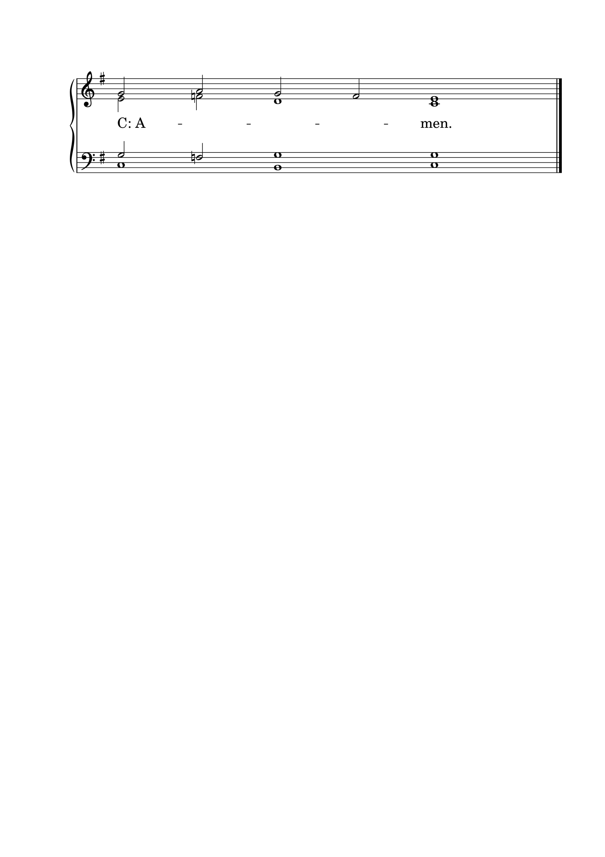

ANNOUNCEMENTS
• CALL NEWS Pastor Timothy Daub of Prince of Peace Lutheran Church, Hecla, SD, Zion Ev. Lutheran Church, Aberdeen, SD, and Redeemer Lutheran Church, Bowdle, SD, has received the call from the CLC Board of Missions to serve as Part-Time Missionary to Mexico. <> Pastor Rob Sauers of Immanuel Lutheran Church, Winter Haven, FL, has received the call from the CLC Board of Missions to serve as Part-Time Missionary to India. <> Pastor Frank Gantt of Zion Ev. Lutheran Church, Loganville, GA, and Faith Lutheran Church, Manchester, MO, has received the call to St. Luke’s Ev. Lutheran Church, Lemmon, SD. <> Pastor Paul Krause of Trinity Lutheran Church, Watertown, SD, and Zion Lutheran Church, Hidewood Township, SD, has received the call to Mt. Zion Lutheran Church, Madison Heights, MI. <> Pastor Matthew Hanel of St. Matthew Ev. Lutheran Church, Dallas, TX, has returned the call to Gift of God Lutheran Church, Mapleton, ND, and to St. Paul’s Lutheran Church, Ponsford, MN. <> Pastor Aaron Ude of Good Shepherd Lutheran Church, Rapid City, SD, has returned the call to St. Paul’s Ev. Lutheran Church, Austin, MN. <> Pastor Zachary Sippert of Grace Ev. Lutheran Church, Sleepy Eye, MN, has received the call to Holy Cross Ev. Lutheran Church, Phoenix, AZ. <> Pastor Glenn Oster of Gift of God Lutheran Church, Fairfax, VA, has returned the call to Trinity Ev. Lutheran Church, Spokane, WA.
• ANNIVERSARIES Ascension Lutheran Church, Batavia, IL, will be celebrating its 60th anniversary on October 11, 2026. Pastor Emeritus David Schierenbeck will be the guest speaker.

“Scripture taken from the New King James Version®. Copyright © 1982 by Thomas Nelson. Used by permission. All rights reserved.”

