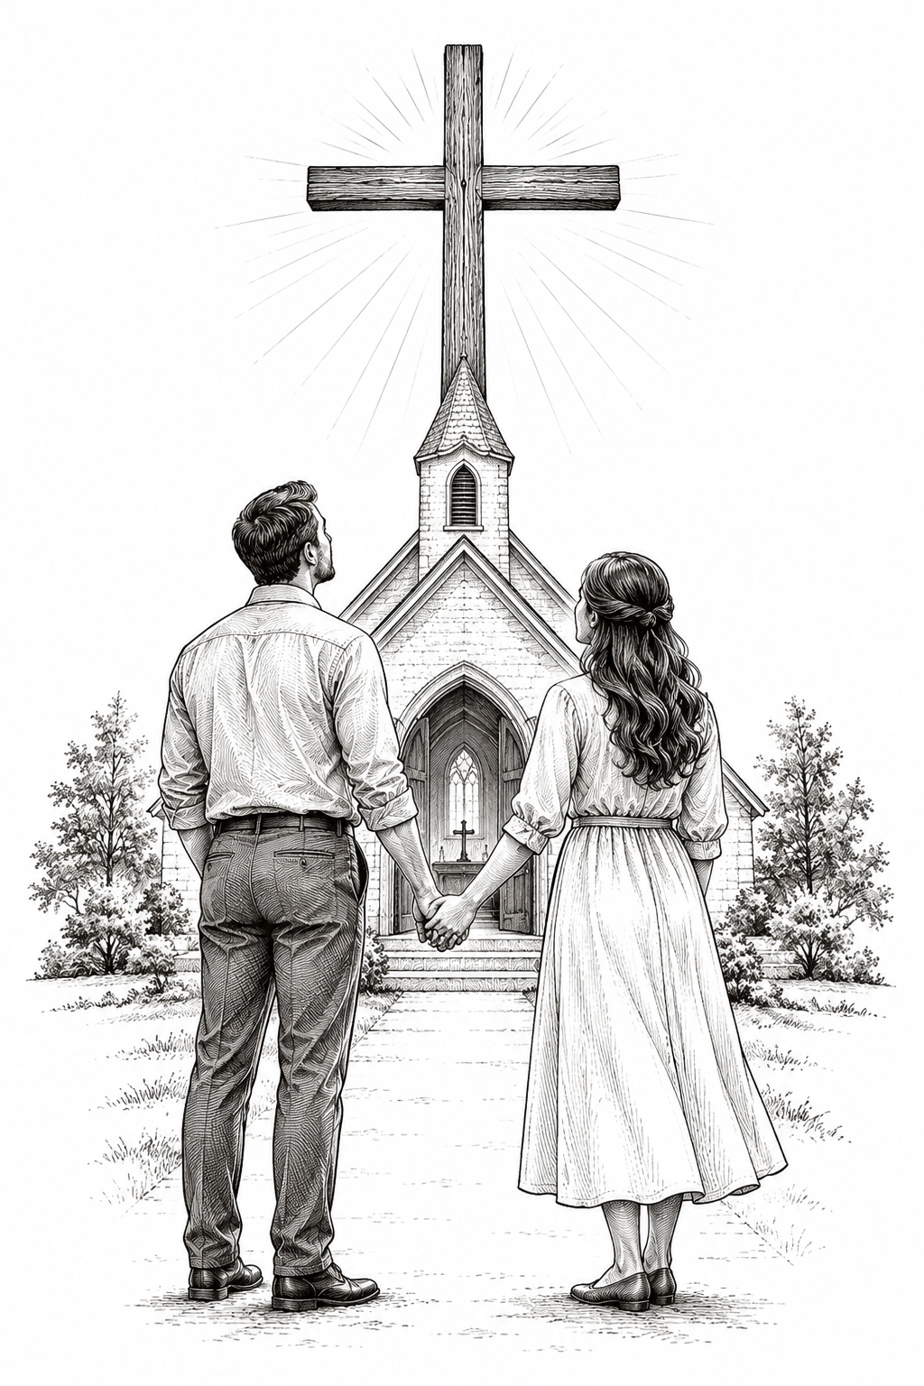
A Church of the Lutheran Confession
October 11, 2026
20th Sunday of Trinity

HYMNS
625; 624; 340; 313

PSALM OF THE DAY
L: Blessed is every one who fears the Lord,
C: Who walks in His ways.
L: When you eat the labor of your hands,
C: You shall be happy, and it shall be well with you.
L: Your wife shall be like a fruitful vine In the very heart of your house,
C: Your children like olive plants All around your table.
L: Behold, thus shall the man
C: be blessed Who fears the Lord.
L: The Lord bless you out of Zion,
C: And may you see the good of Jerusalem All the days of your life.
L: Yes, may you see your children’s children.
C: Peace be upon Israel! (Psalm 128)

THE COLLECT
Almighty God, our heavenly Father, You established marriage as a good and gracious gift and revealed Your faithful love in Jesus Christ, who gave Himself for His church: Forgive our selfishness, and renew us through Your Word, that husbands may love and serve their wives, wives may respect and support their husbands, and all Your people may find comfort in the love of their Savior; through Jesus Christ, Your Son, our Lord, who lives and reigns with You and the Holy Spirit, one God, now and forever. Amen.

FIRST SCRIPTURE READING
Genesis 2:18-25
[18] And the Lord God said, “It is not good that man should be alone; I will make him a helper comparable to him.” [19] Out of the ground the Lord God formed every beast of the field and every bird of the air, and brought them to Adam to see what he would call them. And whatever Adam called each living creature, that was its name. [20] So Adam gave names to all cattle, to the birds of the air, and to every beast of the field. But for Adam there was not found a helper comparable to him.
[21] And the Lord God caused a deep sleep to fall on Adam, and he slept; and He took one of his ribs, and closed up the flesh in its place. [22] Then the rib which the Lord God had taken from man He made into a woman, and He brought her to the man. [23] And Adam said: “This is now bone of my bones
And flesh of my flesh; She shall be called Woman, Because she was taken out of Man.”
[24] Therefore a man shall leave his father and mother and be joined to his wife, and they shall become one flesh. [25] And they were both naked, the man and his wife, and were not ashamed.

SECOND SCRIPTURE READING
Mark 10:2-16
[2] The Pharisees came and asked Him, “Is it lawful for a man to divorce his wife?” testing Him.
[3] And He answered and said to them, “What did Moses command you?”
[4] They said, “Moses permitted a man to write a certificate of divorce, and to dismiss her.”
[5] And Jesus answered and said to them, “Because of the hardness of your heart he wrote you this precept. [6] But from the beginning of the creation, God ‘made them male and female.’ [7] ‘For this reason a man shall leave his father and mother and be joined to his wife, [8] and the two shall become one flesh’ ; so then they are no longer two, but one flesh. [9] Therefore what God has joined together, let not man separate.”
[10] In the house His disciples also asked Him again about the same matter. [11] So He said to them, “Whoever divorces his wife and marries another commits adultery against her. [12] And if a woman divorces her husband and marries another, she commits adultery.”
[13] Then they brought little children to Him, that He might touch them; but the disciples rebuked those who brought them. [14] But when Jesus saw it, He was greatly displeased and said to them, “Let the little children come to Me, and do not forbid them; for of such is the kingdom of God. [15] Assuredly, I say to you, whoever does not receive the kingdom of God as a little child will by no means enter it.” [16] And He took them up in His arms, laid His hands on them, and blessed them.

THE SERMON
Sermon Text: Ephesians 5:22-33 NKJ
"Wives, submit to your own husbands, as to the Lord. 23 For the husband is head of the wife, as also Christ is head of the church; and He is the Savior of the body. 24 Therefore, just as the church is subject to Christ, so let the wives be to their own husbands in everything. 25 Husbands, love your wives, just as Christ also loved the church and gave Himself for her, 26 that He might sanctify and cleanse her with the washing of water by the word, 27 that He might present her to Himself a glorious church, not having spot or wrinkle or any such thing, but that she should be holy and without blemish. 28 So husbands ought to love their own wives as their own bodies; he who loves his wife loves himself. 29 For no one ever hated his own flesh, but nourishes and cherishes it, just as the Lord does the church. 30 For we are members of His body, of His flesh and of His bones. 31 "For this reason a man shall leave his father and mother and be joined to his wife, and the two shall become one flesh." 32 This is a great mystery, but I speak concerning Christ and the church. 33 Nevertheless let each one of you in particular so love his own wife as himself, and let the wife see that she respects her husband."

Sermon Theme: Christ and the Church: God’s Pattern for Marriage

ANNOUNCEMENTS
• CALL NEWS Pastor Timothy Daub has received the call from the CLC Board of Missions to serve as Part-Time Missionary to Mexico. <> Pastor Rob Sauers of Immanuel Lutheran Church, Winter Haven, FL, has received the call from the CLC Board of Missions to serve as Part-Time Missionary to India. <> Pastor Frank Gantt of Zion Ev. Lutheran Church, Loganville, GA, and Faith Lutheran Church, Manchester, MO, has received the call to St. Luke’s Ev. Lutheran Church, Lemmon, SD. <> Pastor Paul Krause of Trinity Lutheran Church, Watertown, SD, and Zion Lutheran Church, Hidewood Township, SD, has received the call to Mt. Zion Lutheran Church, Madison Heights, MI. <> Pastor Matthew Hanel of St. Matthew Ev. Lutheran Church, Dallas, TX, has returned the call to Gift of God Lutheran Church, Mapleton, ND, and to St. Paul’s Lutheran Church, Ponsford, MN. <> Pastor Zachary Sippert of Grace Ev. Lutheran Church, Sleepy Eye, MN, has received the call to Holy Cross Ev. Lutheran Church, Phoenix, AZ.

“Scripture taken from the New King James Version®. Copyright © 1982 by Thomas Nelson. Used by permission. All rights reserved.”

