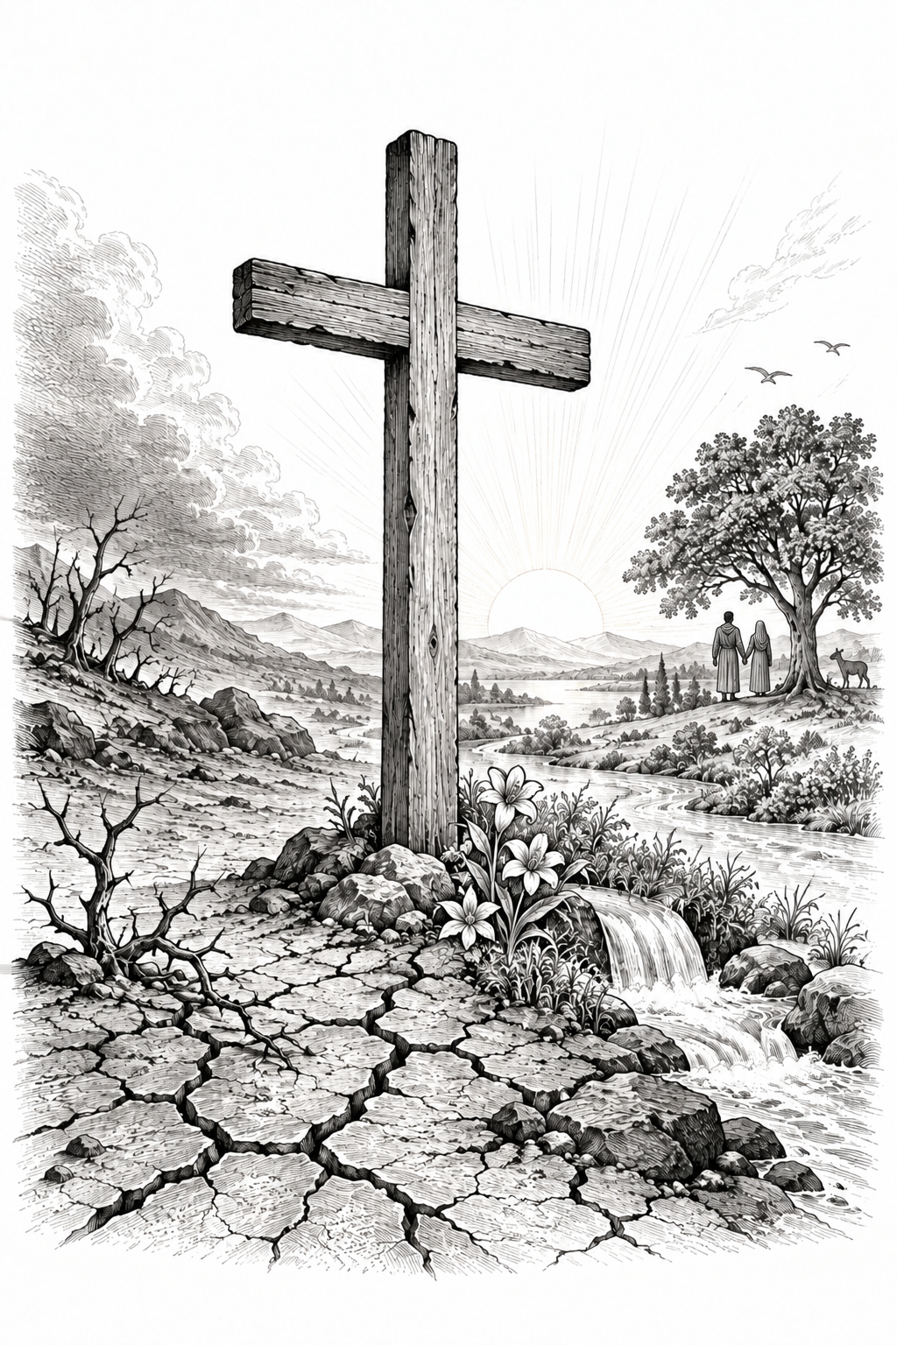

THE COMMON SERVICE
This liturgy is adapted from the Common Service Book of the Lutheran Church (1917-1918) and Evangelical Lutheran Hymn-book (1912), which are in the public domain. Bold faced congregational responses may be spoken or sung as desired.

OPENING HYMN 457
Leader: (The congregation rises.) In the name of the Father, and of the Son, and of the Holy Spirit.
Congregation: Amen.

THE CONFESSION OF SINS
L : Beloved in the Lord! Let us draw near with a true heart and confess our sins to God our Father, asking Him, in the name of our Lord Jesus Christ, to grant us forgiveness.
L: Our help is in the name of the Lord.
C: Who made heaven and earth.
L: I said, I will confess my transgressions to the Lord.
C: And You forgave the iniquity of my sin.
L : Almighty God, our Maker and Redeemer, we poor sinners confess to You that we are by nature sinful and unclean, and that we have sinned against You by thought, word, and deed. Therefore we flee for refuge to Your infinite mercy, seeking and imploring Your grace for the sake of our Lord Jesus Christ.
C: O most merciful God, who has given Your only-begotten Son to die for us, have mercy upon us, and for His sake grant us remission of all our sins; and by Your Holy Spirit increase in us true knowledge of You and of Your will, and true obedience to Your Word, so that by Your grace we may come to everlasting life; through Jesus Christ our Lord. Amen.
L : Almighty God, our heavenly Father, has had mercy upon us and has given His only Son to die for us, and for His sake forgives us all our sins. To those who believe in His name He gives power to become the children of God and bestows upon them His Holy Spirit. Whoever believes and is baptized will be saved. Grant this, O Lord, to us all.
C: Amen.

PSALM OF THE DAY
L: Make a joyful shout to the Lord,
C: all you lands!
L: Serve the Lord with gladness;
C: Come before His presence with singing.
L: Know that the Lord, He is God; It is He who has made us, and not we ourselves;
C: We are His people and the sheep of His pasture.
L: Enter into His gates with thanksgiving,
C: And into His courts with praise. Be thankful to Him, and bless His name.
L: For the Lord is good;
C: His mercy is everlasting, And His truth endures to all generations. (Psalm 100)

GLORIA PATRI
C: Glory be to the Father, and to the Son, and to the Holy Spirit; as it was in the beginning, is now, and will be forever. Amen.

KYRIE
C: Lord, have mercy upon us.
Christ, have mercy upon us.
Lord, have mercy upon us.
GLORIA
The Lutheran Hymnal hymn 244 Verses 1 & 2

C: 1. Glory be to God the Father,
Glory be to God the Son,
Glory be to God the Spirit:
Great Jehovah, Three in One!
Glory, glory,
While eternal ages run!

2. Glory be to Him who loved us,
Washed us from each spot and stain;
Glory be to Him who bought us,
Made us kings with Him to reign!
Glory, glory,
To the Lamb that once was slain!

THE COLLECT
L : Let us pray.
L :
Almighty God, You created all things good, but sin has brought corruption and death into Your creation. Forgive and renew us through Your Son, Jesus Christ, and keep us in the true faith until You bring us into the new heavens and the new earth, where all things will again be very good; through Jesus Christ, our Lord. Amen.
C: Amen.

FIRST SCRIPTURE READING
L: (The congregation may be seated.) The First Scripture Reading for 19th Sunday of Trinity is written in the 8th chapter of Romans, beginning at verse 15.
[15] For you did not receive the spirit of bondage again to fear, but you received the Spirit of adoption by whom we cry out, “Abba, Father.” [16] The Spirit Himself bears witness with our spirit that we are children of God, [17] and if children, then heirs—heirs of God and joint heirs with Christ, if indeed we suffer with Him, that we may also be glorified together.
[18] For I consider that the sufferings of this present time are not worthy to be compared with the glory which shall be revealed in us. [19] For the earnest expectation of the creation eagerly waits for the revealing of the sons of God. [20] For the creation was subjected to futility, not willingly, but because of Him who subjected it in hope; [21] because the creation itself also will be delivered from the bondage of corruption into the glorious liberty of the children of God. [22] For we know that the whole creation groans and labors with birth pangs together until now. [23] Not only that, but we also who have the firstfruits of the Spirit, even we ourselves groan within ourselves, eagerly waiting for the adoption, the redemption of our body. [24] For we were saved in this hope, but hope that is seen is not hope; for why does one still hope for what he sees? [25] But if we hope for what we do not see, we eagerly wait for it with perseverance.
L: Here ends the First Scripture Reading.

SECOND SCRIPTURE READING
L: The Second Scripture Reading is written in the 10th chapter of Mark, beginning at verse 2.
C: Glory be to You, O Lord.
[2] The Pharisees came and asked Him, “Is it lawful for a man to divorce his wife?” testing Him.
[3] And He answered and said to them, “What did Moses command you?”
[4] They said, “Moses permitted a man to write a certificate of divorce, and to dismiss her.”
[5] And Jesus answered and said to them, “Because of the hardness of your heart he wrote you this precept. [6] But from the beginning of the creation, God ‘made them male and female.’ [7] ‘For this reason a man shall leave his father and mother and be joined to his wife, [8] and the two shall become one flesh’ ; so then they are no longer two, but one flesh. [9] Therefore what God has joined together, let not man separate.”
[10] In the house His disciples also asked Him again about the same matter. [11] So He said to them, “Whoever divorces his wife and marries another commits adultery against her. [12] And if a woman divorces her husband and marries another, she commits adultery.”
[13] Then they brought little children to Him, that He might touch them; but the disciples rebuked those who brought them. [14] But when Jesus saw it, He was greatly displeased and said to them, “Let the little children come to Me, and do not forbid them; for of such is the kingdom of God. [15] Assuredly, I say to you, whoever does not receive the kingdom of God as a little child will by no means enter it.” [16] And He took them up in His arms, laid His hands on them, and blessed them.

L: Here ends the Second Scripture Reading.
C: Praise be to You, O Christ.

THE APOSTLES' CREED
C: I believe in God the Father almighty, maker of heaven and earth. And in Jesus Christ, His only Son, our Lord, who was conceived by the Holy Spirit, born of the Virgin Mary; suffered under Pontius Pilate, was crucified, died, and was buried. He descended into hell. The third day He rose again from the dead. He ascended into heaven and is seated at the right hand of God the Father almighty. From there He will come to judge the living and the dead. I believe in the Holy Spirit; the holy Christian Church, the communion of saints; the forgiveness of sins; the resurrection of the body; and the life everlasting. Amen.

HYMN 374

THE SERMON
Sermon Text: Genesis 2:18-25 NKJ
"And the LORD God said, "It is not good that man should be alone; I will make him a helper comparable to him." 19 Out of the ground the LORD God formed every beast of the field and every bird of the air, and brought them to Adam to see what he would call them. And whatever Adam called each living creature, that was its name. 20 So Adam gave names to all cattle, to the birds of the air, and to every beast of the field. But for Adam there was not found a helper comparable to him. 21 And the LORD God caused a deep sleep to fall on Adam, and he slept; and He took one of his ribs, and closed up the flesh in its place. 22 Then the rib which the LORD God had taken from man He made into a woman, and He brought her to the man. 23 And Adam said: "This is now bone of my bones And flesh of my flesh; She shall be called Woman, Because she was taken out of Man." 24 Therefore a man shall leave his father and mother and be joined to his wife, and they shall become one flesh. 25 And they were both naked, the man and his wife, and were not ashamed."

Sermon Theme: What is Good?
L: (The congregation rises.) And may the peace of God, which surpasses all understanding, guard your hearts and minds through Christ Jesus, amen.

THE OFFERTORY
C: Create in me a clean heart, O God, and renew a right spirit within me. Cast me not away from Your presence, and take not Your Holy Spirit from me. Restore to me the joy of Your salvation, and uphold me with Your free Spirit.
L: Please be seated.

(An offering may be collected at this time, or the congregation may be informed that the offering plate is located at the back of the church.)

HYMN 375

GENERAL PRAYER

THE LORD'S PRAYER
C: Our Father, who art in heaven, hallowed be Your name; Your kingdom come; Your will be done on earth as it is in heaven. Give us this day our daily bread; and forgive us our trespasses, as we forgive those who trespass against us; and lead us not into temptation; but deliver us from evil. For Yours is the kingdom and the power and the glory forever and ever. Amen.

(If Communion is celebrated, refer to the order of Holy Communion.)

FINAL HYMN 36

THE BENEDICTION
L : (The congregation rises.) The Lord bless you and keep you. The Lord make His face shine upon you and be gracious to you. The Lord lift up His countenance upon you and give you peace.
C: Amen.

ANNOUNCEMENTS
• CALL NEWS Pastor Zachary Sippert of Grace Ev. Lutheran Church, Sleepy Eye, MN, has received the call to Holy Cross Ev. Lutheran Church, Phoenix, AZ. <> Pastor Glenn Oster of Gift of God Lutheran Church, Fairfax, VA, has returned the call to Trinity Ev. Lutheran Church, Spokane, WA. <> Pastor Chad Seybt of Morning Star Lutheran Church, Fairchild, WI, Peace with God Lutheran Church, Onalaska, WI, St. Paul’s Lutheran Church, Melrose, WI, and Trinity Lutheran Church, Millston, WI, has returned the call to Holy Cross Ev. Lutheran Church, Phoenix, AZ. <> Mr. Nick Naumann has returned the call to St. Luke’s Ev. Lutheran Church, Lemmon, SD. <> Pastor Tom Schuetze of St. Paul Ev. Lutheran Church, Lakewood, CO, has returned the call to Living Hope Lutheran Church, Appleton, WI. <> Pastor Matthew Hanel of St. Matthew Ev. Lutheran Church, Dallas, TX, has received the call to Gift of God Lutheran Church, Mapleton, ND, and to St. Paul’s Lutheran Church, Ponsford, MN. <> Pastor Aaron Ude of Good Shepherd Lutheran Church, Rapid City, SD, has received the call to St. Paul’s Ev. Lutheran Church, Austin, MN.
• ANNIVERSARIES Gethsemane Lutheran Church, Spokane Valley, WA, will be celebrating its 75th anniversary on September 20, 2026. President Michael Wilke will be the guest speaker. <> Ascension Lutheran Church, Batavia, IL, will be celebrating its 60th anniversary on October 11, 2026. Pastor Emeritus David Schierenbeck will be the guest speaker.

“Scripture taken from the New King James Version®. Copyright © 1982 by Thomas Nelson. Used by permission. All rights reserved.”

