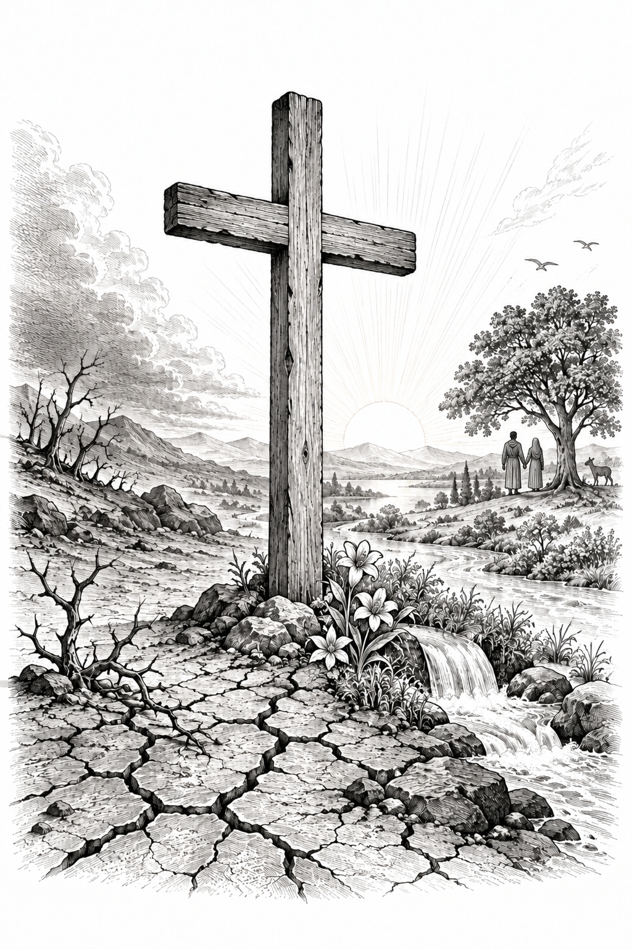
A Church of the Lutheran Confession
October 4, 2026
19th Sunday of Trinity

HYMNS
457; 374; 375; 36

PSALM OF THE DAY
L: Make a joyful shout to the Lord,
C: all you lands!
L: Serve the Lord with gladness;
C: Come before His presence with singing.
L: Know that the Lord, He is God; It is He who has made us, and not we ourselves;
C: We are His people and the sheep of His pasture.
L: Enter into His gates with thanksgiving,
C: And into His courts with praise. Be thankful to Him, and bless His name.
L: For the Lord is good;
C: His mercy is everlasting, And His truth endures to all generations. (Psalm 100)

THE COLLECT
Almighty God, You created all things good, but sin has brought corruption and death into Your creation. Forgive and renew us through Your Son, Jesus Christ, and keep us in the true faith until You bring us into the new heavens and the new earth, where all things will again be very good; through Jesus Christ, our Lord. Amen.

FIRST SCRIPTURE READING
Romans 8:15-25
[15] For you did not receive the spirit of bondage again to fear, but you received the Spirit of adoption by whom we cry out, “Abba, Father.” [16] The Spirit Himself bears witness with our spirit that we are children of God, [17] and if children, then heirs—heirs of God and joint heirs with Christ, if indeed we suffer with Him, that we may also be glorified together.
[18] For I consider that the sufferings of this present time are not worthy to be compared with the glory which shall be revealed in us. [19] For the earnest expectation of the creation eagerly waits for the revealing of the sons of God. [20] For the creation was subjected to futility, not willingly, but because of Him who subjected it in hope; [21] because the creation itself also will be delivered from the bondage of corruption into the glorious liberty of the children of God. [22] For we know that the whole creation groans and labors with birth pangs together until now. [23] Not only that, but we also who have the firstfruits of the Spirit, even we ourselves groan within ourselves, eagerly waiting for the adoption, the redemption of our body. [24] For we were saved in this hope, but hope that is seen is not hope; for why does one still hope for what he sees? [25] But if we hope for what we do not see, we eagerly wait for it with perseverance.

SECOND SCRIPTURE READING
Mark 10:2-16
[2] The Pharisees came and asked Him, “Is it lawful for a man to divorce his wife?” testing Him.
[3] And He answered and said to them, “What did Moses command you?”
[4] They said, “Moses permitted a man to write a certificate of divorce, and to dismiss her.”
[5] And Jesus answered and said to them, “Because of the hardness of your heart he wrote you this precept. [6] But from the beginning of the creation, God ‘made them male and female.’ [7] ‘For this reason a man shall leave his father and mother and be joined to his wife, [8] and the two shall become one flesh’ ; so then they are no longer two, but one flesh. [9] Therefore what God has joined together, let not man separate.”
[10] In the house His disciples also asked Him again about the same matter. [11] So He said to them, “Whoever divorces his wife and marries another commits adultery against her. [12] And if a woman divorces her husband and marries another, she commits adultery.”
[13] Then they brought little children to Him, that He might touch them; but the disciples rebuked those who brought them. [14] But when Jesus saw it, He was greatly displeased and said to them, “Let the little children come to Me, and do not forbid them; for of such is the kingdom of God. [15] Assuredly, I say to you, whoever does not receive the kingdom of God as a little child will by no means enter it.” [16] And He took them up in His arms, laid His hands on them, and blessed them.
THE SERMON
Sermon Text: Genesis 2:18-25 NKJ
"And the LORD God said, "It is not good that man should be alone; I will make him a helper comparable to him." 19 Out of the ground the LORD God formed every beast of the field and every bird of the air, and brought them to Adam to see what he would call them. And whatever Adam called each living creature, that was its name. 20 So Adam gave names to all cattle, to the birds of the air, and to every beast of the field. But for Adam there was not found a helper comparable to him. 21 And the LORD God caused a deep sleep to fall on Adam, and he slept; and He took one of his ribs, and closed up the flesh in its place. 22 Then the rib which the LORD God had taken from man He made into a woman, and He brought her to the man. 23 And Adam said: "This is now bone of my bones And flesh of my flesh; She shall be called Woman, Because she was taken out of Man." 24 Therefore a man shall leave his father and mother and be joined to his wife, and they shall become one flesh. 25 And they were both naked, the man and his wife, and were not ashamed."

Sermon Theme: What is Good?

ANNOUNCEMENTS
• CALL NEWS Pastor Zachary Sippert of Grace Ev. Lutheran Church, Sleepy Eye, MN, has received the call to Holy Cross Ev. Lutheran Church, Phoenix, AZ. <> Pastor Glenn Oster of Gift of God Lutheran Church, Fairfax, VA, has returned the call to Trinity Ev. Lutheran Church, Spokane, WA. <> Pastor Chad Seybt of Morning Star Lutheran Church, Fairchild, WI, Peace with God Lutheran Church, Onalaska, WI, St. Paul’s Lutheran Church, Melrose, WI, and Trinity Lutheran Church, Millston, WI, has returned the call to Holy Cross Ev. Lutheran Church, Phoenix, AZ. <> Mr. Nick Naumann has returned the call to St. Luke’s Ev. Lutheran Church, Lemmon, SD. <> Pastor Tom Schuetze of St. Paul Ev. Lutheran Church, Lakewood, CO, has returned the call to Living Hope Lutheran Church, Appleton, WI. <> Pastor Matthew Hanel of St. Matthew Ev. Lutheran Church, Dallas, TX, has received the call to Gift of God Lutheran Church, Mapleton, ND, and to St. Paul’s Lutheran Church, Ponsford, MN. <> Pastor Aaron Ude of Good Shepherd Lutheran Church, Rapid City, SD, has received the call to St. Paul’s Ev. Lutheran Church, Austin, MN.

“Scripture taken from the New King James Version®. Copyright © 1982 by Thomas Nelson. Used by permission. All rights reserved.”

