

THE COMMON SERVICE
This liturgy is adapted from the Common Service Book of the Lutheran Church (1917-1918), Evangelical Lutheran Hymn-book (1912), and Music for the Liturgy: in Conformity with the Evangelical Lutheran Hymn book which are in the public domain.

OPENING HYMN 360
Leader : (The congregation rises.) In the name of the Father, and of the Son, and of the Holy Spirit.



THE CONFESSION OF SINS
L: Beloved in the Lord! Let us draw near with a true heart and confess our sins to God our Father, asking Him, in the name of our Lord Jesus Christ, to grant us forgiveness.
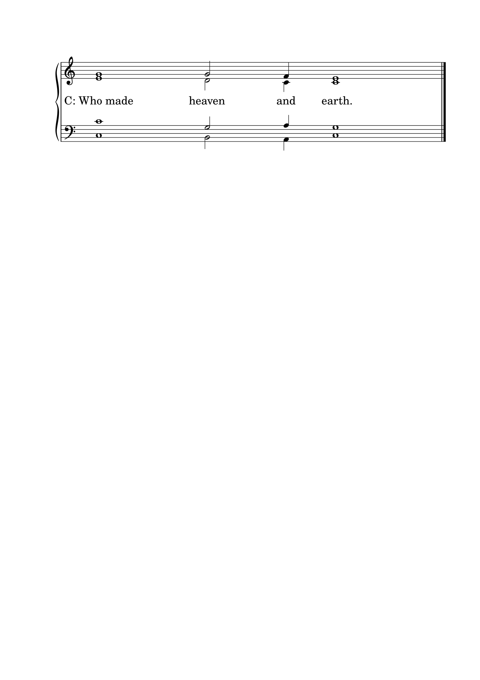L: Our help is in the name of the Lord.

L: I said, I will confess my transgressions to the Lord.
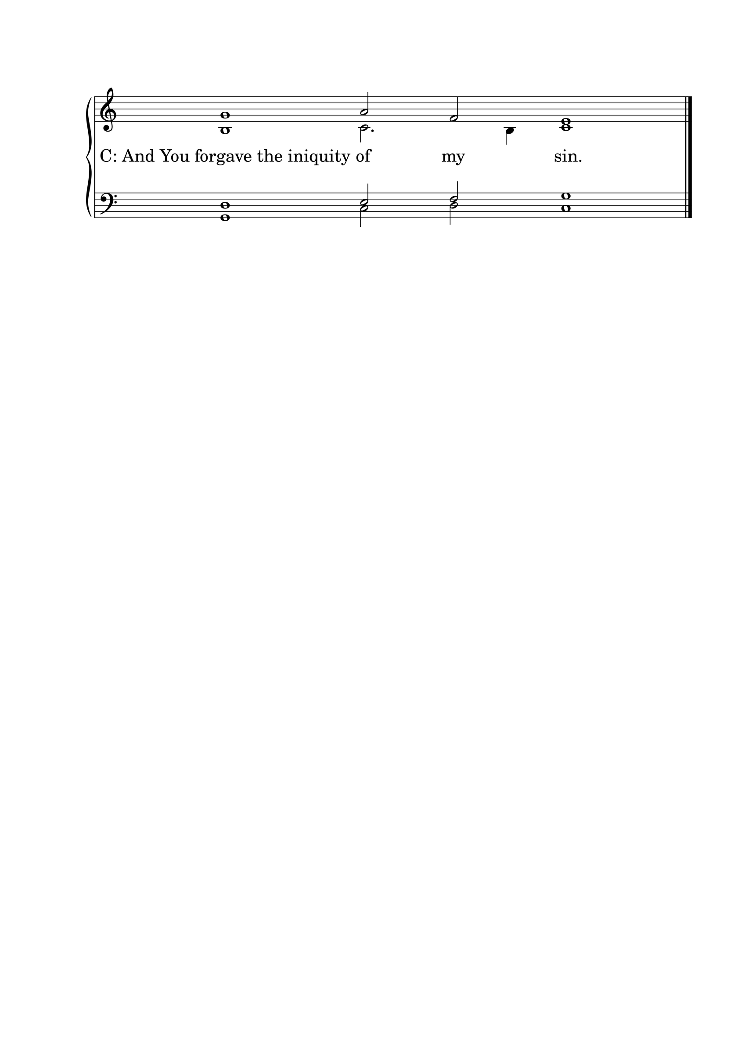

L : Almighty God, our Maker and Redeemer, we poor sinners confess to You that we are by nature sinful and unclean, and that we have sinned against You by thought, word, and deed. Therefore we flee for refuge to Your infinite mercy, seeking and imploring Your grace for the sake of our Lord Jesus Christ.
C: O most merciful God, who has given Your only-begotten Son to die for us, have mercy upon us, and for His sake grant us remission of all our sins; and by Your Holy Spirit increase in us true knowledge of You and of Your will, and true obedience to Your Word, so that by Your grace we may come to everlasting life; through Jesus Christ our Lord. Amen.

THE ABSOLUTION
L : Almighty God, our heavenly Father, has had mercy upon us and has given His only Son to die for us, and for His sake forgives us all our sins. To those who believe in His name He gives power to become the children of God and bestows upon them His Holy Spirit. Whoever believes and is baptized will be saved. Grant this, O Lord, to us all.
C: Amen.

PSALM OF THE DAY
L: I will bless the Lord at all times;
C: his praise shall continually be in my mouth.
L: My soul makes its boast in the Lord;
C: let the humble hear and be glad.
L: Oh, magnify the Lord with me,
C: and let us exalt his name together!
L: Come, O children, listen to me;
C: I will teach you the fear of the Lord.
L: What man is there who desires life
C: and loves many days, that he may see good?
L: Keep your tongue from evil
C: and your lips from speaking deceit.
L: Turn away from evil and do good;
C: seek peace and pursue it.
L: The Lord redeems the life of his servants;
C: none of those who take refuge in him will be condemned. (Psalm 34)

GLORIA PATRI

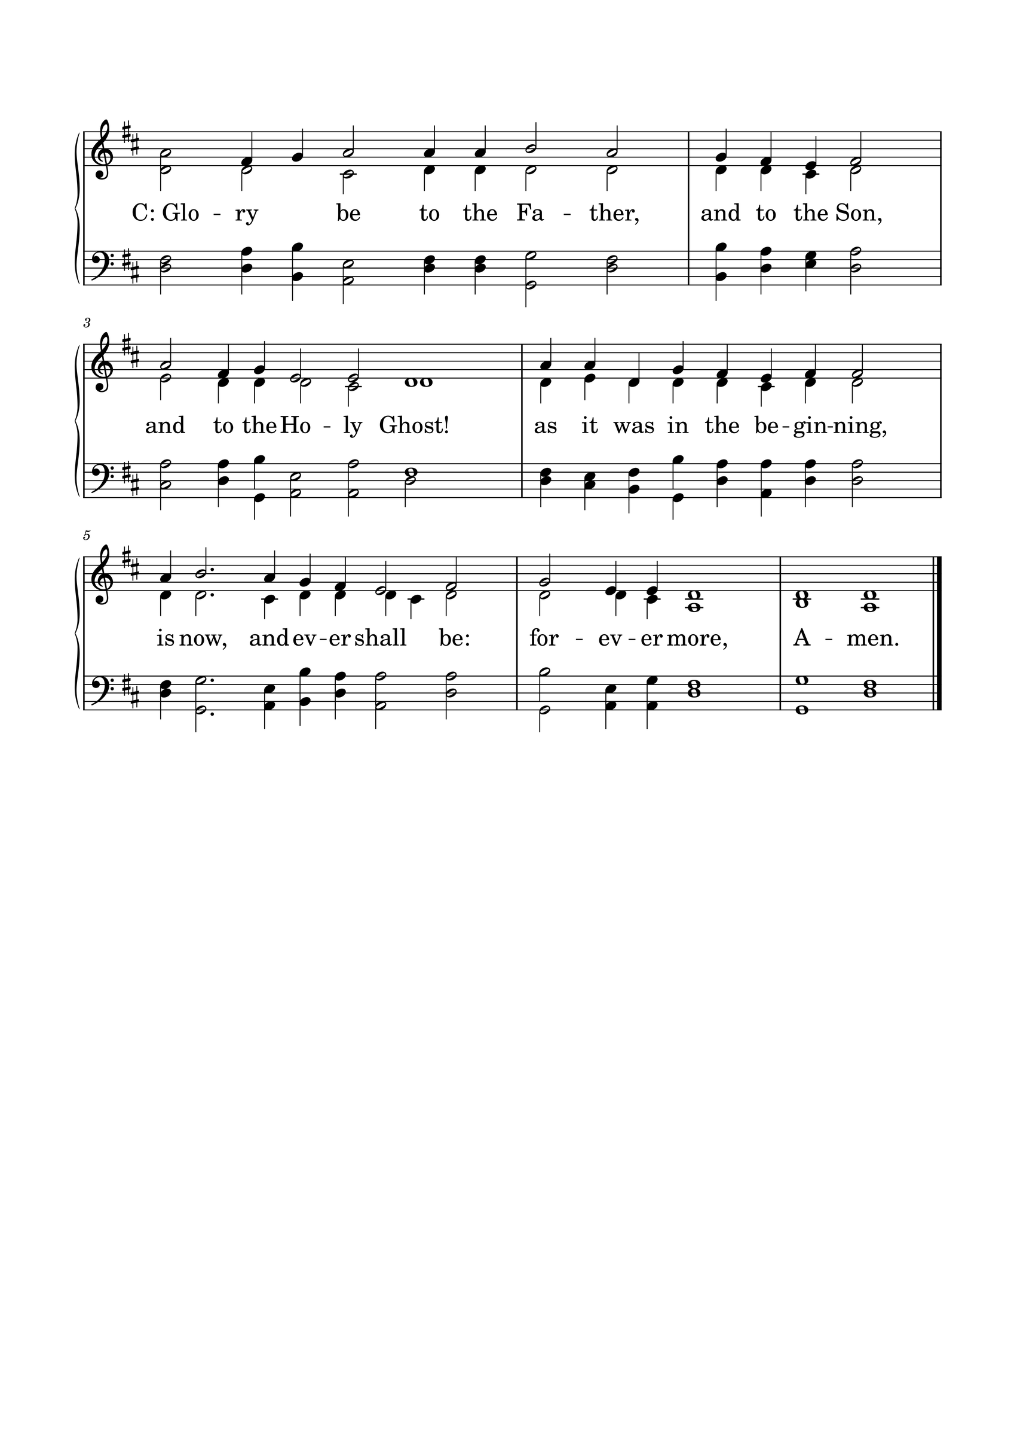

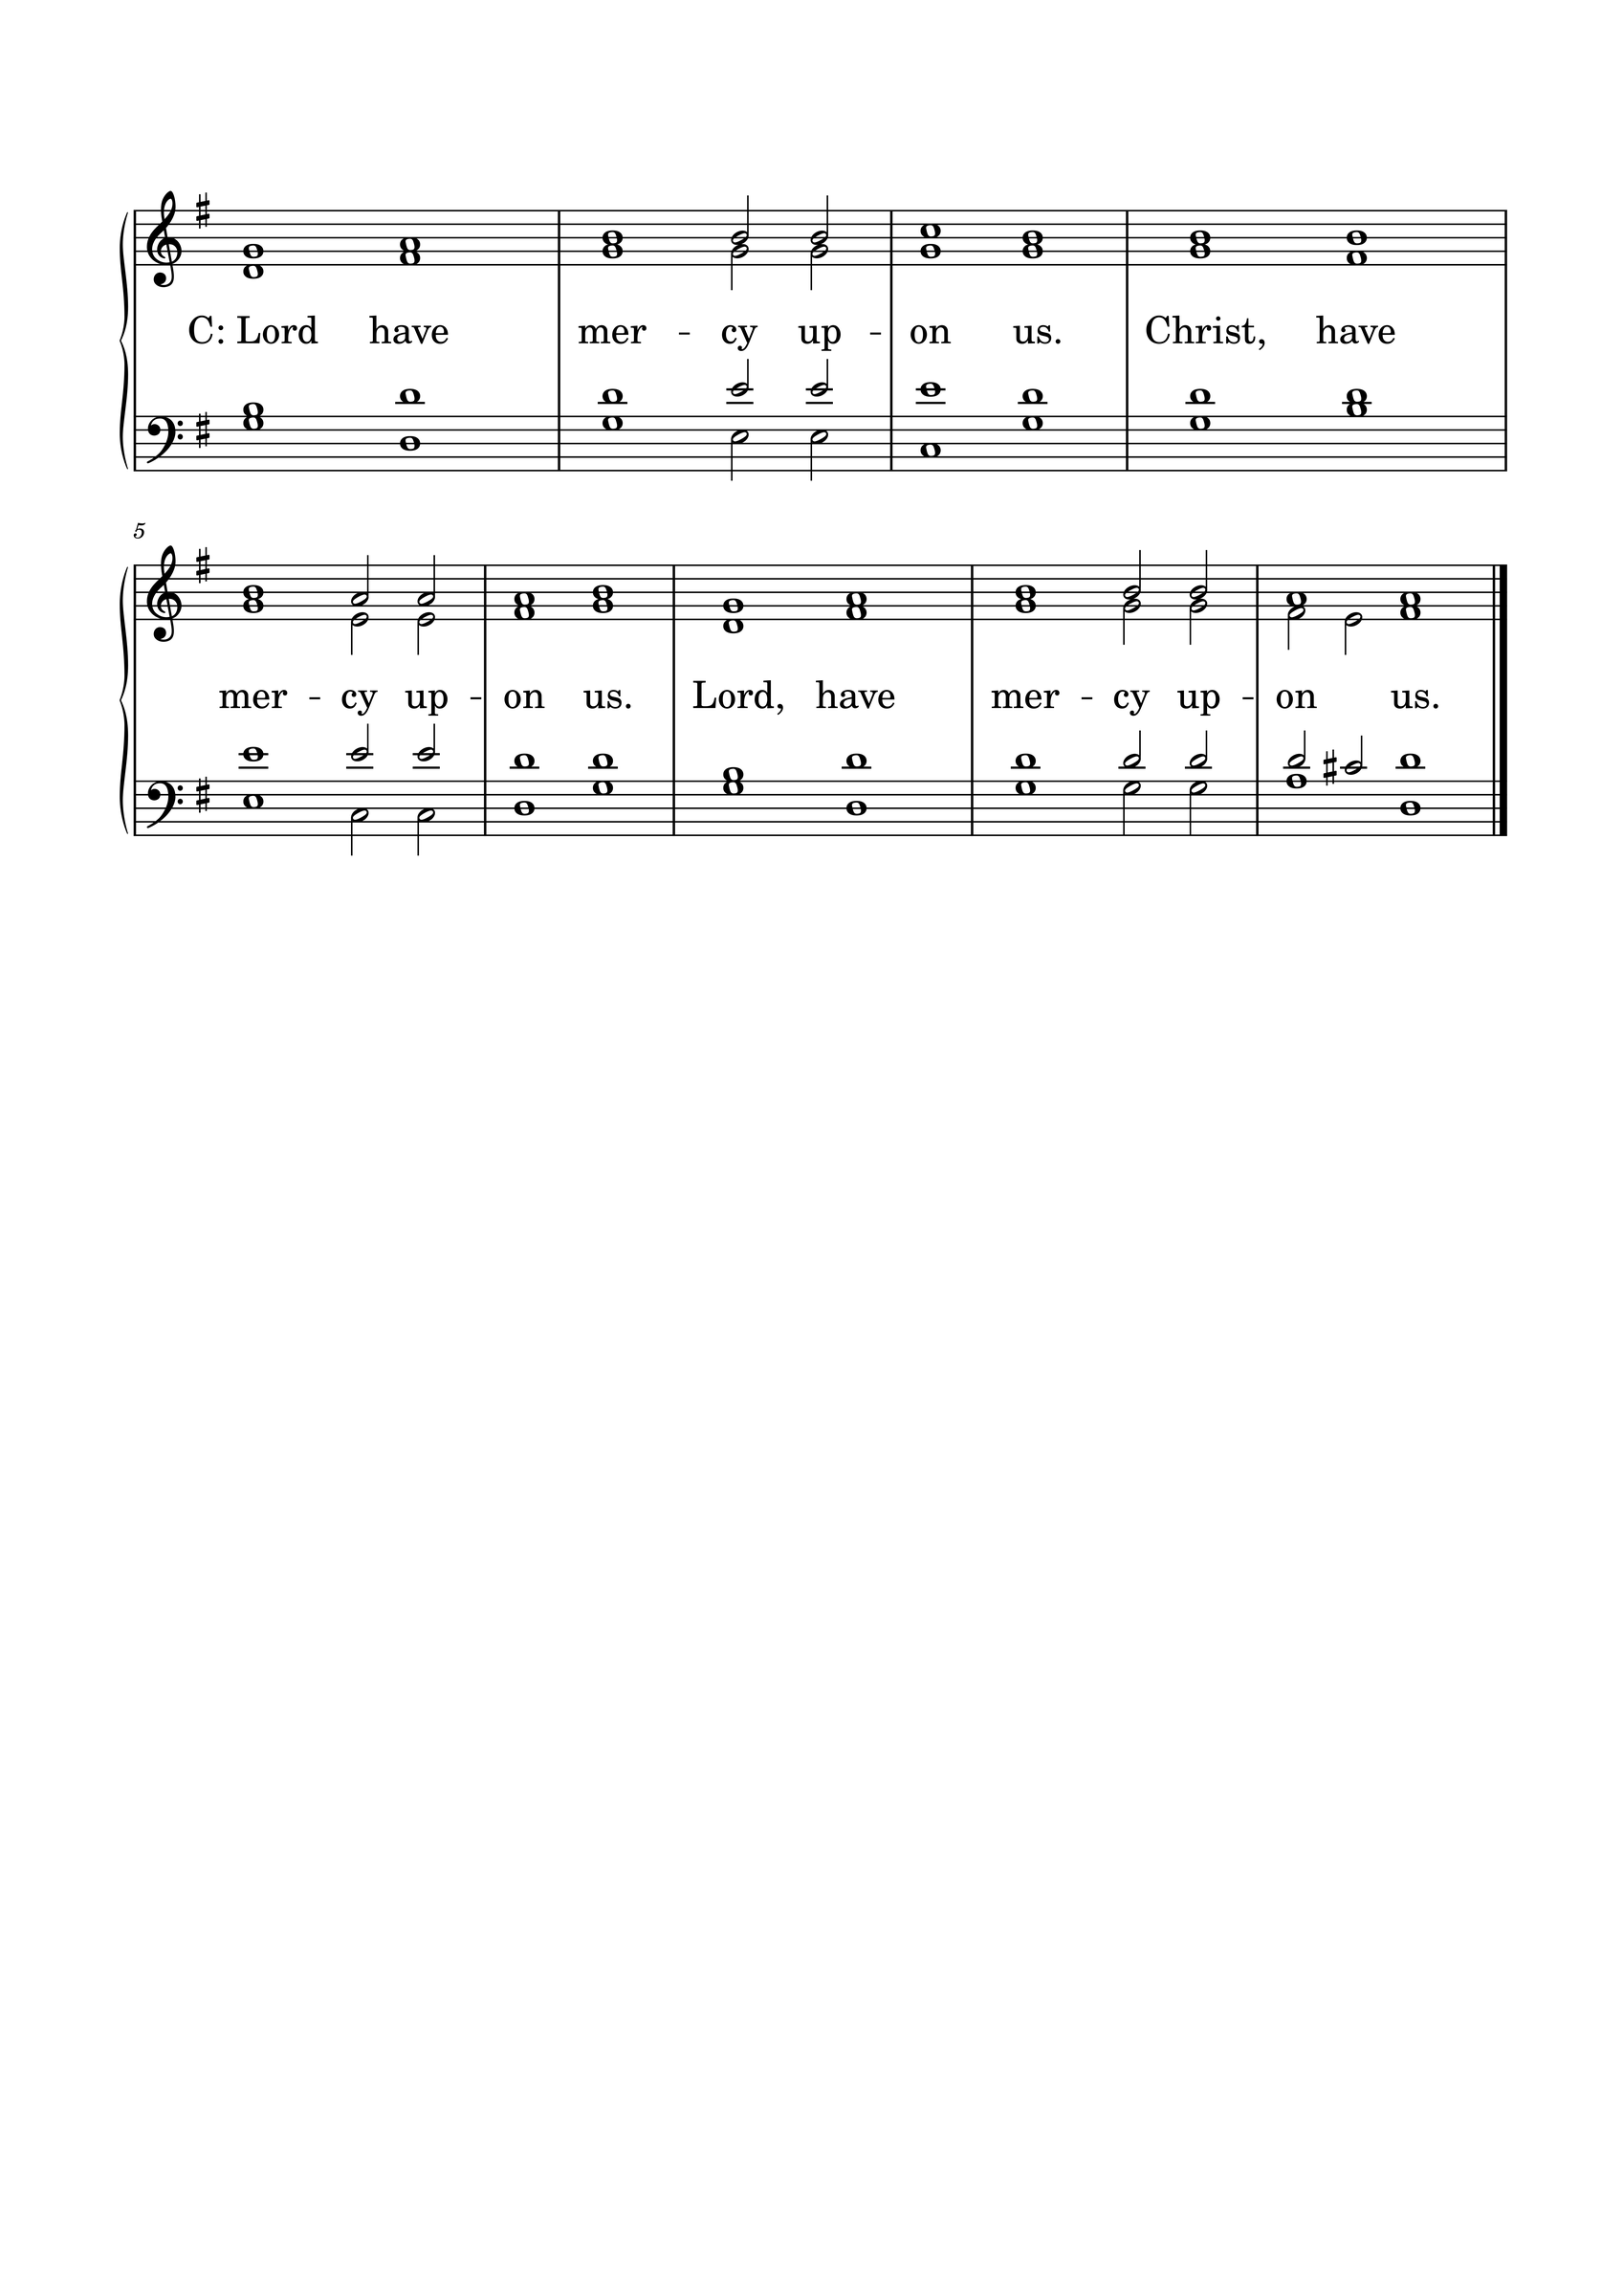KYRIE

GLORIA
The Lutheran Hymnal hymn 244 Verses 1 & 2
C: 1. Glory be to God the Father,
Glory be to God the Son,
Glory be to God the Spirit:
Great Jehovah, Three in One!
Glory, glory,
While eternal ages run!

2. Glory be to Him who loved us,
Washed us from each spot and stain;
Glory be to Him who bought us,
Made us kings with Him to reign!
Glory, glory,
To the Lamb that once was slain!

THE COLLECT
L : Let us pray.
L :
Lord God, bless Your Word wherever it is proclaimed. Make it a word of power and peace to convert those not yet Your own and to confirm those who have come to saving faith. May Your Word pass from the ear to the heart, from the heart to the lip, and from the lip to the life that, as You have promised, Your Word may achieve the purpose for which You send it; through Jesus Christ, our Lord. Amen.
C: Amen.

FIRST SCRIPTURE READING
L: (The congregation may be seated.) The First Scripture Reading for the 18th Sunday of Trinity is written in the 12th chapter of Numbers, beginning at verse 1.
[1] Then Miriam and Aaron spoke against Moses because of the Ethiopian woman whom he had married; for he had married an Ethiopian woman. [2] So they said, “Has the Lord indeed spoken only through Moses? Has He not spoken through us also?” And the Lord heard it. [3] (Now the man Moses was very humble, more than all men who were on the face of the earth.)
[4] Suddenly the Lord said to Moses, Aaron, and Miriam, “Come out, you three, to the tabernacle of meeting!” So the three came out. [5] Then the Lord came down in the pillar of cloud and stood in the door of the tabernacle, and called Aaron and Miriam. And they both went forward. [6] Then He said,
“Hear now My words:
If there is a prophet among you,
I, the Lord, make Myself known to him in a vision;
I speak to him in a dream.
[7] Not so with My servant Moses;
He is faithful in all My house.
[8] I speak with him face to face,
Even plainly, and not in dark sayings;
And he sees the form of the Lord.
Why then were you not afraid
To speak against My servant Moses?”
[9] So the anger of the Lord was aroused against them, and He departed. [10] And when the cloud departed from above the tabernacle, suddenly Miriam became leprous, as white as snow. Then Aaron turned toward Miriam, and there she was, a leper. [11] So Aaron said to Moses, “Oh, my lord! Please do not lay this sin on us, in which we have done foolishly and in which we have sinned. [12] Please do not let her be as one dead, whose flesh is half consumed when he comes out of his mother’s womb!”
[13] So Moses cried out to the Lord, saying, “Please heal her, O God, I pray!”
[14] Then the Lord said to Moses, “If her father had but spit in her face, would she not be shamed seven days? Let her be shut out of the camp seven days, and afterward she may be received again.” [15] So Miriam was shut out of the camp seven days, and the people did not journey till Miriam was brought in again.
L: Here ends the First Scripture Reading.

SECOND SCRIPTURE READING
L: The Second Scripture Reading is written in the 6th chapter of Luke, beginning at verse 6.
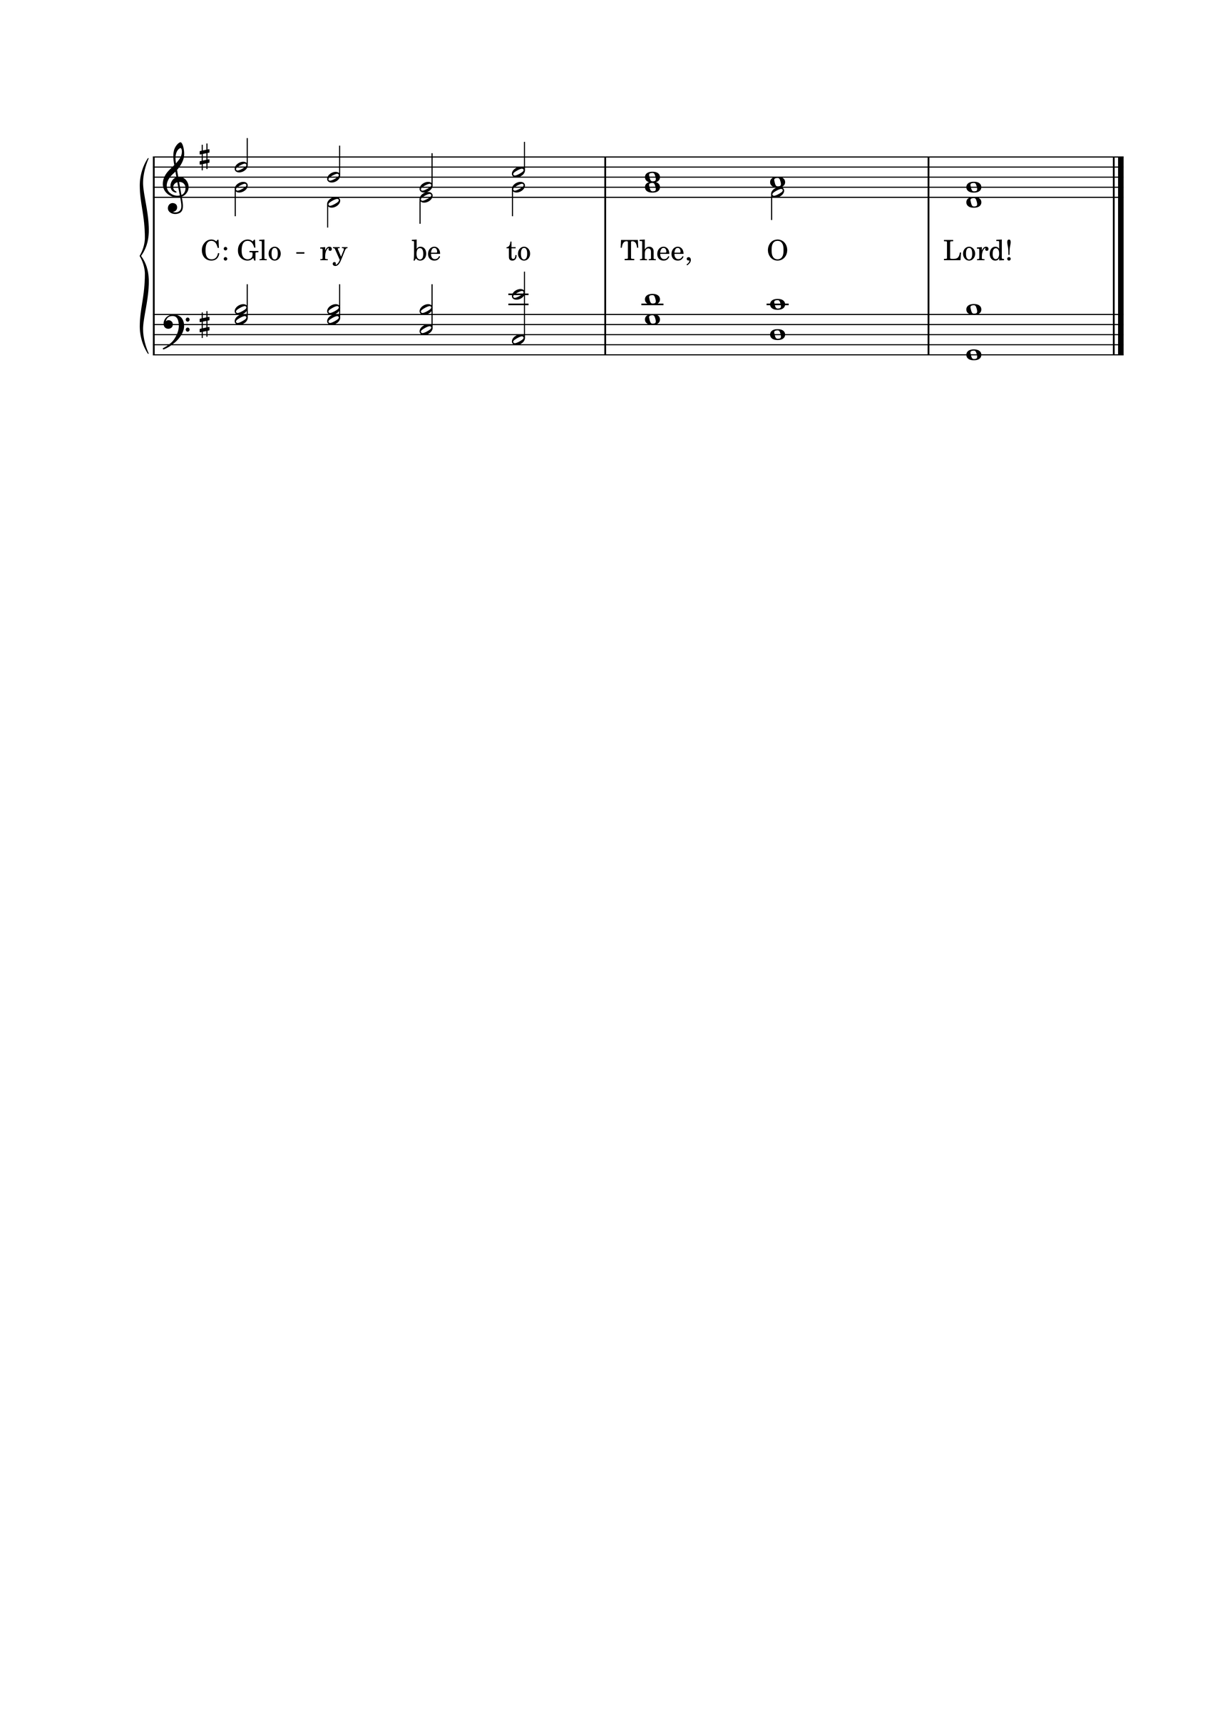

[6] Now it happened on another Sabbath, also, that He entered the synagogue and taught. And a man was there whose right hand was withered. [7] So the scribes and Pharisees watched Him closely, whether He would heal on the Sabbath, that they might find an accusation against Him. [8] But He knew their thoughts, and said to the man who had the withered hand, “Arise and stand here.” And he arose and stood. [9] Then Jesus said to them, “I will ask you one thing: Is it lawful on the Sabbath to do good or to do evil, to save life or to destroy?” [10] And when He had looked around at them all, He said to the man, “Stretch out your hand.” And he did so, and his hand was restored as whole as the other. [11] But they were filled with rage, and discussed with one another what they might do to Jesus.

L: Here ends the Second Scripture Reading.

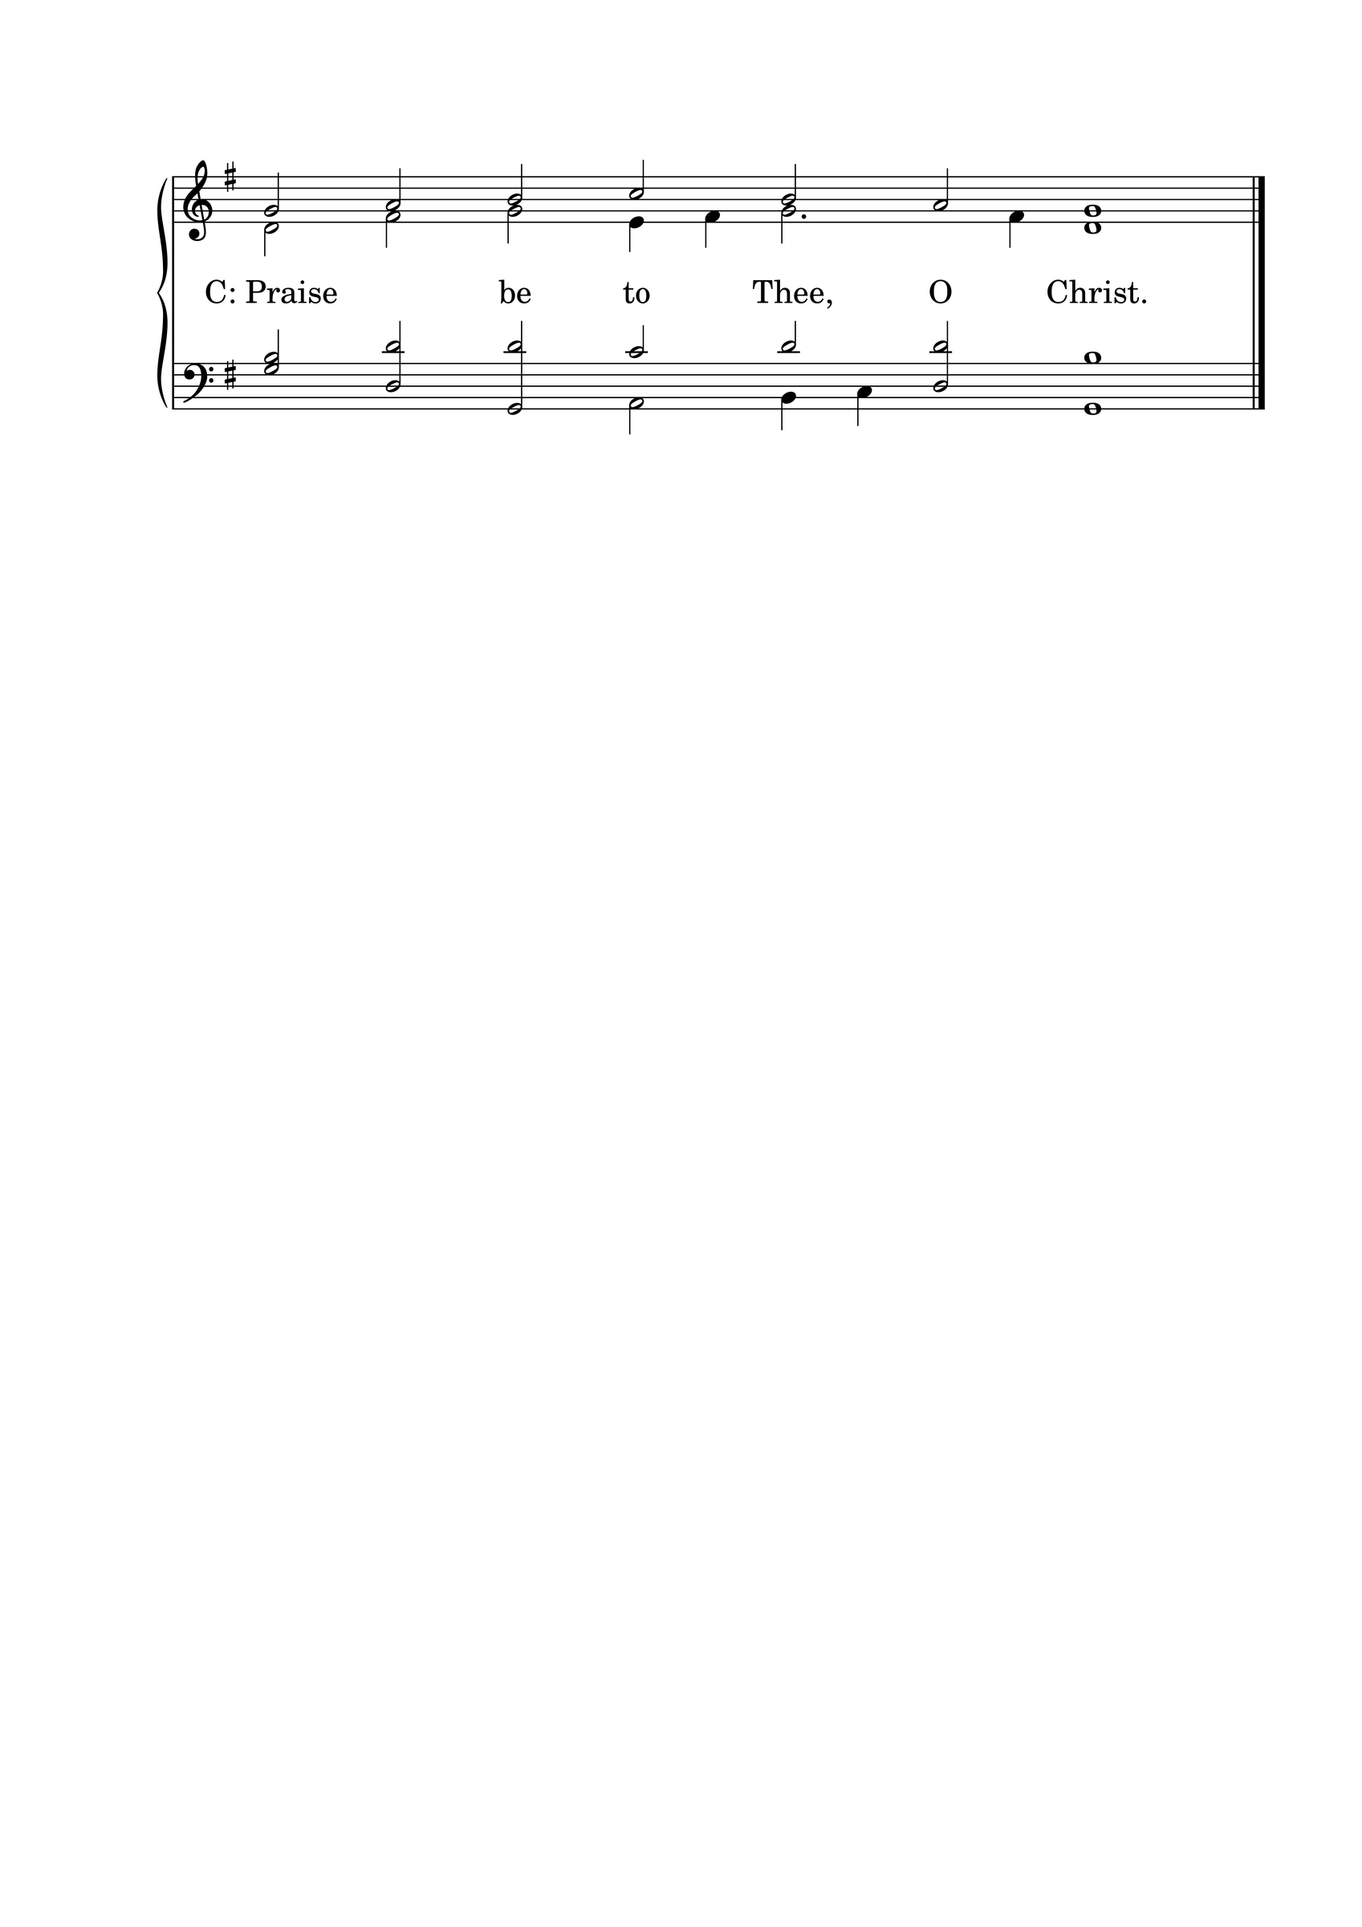

THE APOSTLES' CREED
C: I believe in God the Father almighty, maker of heaven and earth. And in Jesus Christ, His only Son, our Lord, who was conceived by the Holy Spirit, born of the Virgin Mary; suffered under Pontius Pilate, was crucified, died, and was buried. He descended into hell. The third day He rose again from the dead. He ascended into heaven and is seated at the right hand of God the Father almighty. From there He will come to judge the living and the dead. I believe in the Holy Spirit; the holy Christian Church, the communion of saints; the forgiveness of sins; the resurrection of the body; and the life everlasting. Amen.

HYMN 294

THE SERMON
Sermon Text: James 3:6-18 ESV
"And the tongue is a fire, a world of unrighteousness. The tongue is set among our members, staining the whole body, setting on fire the entire course of life, and set on fire by hell. ⁷ For every kind of beast and bird, of reptile and sea creature, can be tamed and has been tamed by mankind, ⁸ but no human being can tame the tongue. It is a restless evil, full of deadly poison. ⁹ With it we bless our Lord and Father, and with it we curse people who are made in the likeness of God. ¹⁰ From the same mouth come blessing and cursing. My brothers, these things ought not to be so. ¹¹ Does a spring pour forth from the same opening both fresh and salt water? ¹² Can a fig tree, my brothers, bear olives, or a grapevine produce figs? Neither can a salt pond yield fresh water. ¹³ Who is wise and understanding among you? By his good conduct let him show his works in the meekness of wisdom. ¹⁴ But if you have bitter jealousy and selfish ambition in your hearts, do not boast and be false to the truth. ¹⁵ This is not the wisdom that comes down from above, but is earthly, unspiritual, demonic. ¹⁶ For where jealousy and selfish ambition exist, there will be disorder and every vile practice. ¹⁷ But the wisdom from above is first pure, then peaceable, gentle, open to reason, full of mercy and good fruits, impartial and sincere. ¹⁸ And a harvest of righteousness is sown in peace by those who make peace."

Sermon Theme: Pray for Heavenly Wisdom! It affects our words and our works

L: (The congregation rises.) And may the peace of God, which surpasses all understanding, guard your hearts and minds through Christ Jesus, amen.

THE OFFERTORY
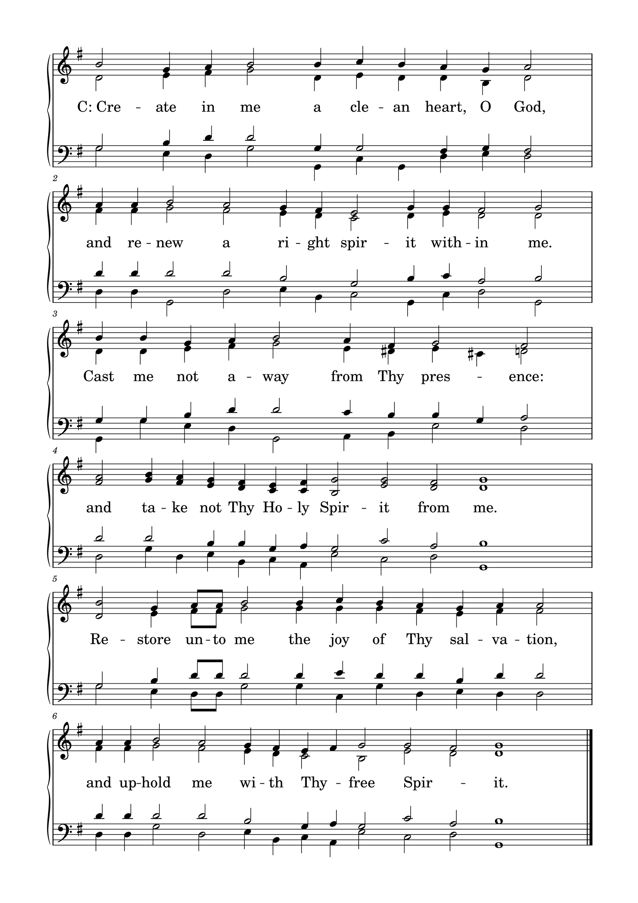

L: Please be seated.

(An offering may be collected at this time, or the congregation may be informed that the offering plate is located at the back of the church.)

HYMN 416

GENERAL PRAYER

THE LORD'S PRAYER
C: Our Father, who art in heaven, hallowed be Your name; Your kingdom come; Your will be done on earth as it is in heaven. Give us this day our daily bread; and forgive us our trespasses, as we forgive those who trespass against us; and lead us not into temptation; but deliver us from evil. For Yours is the kingdom and the power and the glory forever and ever. Amen.

(If Communion is celebrated, refer to the order of Holy Communion.)

FINAL HYMN 400, V:1, 3, 5, 6

THE BENEDICTION
L : (The congregation rises.) The Lord bless you and keep you. The Lord make His face shine upon you and be gracious to you. The Lord lift up His countenance upon you and give you peace.


ANNOUNCEMENTS
• CALL NEWS Pastor Glenn Oster of Gift of God Lutheran Church, Fairfax, VA, has received the call to Trinity Ev. Lutheran Church, Spokane, WA. <> Pastor Chad Seybt of Morning Star Lutheran Church, Fairchild, WI, Peace with God Lutheran Church, Onalaska, WI, St. Paul’s Lutheran Church, Melrose, WI, and Trinity Lutheran Church, Millston, WI, has returned the call to Holy Cross Ev. Lutheran Church, Phoenix, AZ. <> Mr. Nick Naumann has returned the call to St. Luke’s Ev. Lutheran Church, Lemmon, SD. <> Pastor Tom Schuetze of St. Paul Ev. Lutheran Church, Lakewood, CO, has returned the call to Living Hope Lutheran Church, Appleton, WI. <> Pastor Matthew Hanel of St. Matthew Ev. Lutheran Church, Dallas, TX, has received the call to Gift of God Lutheran Church, Mapleton, ND, and to St. Paul’s Lutheran Church, Ponsford, MN. <> Pastor Aaron Ude of Good Shepherd Lutheran Church, Rapid City, SD, has received the call to St. Paul’s Ev. Lutheran Church, Austin, MN.
• ANNIVERSARIES Grace Lutheran School, Fridley, MN, will be celebrating its 50th anniversary on September 13, 2026. Pastor Neal Radichel will be the guest speaker. <> Gethsemane Lutheran Church, Spokane Valley, WA, will be celebrating its 75th anniversary on September 20, 2026. President Michael Wilke will be the guest speaker. <> Ascension Lutheran Church, Batavia, IL, will be celebrating its 60th anniversary on October 11, 2026. Pastor Emeritus David Schierenbeck will be the guest speaker.
• ManUp! Weekend - 2026 is the 10th Anniversary of the ManUp! Weekend, to be held September 24-27 at Wyalusing State Park near Prairie du Chien, WI. The facility is set up for 108 men, and currently 105 have registered. Typically, there are a couple of cancellations, and there are some attendees that said they will be staying off site. That means there is still room for around 5-8 more men - like YOU and/or that friend you have been meaning to ask. The plan is to slightly over-book the weekend, like an airline. Then you can be "on call" on a waiting list if you choose. If you register after we reach 108, you will be contacted by someone on the Planning Committee to see if you would like to be on a waiting list. Register here: www.manup.clclutheran.org. Join us for encouragement, fellowship, worship, team building, and more! The $150 registration fee covers all meals, lodging, and activities. Sign up today!
• There are currently twelve seminary students without a Kinship sponsor. These twelve students attend seminaries in India, Nepal, Congo, and Tanzania. The cost of support ranges from $35/month to $60/month. As the mission field overseas continues to grow, so does our opportunity to support it, so please give sponsorship prayerful consideration. To become a sponsor or for more information, please contact Dan Roehl at danroehl@hotmail.com or 507-381-2042.

“Scripture taken from the New King James Version®. Copyright © 1982 by Thomas Nelson. Used by permission. All rights reserved.”

