

THE COMMON SERVICE
This liturgy is adapted from the Common Service Book of the Lutheran Church (1917-1918), Evangelical Lutheran Hymn-book (1912), and Music for the Liturgy: in Conformity with the Evangelical Lutheran Hymn book which are in the public domain.

OPENING HYMN 395, V:1-5
Leader : (The congregation rises.) In the name of the Father, and of the Son, and of the Holy Spirit.

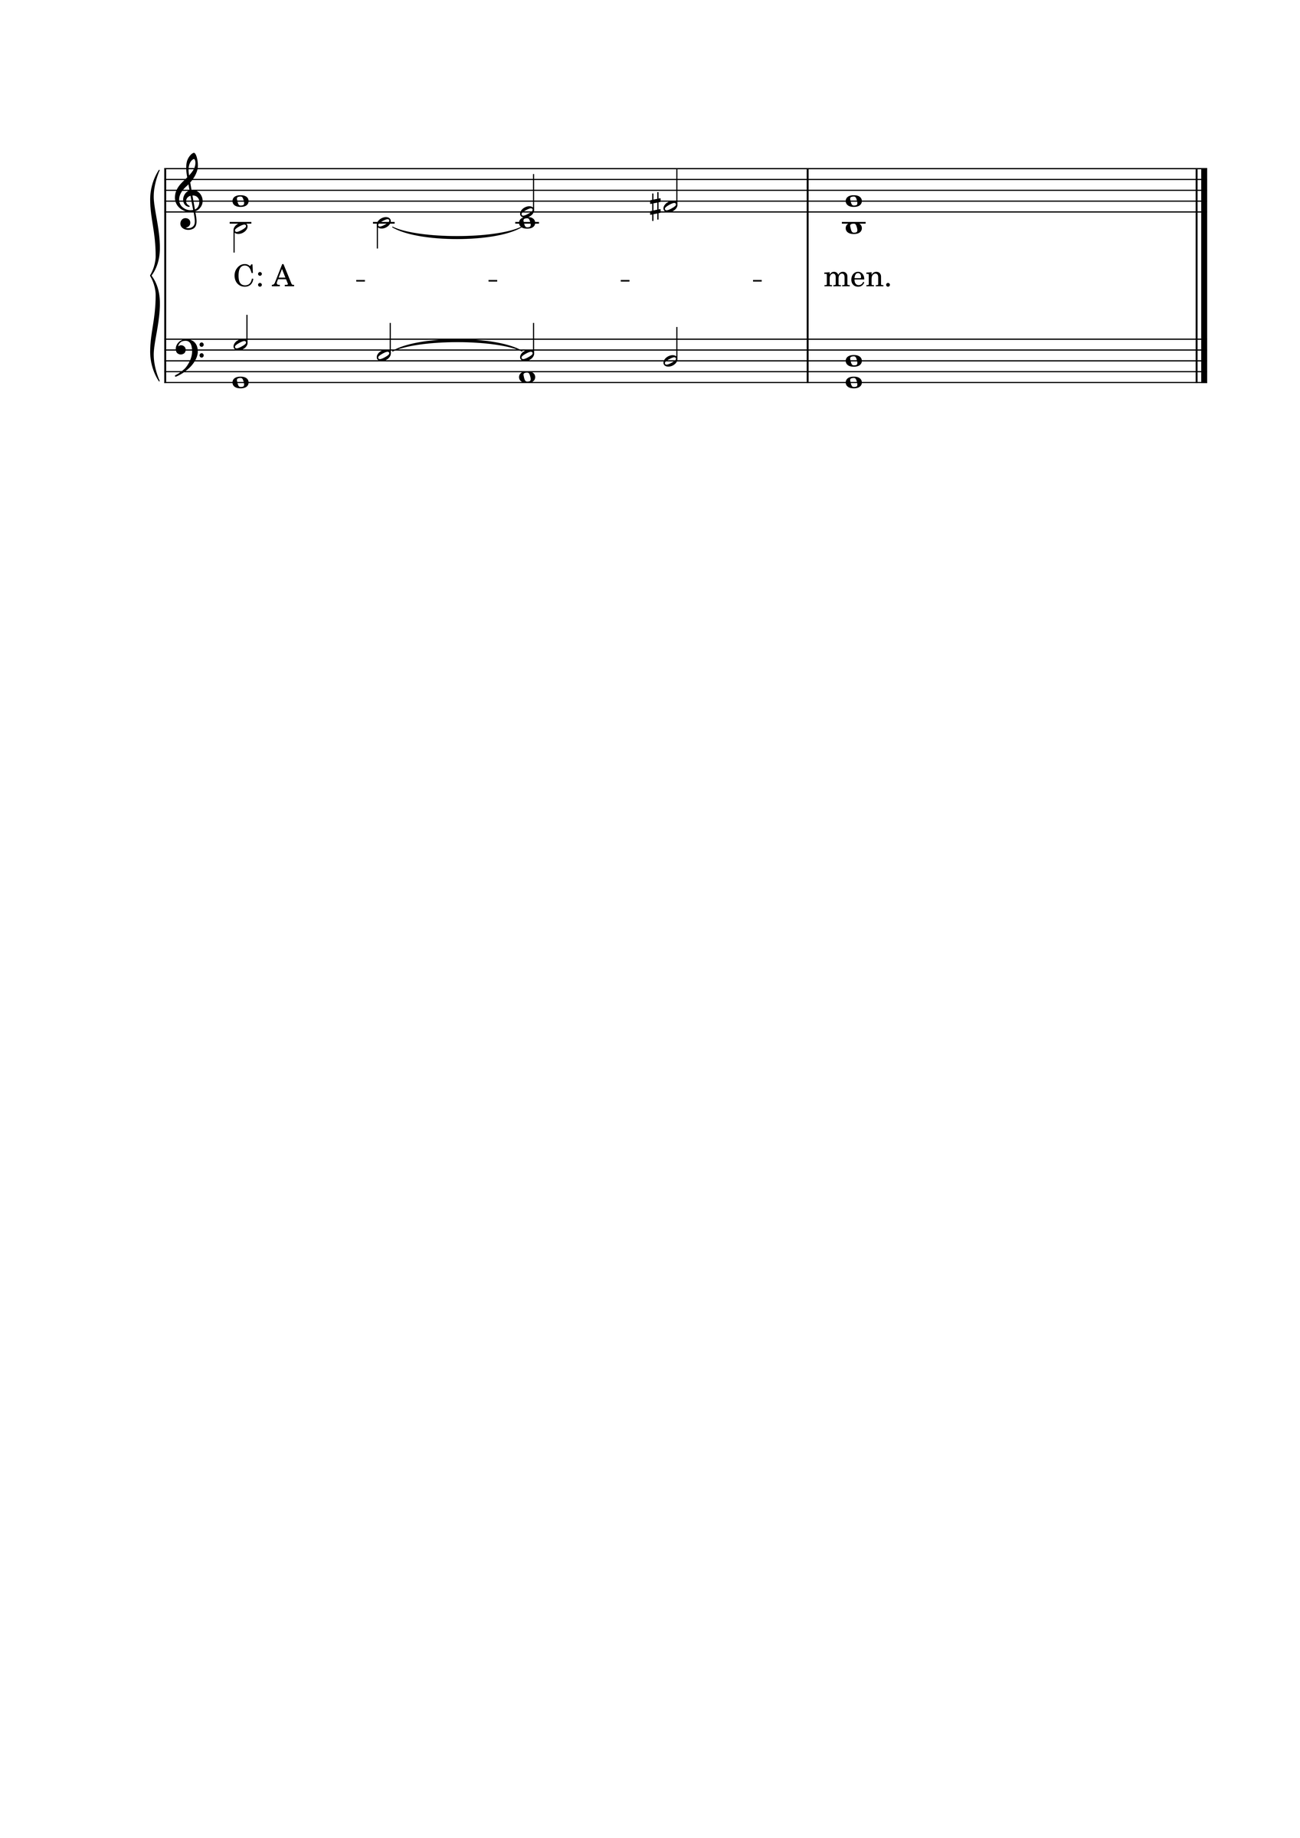

THE CONFESSION OF SINS
L: Beloved in the Lord! Let us draw near with a true heart and confess our sins to God our Father, asking Him, in the name of our Lord Jesus Christ, to grant us forgiveness.
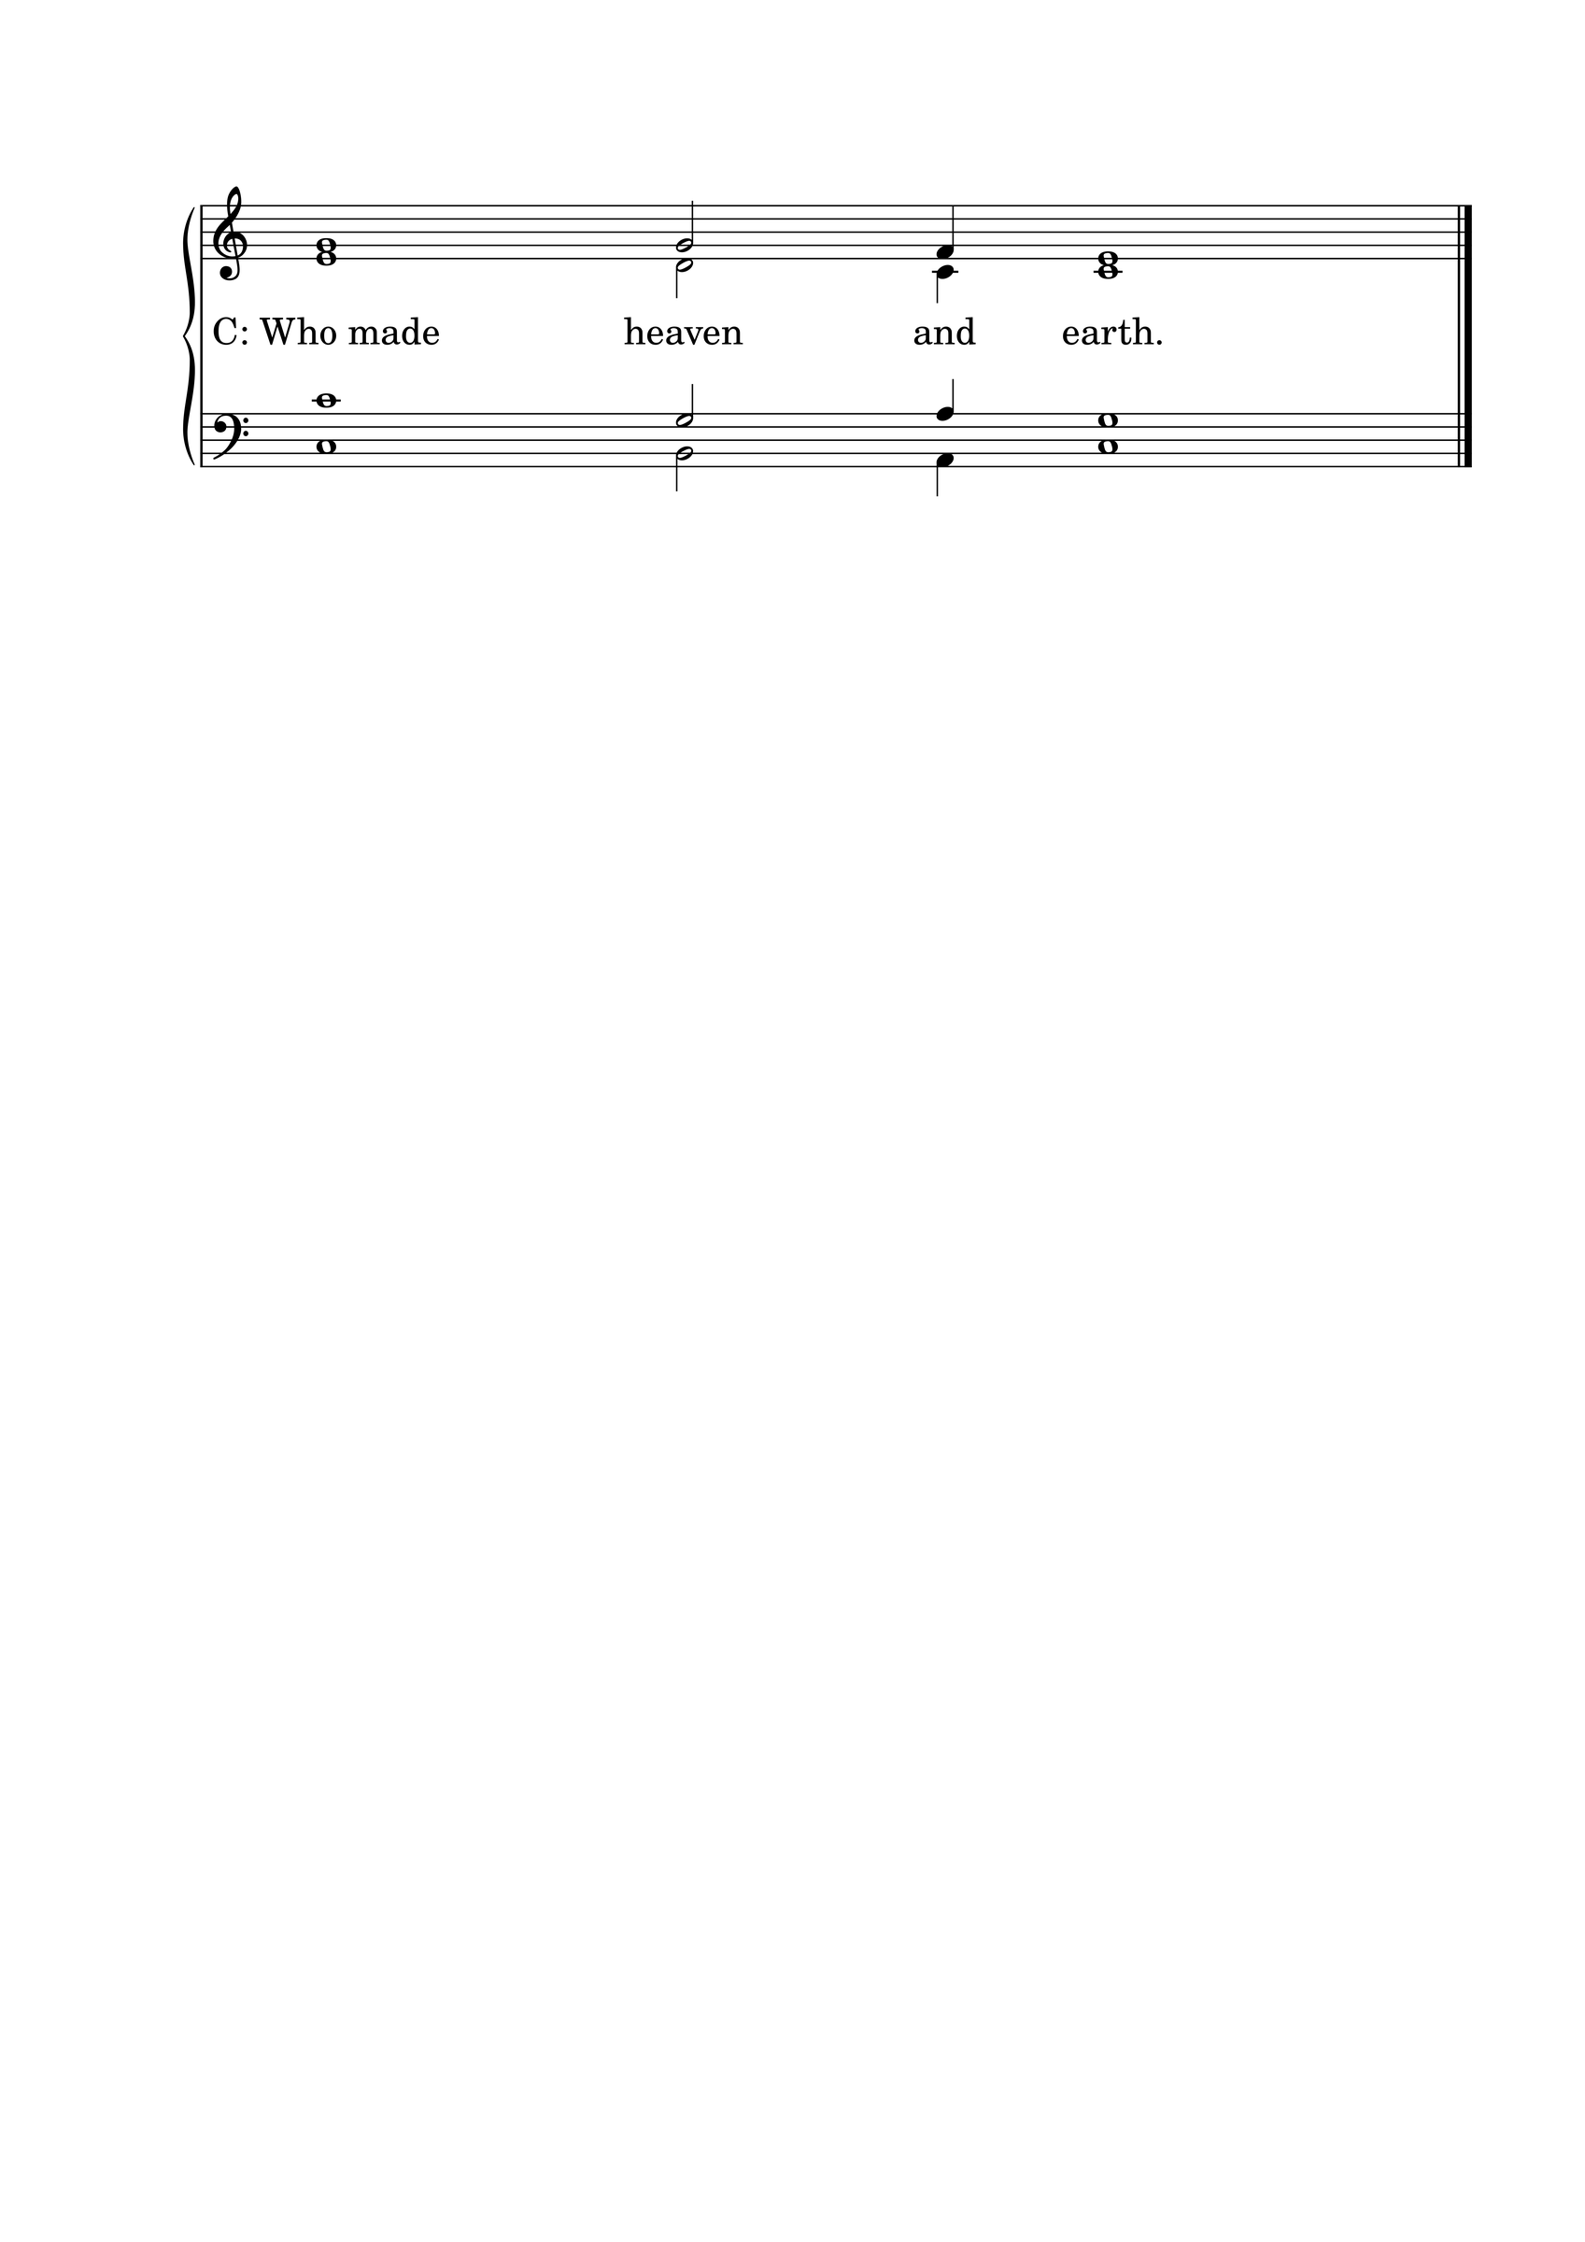L: Our help is in the name of the Lord.

L: I said, I will confess my transgressions to the Lord.
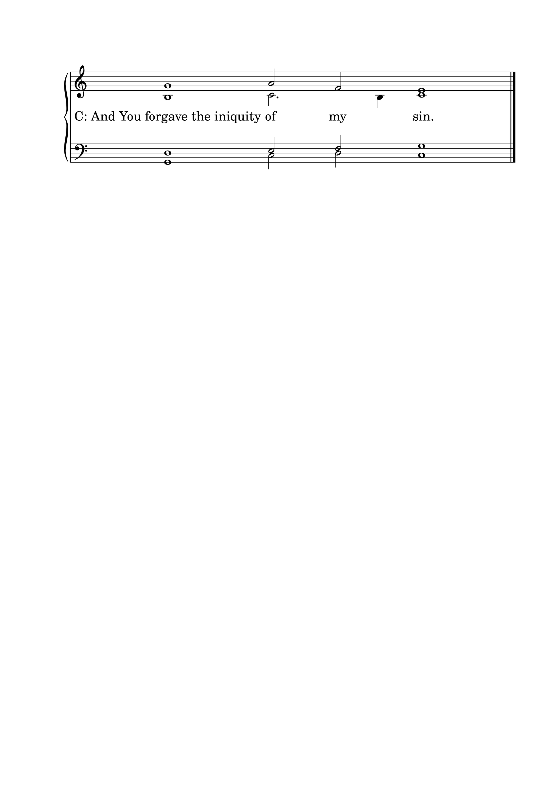

L : Almighty God, our Maker and Redeemer, we poor sinners confess to You that we are by nature sinful and unclean, and that we have sinned against You by thought, word, and deed. Therefore we flee for refuge to Your infinite mercy, seeking and imploring Your grace for the sake of our Lord Jesus Christ.
C: O most merciful God, who has given Your only-begotten Son to die for us, have mercy upon us, and for His sake grant us remission of all our sins; and by Your Holy Spirit increase in us true knowledge of You and of Your will, and true obedience to Your Word, so that by Your grace we may come to everlasting life; through Jesus Christ our Lord. Amen.

THE ABSOLUTION
L : Almighty God, our heavenly Father, has had mercy upon us and has given His only Son to die for us, and for His sake forgives us all our sins. To those who believe in His name He gives power to become the children of God and bestows upon them His Holy Spirit. Whoever believes and is baptized will be saved. Grant this, O Lord, to us all.
C: Amen.

PSALM OF THE DAY
L: Why do the nations rage,
C: And the people plot a vain thing?
L: The kings of the earth set themselves, And the rulers take counsel together,
C: Against the Lord and against His Anointed, saying,
L: “Let us break Their bonds in pieces
C: And cast away Their cords from us.”
L: He who sits in the heavens shall laugh;
C: The Lord shall hold them in derision.
L: Then He shall speak to them in His wrath,
C: And distress them in His deep displeasure:
L: “Yet I have set My King
C: On My holy hill of Zion.” (Psalm 2)

GLORIA PATRI

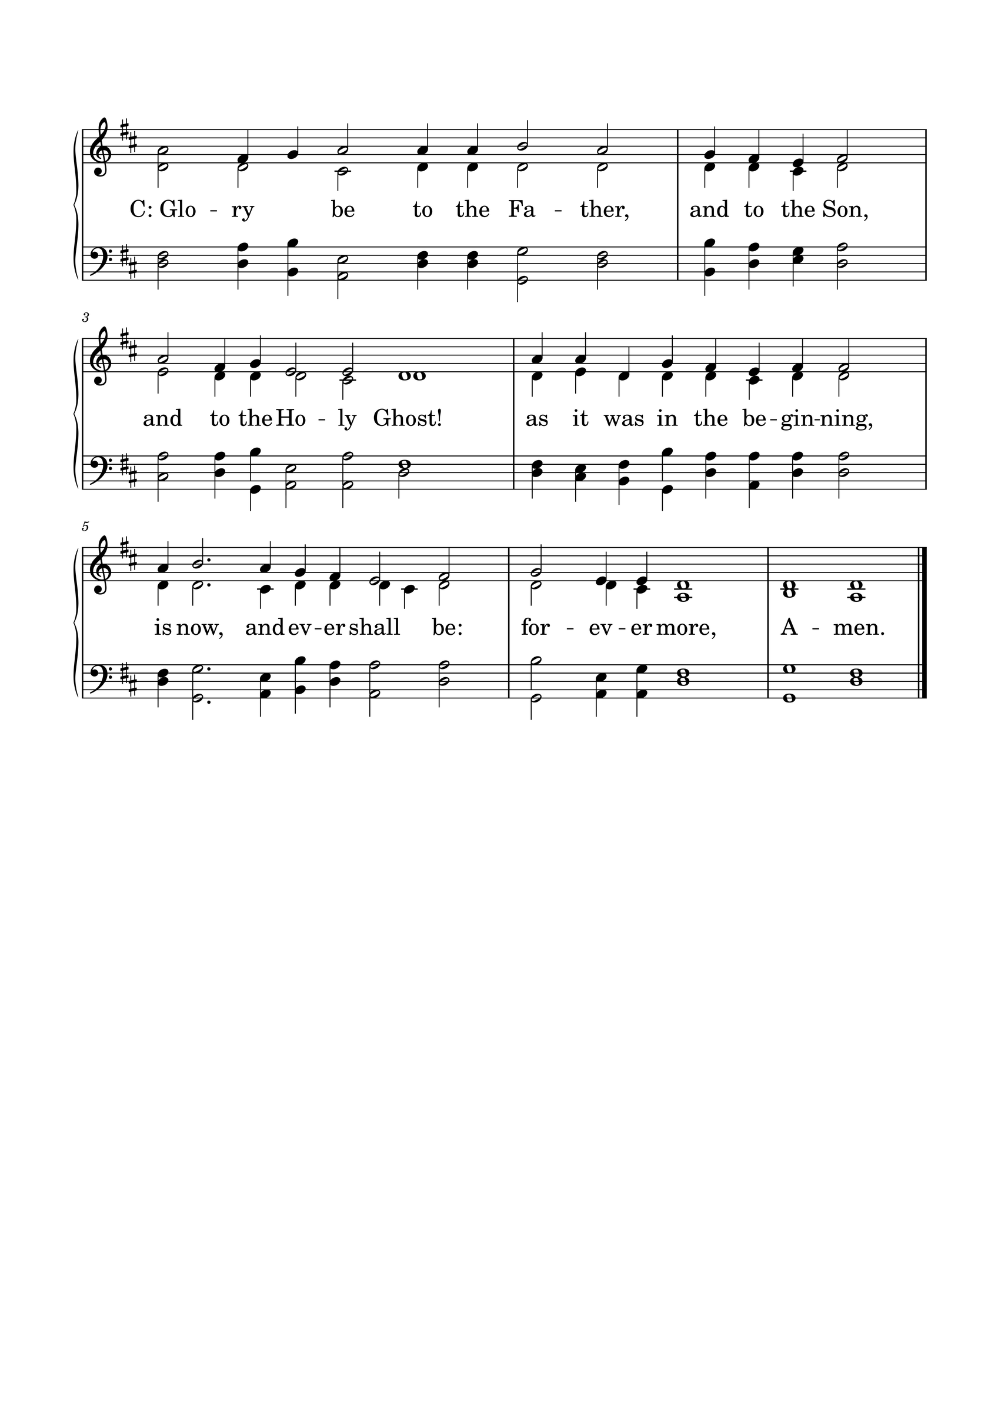

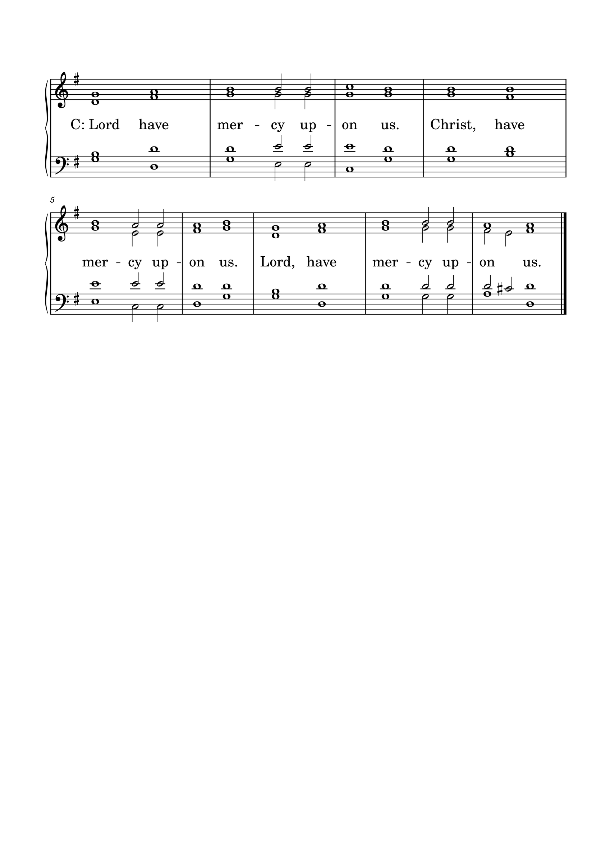KYRIE

GLORIA
The Lutheran Hymnal hymn 244 Verses 1 & 2
C: 1. Glory be to God the Father,
Glory be to God the Son,
Glory be to God the Spirit:
Great Jehovah, Three in One!
Glory, glory,
While eternal ages run!

2. Glory be to Him who loved us,
Washed us from each spot and stain;
Glory be to Him who bought us,
Made us kings with Him to reign!
Glory, glory,
To the Lamb that once was slain!

THE COLLECT
L : Let us pray.
L :
Lord Jesus Christ, You have made peace between God and sinners through Your cross. Grant us humble hearts, faithful prayer, and wisdom from above, that we may sow peace and bear the fruits of righteousness; for You live and reign with the Father and the Holy Spirit, one God, forever and ever. Amen.
C: Amen.

FIRST SCRIPTURE READING
L: (The congregation may be seated.) The First Scripture Reading for the 17th Sunday of Trinity is written in the 25th chapter of Proverbs, beginning at verse 6.
[6] Do not exalt yourself in the presence of the king,
And do not stand in the place of the great;
[7] For it is better that he say to you,
“Come up here,”
Than that you should be put lower in the presence of the prince,
Whom your eyes have seen.
[8] Do not go hastily to court;
For what will you do in the end,
When your neighbor has put you to shame?
[9] Debate your case with your neighbor,
And do not disclose the secret to another;
[10] Lest he who hears it expose your shame,
And your reputation be ruined.
[11] A word fitly spoken is like apples of gold
In settings of silver.
[12] Like an earring of gold and an ornament of fine gold
Is a wise rebuker to an obedient ear.
[13] Like the cold of snow in time of harvest
Is a faithful messenger to those who send him,
For he refreshes the soul of his masters.
[14] Whoever falsely boasts of giving
Is like clouds and wind without rain.
L: Here ends the First Scripture Reading.

SECOND SCRIPTURE READING
L: The Second Scripture Reading is written in the 14th chapter of Luke, beginning at verse 1.
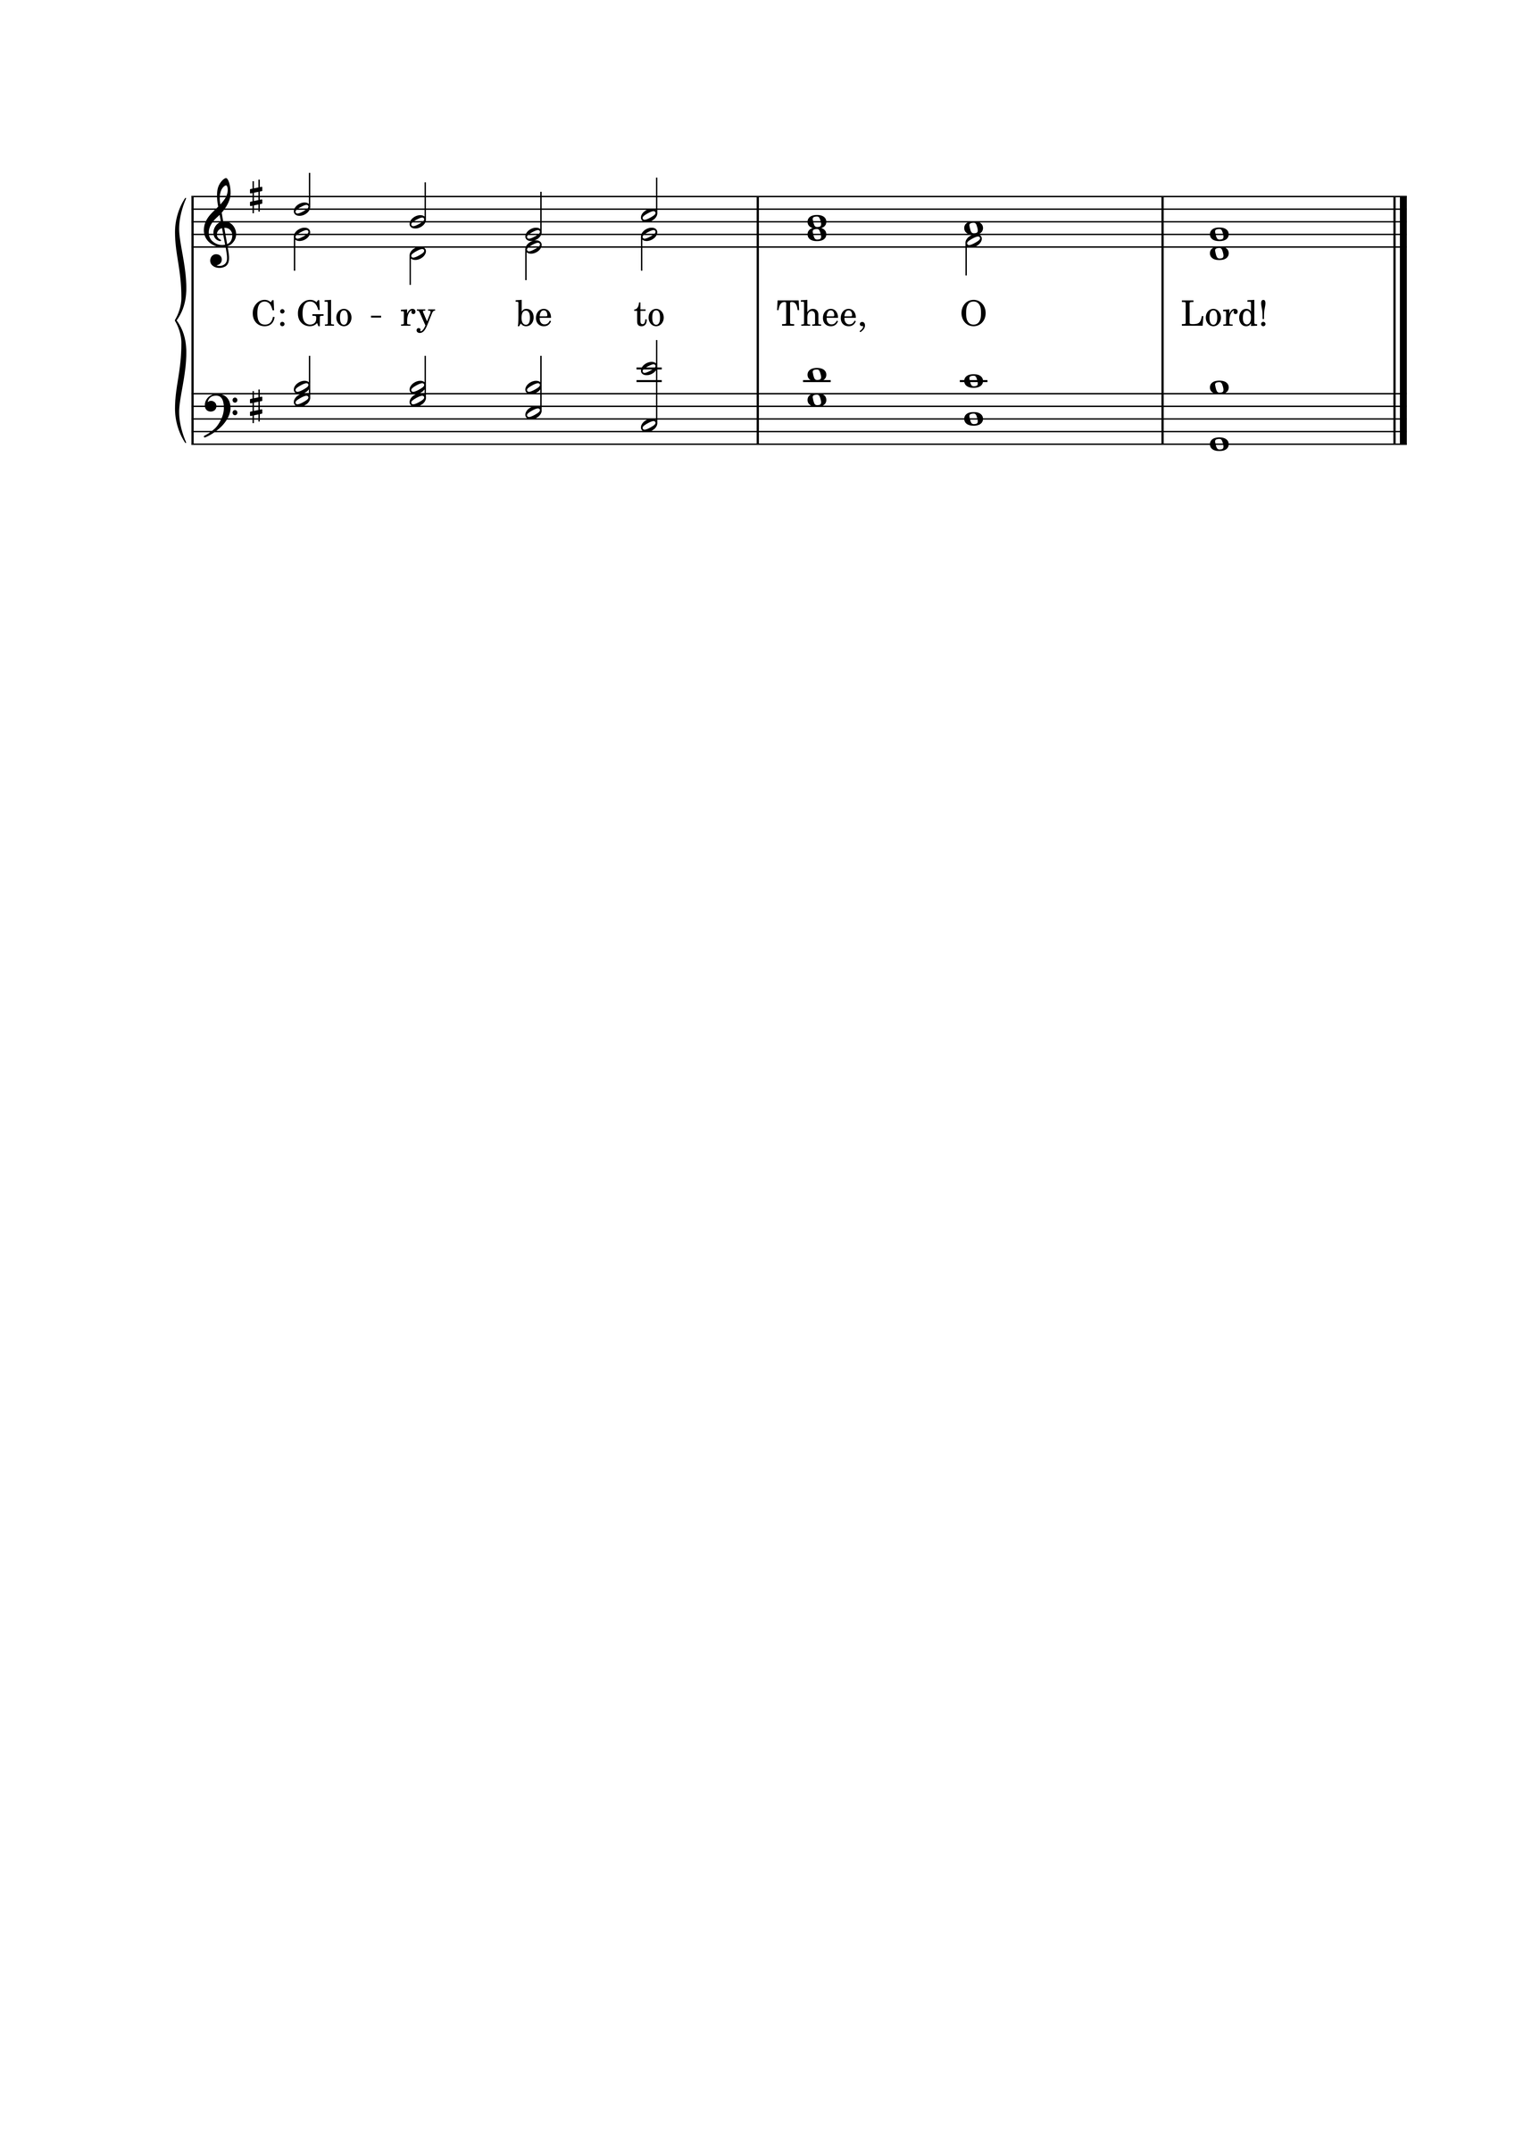

[1] Now it happened, as He went into the house of one of the rulers of the Pharisees to eat bread on the Sabbath, that they watched Him closely. [2] And behold, there was a certain man before Him who had dropsy. [3] And Jesus, answering, spoke to the lawyers and Pharisees, saying, “Is it lawful to heal on the Sabbath?”
[4] But they kept silent. And He took him and healed him, and let him go. [5] Then He answered them, saying, “Which of you, having a donkey or an ox that has fallen into a pit, will not immediately pull him out on the Sabbath day?” [6] And they could not answer Him regarding these things.
[7] So He told a parable to those who were invited, when He noted how they chose the best places, saying to them: [8] “When you are invited by anyone to a wedding feast, do not sit down in the best place, lest one more honorable than you be invited by him; [9] and he who invited you and him come and say to you, ‘Give place to this man,’ and then you begin with shame to take the lowest place. [10] But when you are invited, go and sit down in the lowest place, so that when he who invited you comes he may say to you, ‘Friend, go up higher.’ Then you will have glory in the presence of those who sit at the table with you. [11] For whoever exalts himself will be humbled, and he who humbles himself will be exalted.”

L: Here ends the Second Scripture Reading.

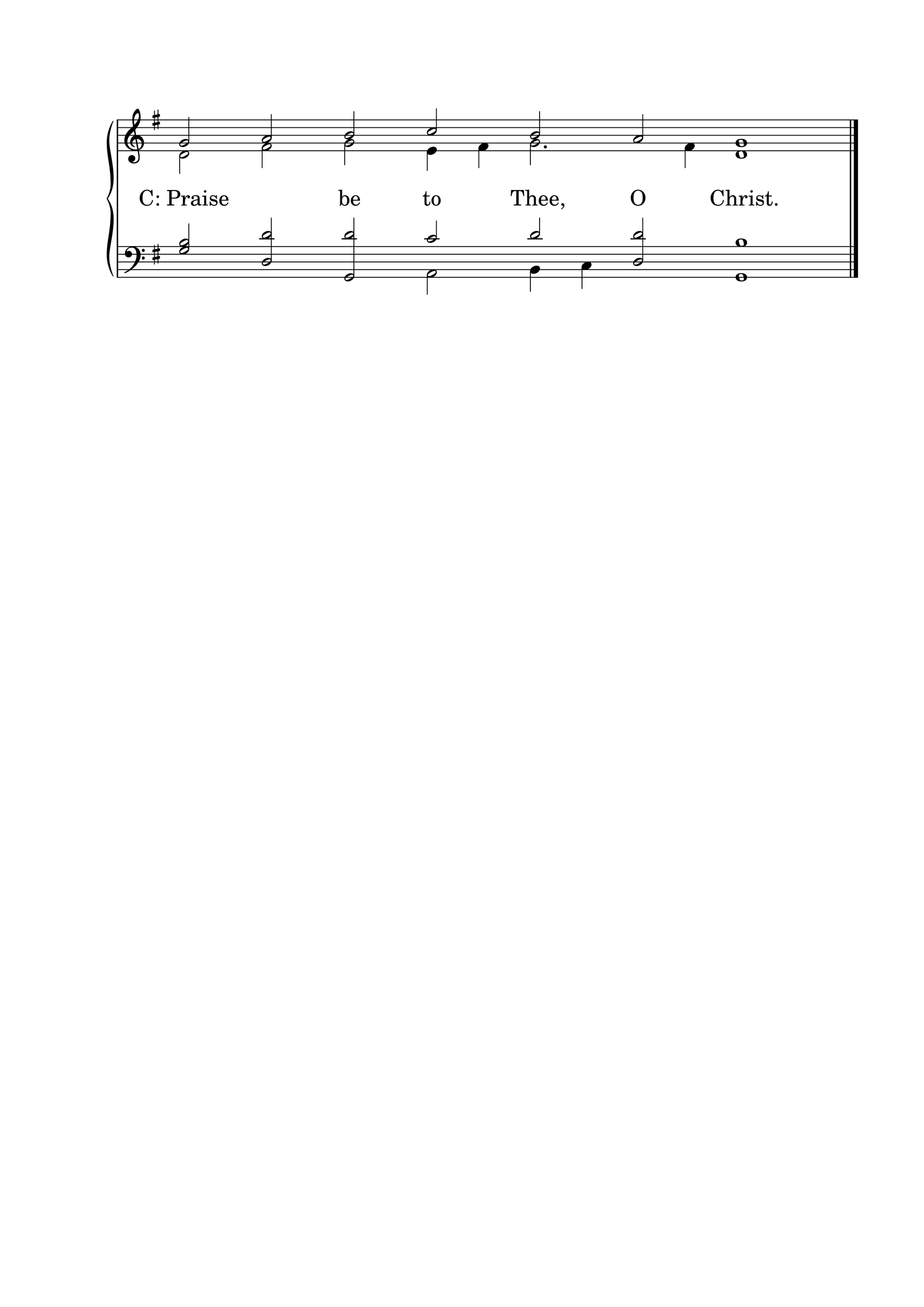

THE APOSTLES' CREED
C: I believe in God the Father almighty, maker of heaven and earth. And in Jesus Christ, His only Son, our Lord, who was conceived by the Holy Spirit, born of the Virgin Mary; suffered under Pontius Pilate, was crucified, died, and was buried. He descended into hell. The third day He rose again from the dead. He ascended into heaven and is seated at the right hand of God the Father almighty. From there He will come to judge the living and the dead. I believe in the Holy Spirit; the holy Christian Church, the communion of saints; the forgiveness of sins; the resurrection of the body; and the life everlasting. Amen.

HYMN 464

THE SERMON
Sermon Text: James 3:16-4:6 ESV
For where jealousy and selfish ambition exist, there will be disorder and every vile practice. But the wisdom from above is first pure, then peaceable, gentle, open to reason, full of mercy and good fruits, impartial and sincere. And a harvest of righteousness is sown in peace by those who make peace. What causes quarrels and what causes fights among you? Is it not this, that your passions are at war within you? You desire and do not have, so you murder. You covet and cannot obtain, so you fight and quarrel. You do not have, because you do not ask. You ask and do not receive, because you ask wrongly, to spend it on your passions. You adulterous people! Do you not know that friendship with the world is enmity with God? Therefore whoever wishes to be a friend of the world makes himself an enemy of God. Or do you suppose it is to no purpose that the Scripture says, “He yearns jealously over the spirit that he has made to dwell in us”? But he gives more grace. Therefore it says, “God opposes the proud but gives grace to the humble.”

Sermon Theme: BLESSED ARE THE PEACEMAKERS

L: (The congregation rises.) And may the peace of God, which surpasses all understanding, guard your hearts and minds through Christ Jesus, amen.

THE OFFERTORY
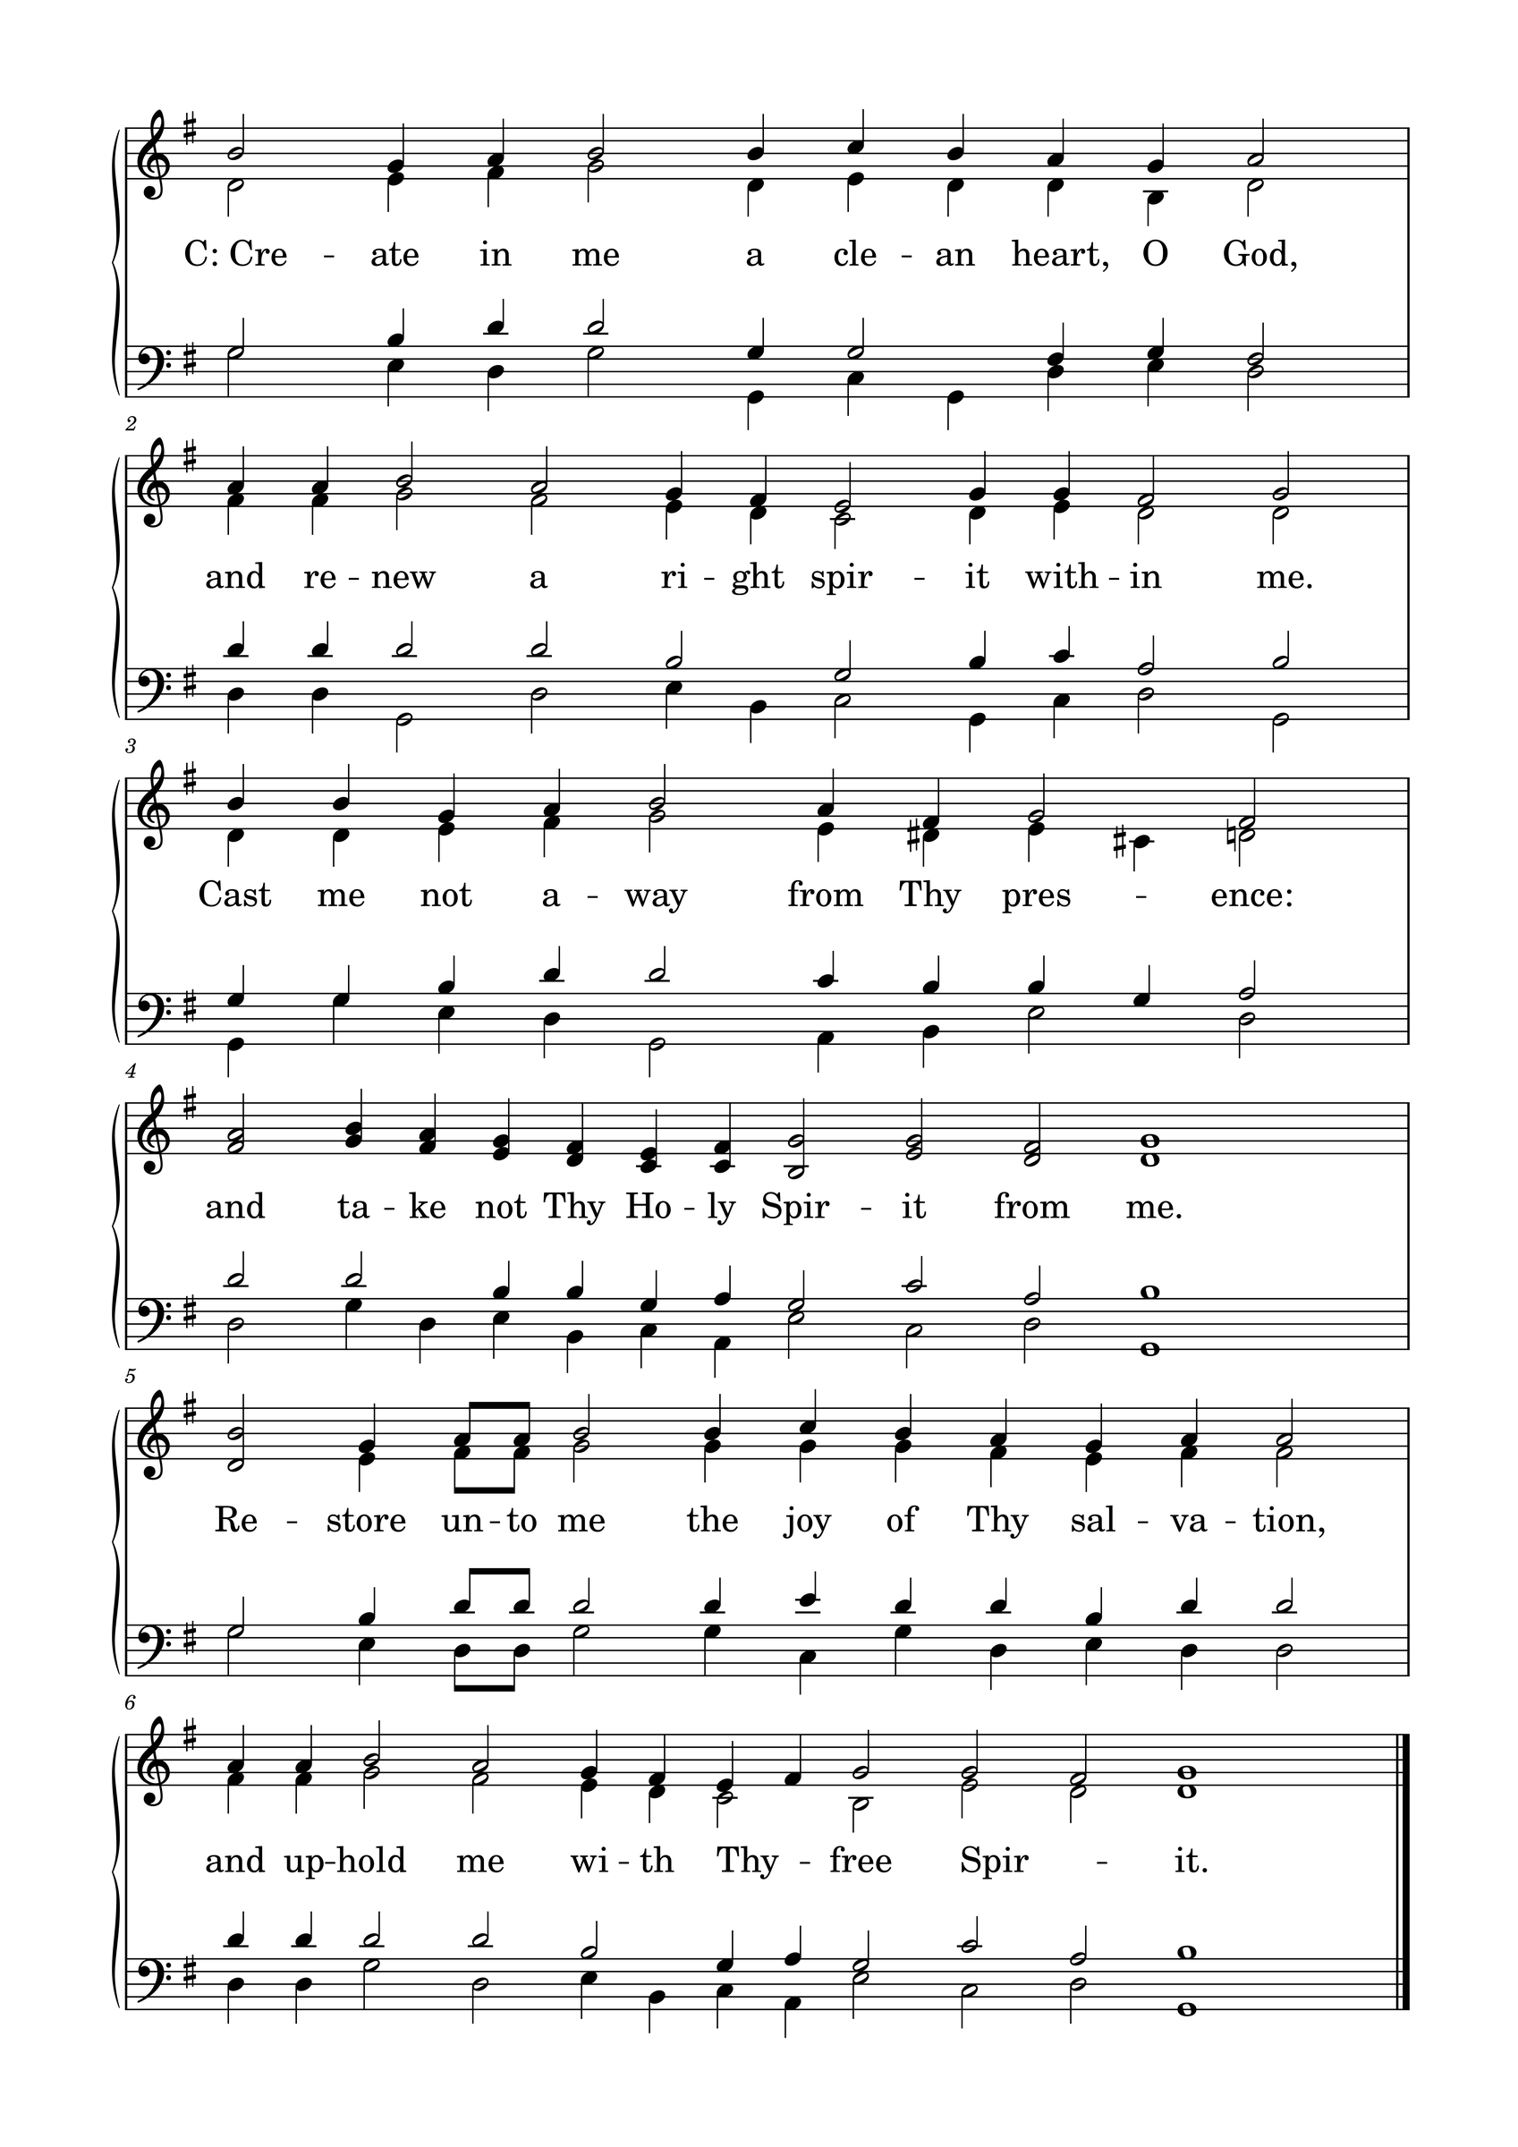

L: Please be seated.

(An offering may be collected at this time, or the congregation may be informed that the offering plate is located at the back of the church.)

HYMN 391

GENERAL PRAYER

THE LORD'S PRAYER
C: Our Father, who art in heaven, hallowed be Your name; Your kingdom come; Your will be done on earth as it is in heaven. Give us this day our daily bread; and forgive us our trespasses, as we forgive those who trespass against us; and lead us not into temptation; but deliver us from evil. For Yours is the kingdom and the power and the glory forever and ever. Amen.

(If Communion is celebrated, refer to the order of Holy Communion.)

FINAL HYMN 409

THE BENEDICTION
L : (The congregation rises.) The Lord bless you and keep you. The Lord make His face shine upon you and be gracious to you. The Lord lift up His countenance upon you and give you peace.
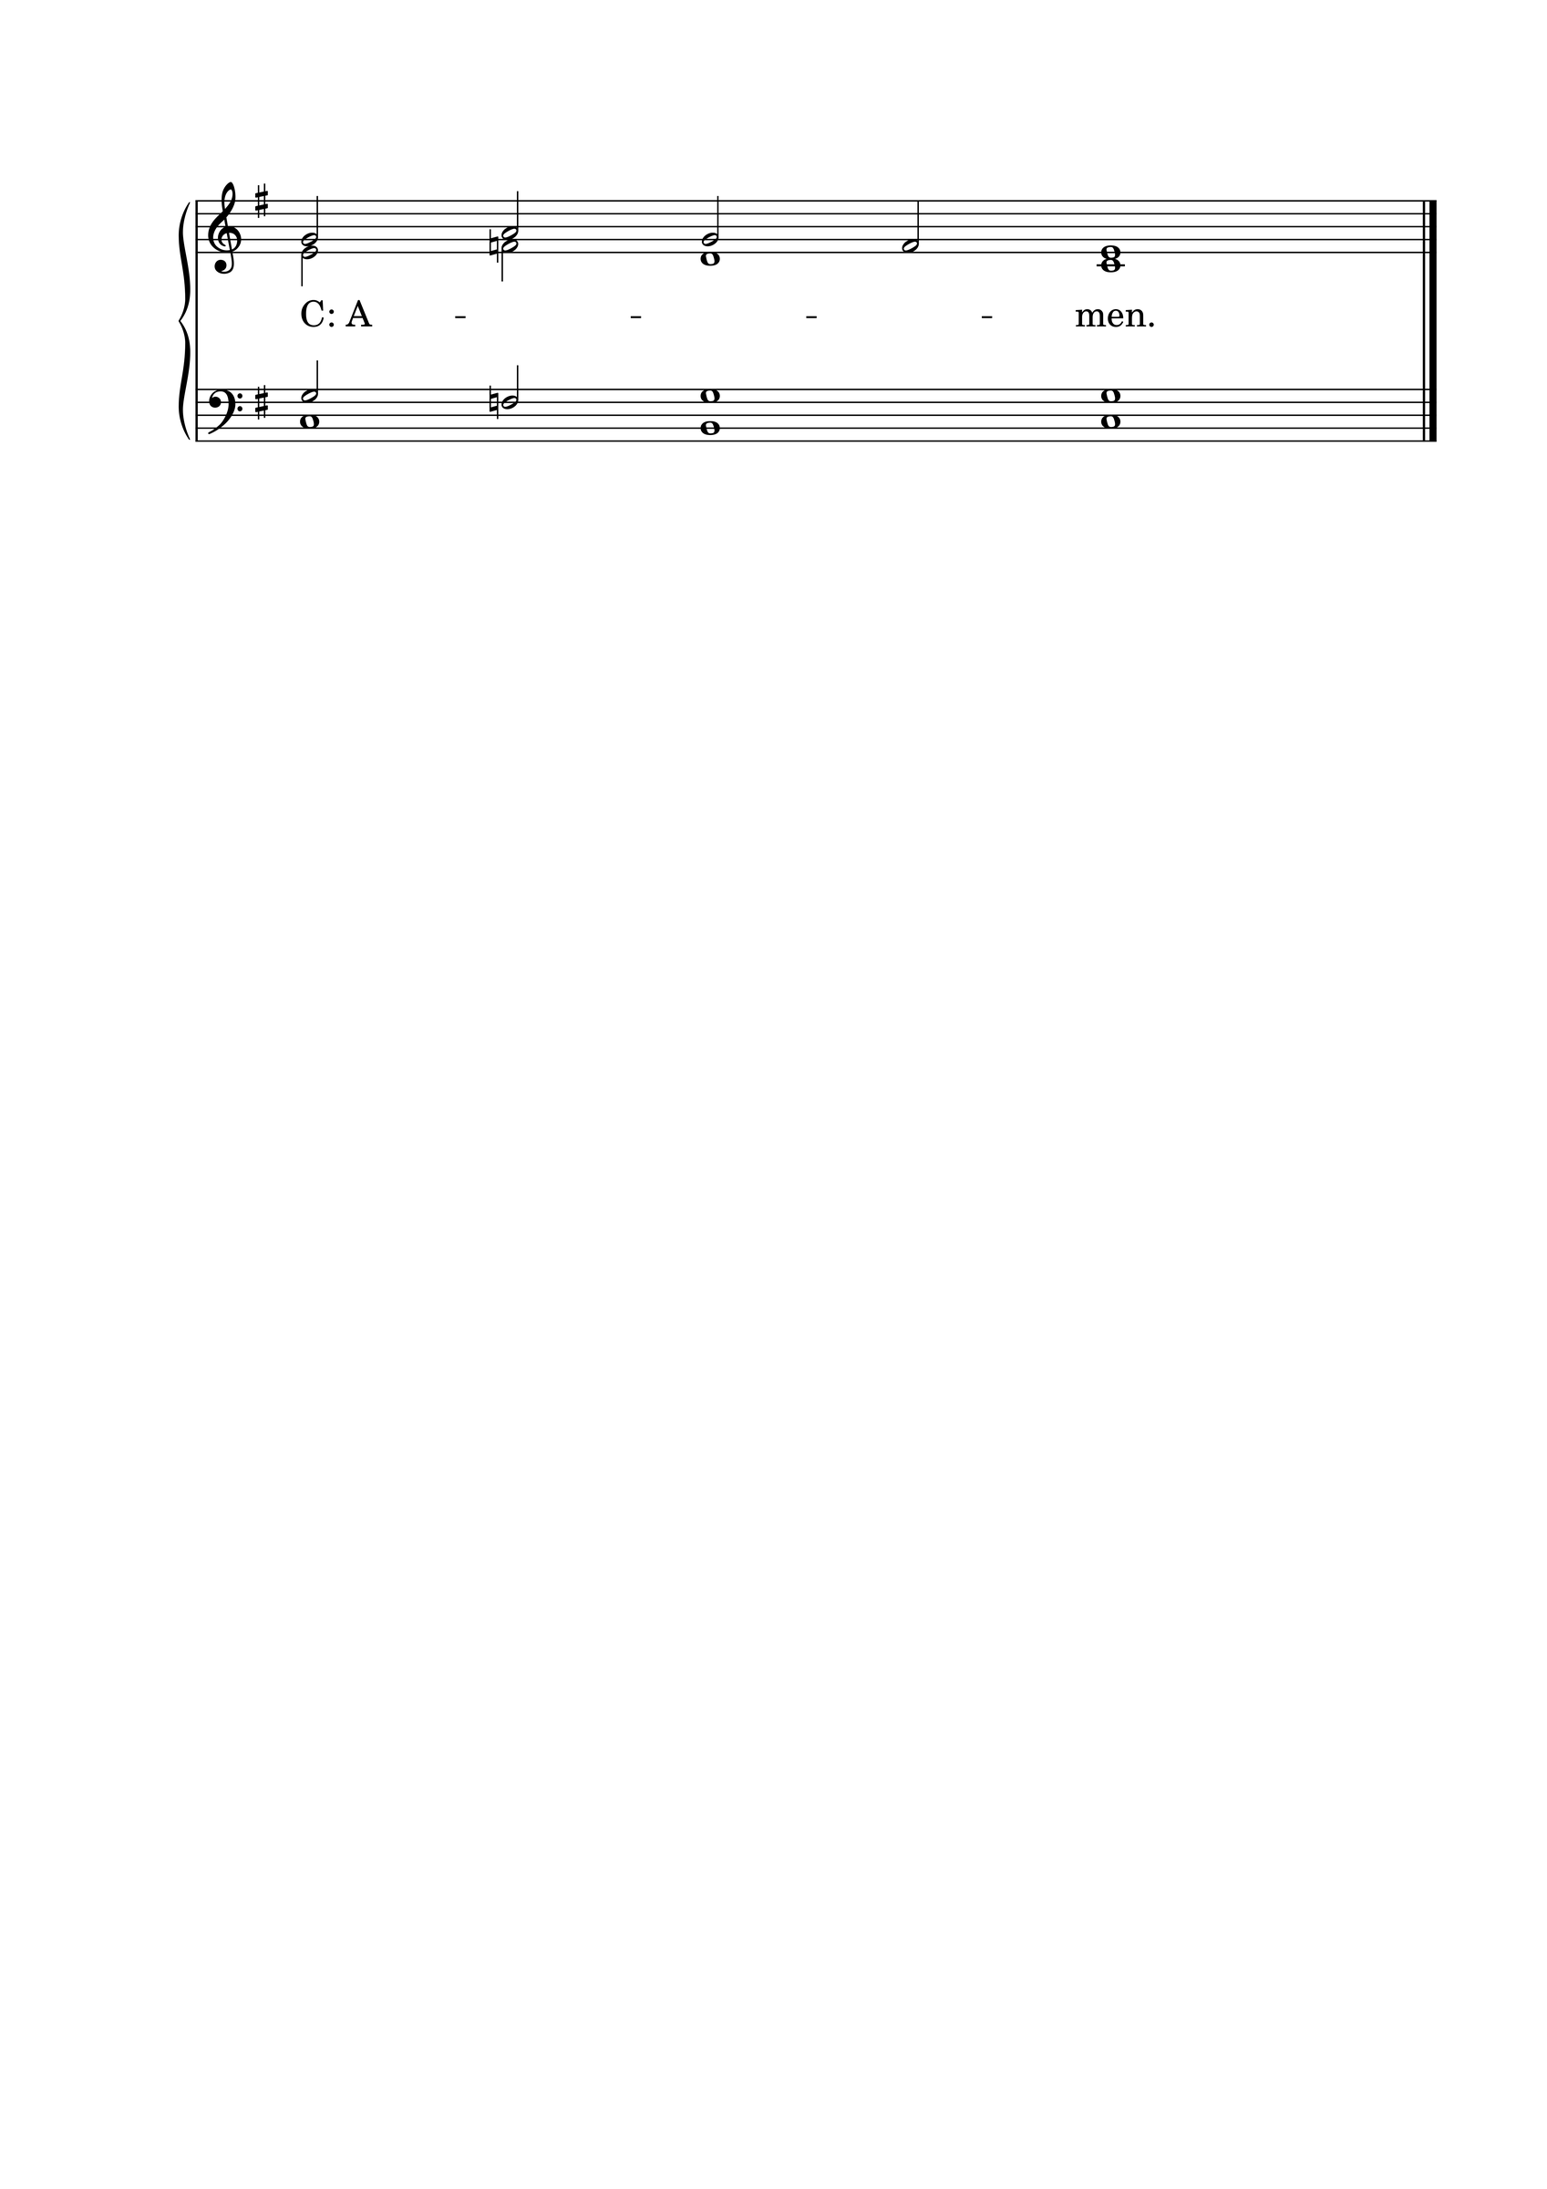

ANNOUNCEMENTS
• Call news: Pastor Matthew Hanel of St. Matthew Ev. Lutheran Church, Dallas, TX, has received the call to Gift of God Lutheran Church, Mapleton, ND. <> Pastor Tom Schuetze of St. Paul Ev. Lutheran Church, Lakewood, CO, has received the call to Living Hope Lutheran Church, Appleton, WI. <> Pastor Chad Seybt of Morning Star Lutheran Church, Fairchild, WI, Peace with God Lutheran Church, Onalaska, WI, St. Paul’s Lutheran Church, Melrose, WI, and Trinity Lutheran Church, Millston, WI, has received the call to Holy Cross Ev. Lutheran Church, Phoenix, AZ. <> Pastor Aaron Ude of Good Shepherd Lutheran Church, Rapid City, SD, has received the call to St. Paul’s Ev. Lutheran Church, Austin, MN. <> Mr. Nick Naumann has received the call to St. Luke’s Ev. Lutheran Church, Lemmon, SD.
• ANNIVERSARIES: Grace Lutheran School, Fridley, MN, will be celebrating its 50th anniversary on September 13, 2026. Pastor Neal Radichel will be the guest speaker. <> Gethsemane Lutheran Church, Spokane Valley, WA, will be celebrating its 75th anniversary on September 20, 2026. President Michael Wilke will be the guest speaker. <> Ascension Lutheran Church, Batavia, IL, will be celebrating its 60th anniversary on October 11, 2026. Pastor Emeritus David Schierenbeck will be the guest speaker.

“Scripture taken from the New King James Version®. Copyright © 1982 by Thomas Nelson. Used by permission. All rights reserved.”

