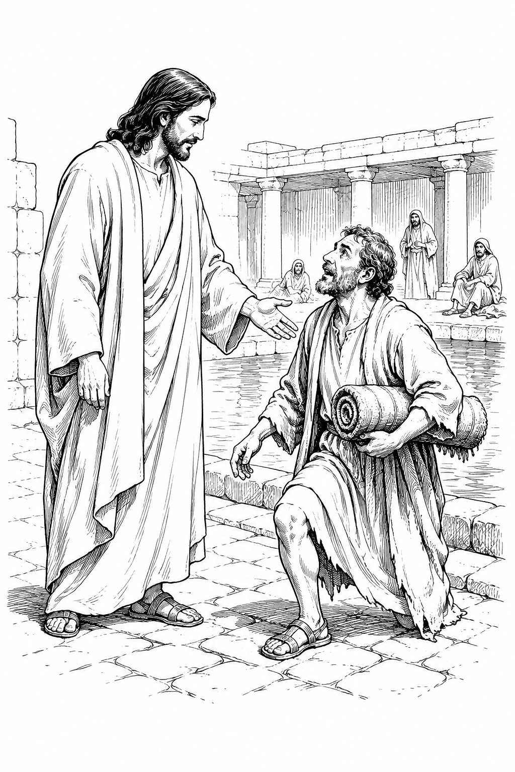

THE COMMON SERVICE
This liturgy is adapted from the Common Service Book of the Lutheran Church (1917-1918), Evangelical Lutheran Hymn-book (1912), and Music for the Liturgy: in Conformity with the Evangelical Lutheran Hymn book which are in the public domain.

OPENING HYMN 11
Leader : (The congregation rises.) In the name of the Father, and of the Son, and of the Holy Spirit.



THE CONFESSION OF SINS
L: Beloved in the Lord! Let us draw near with a true heart and confess our sins to God our Father, asking Him, in the name of our Lord Jesus Christ, to grant us forgiveness.
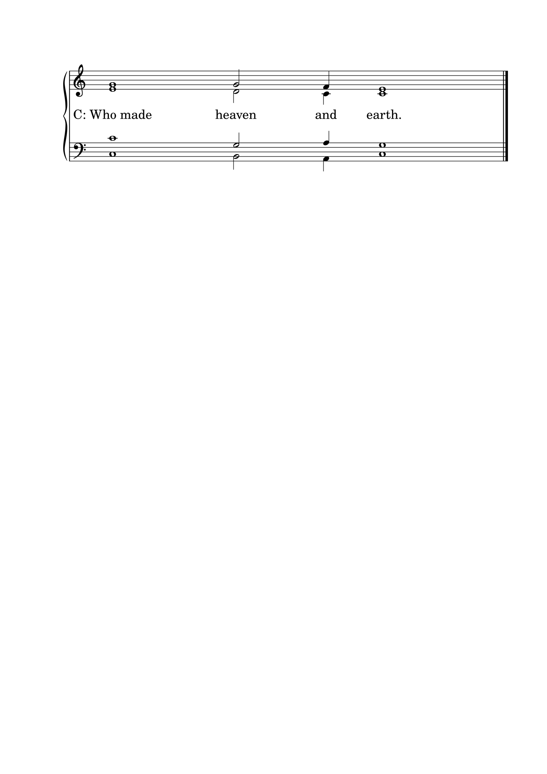L: Our help is in the name of the Lord.

L: I said, I will confess my transgressions to the Lord.
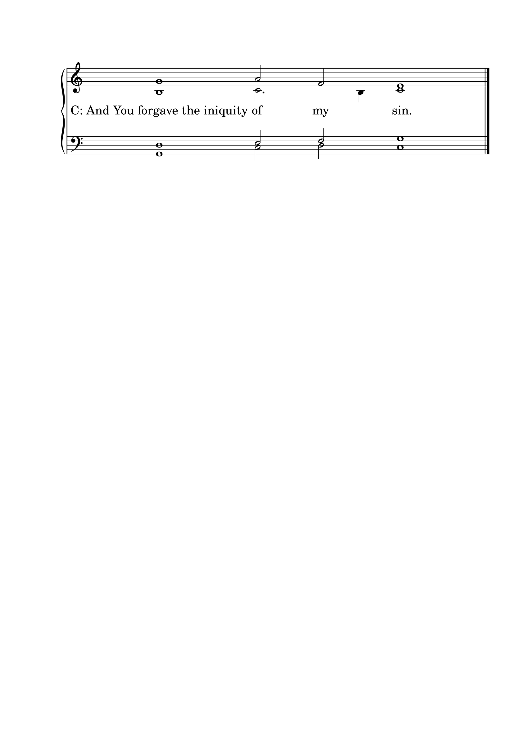

L : Almighty God, our Maker and Redeemer, we poor sinners confess to You that we are by nature sinful and unclean, and that we have sinned against You by thought, word, and deed. Therefore we flee for refuge to Your infinite mercy, seeking and imploring Your grace for the sake of our Lord Jesus Christ.
C: O most merciful God, who has given Your only-begotten Son to die for us, have mercy upon us, and for His sake grant us remission of all our sins; and by Your Holy Spirit increase in us true knowledge of You and of Your will, and true obedience to Your Word, so that by Your grace we may come to everlasting life; through Jesus Christ our Lord. Amen.

THE ABSOLUTION
L : Almighty God, our heavenly Father, has had mercy upon us and has given His only Son to die for us, and for His sake forgives us all our sins. To those who believe in His name He gives power to become the children of God and bestows upon them His Holy Spirit. Whoever believes and is baptized will be saved. Grant this, O Lord, to us all.
C: Amen.

PSALM OF THE DAY
L: I will extol You, O Lord, for You have lifted me up,
C: And have not let my foes rejoice over me.
L: O Lord my God, I cried out to You,
C: And You healed me.
L: O Lord, You brought my soul up from the grave;
C: You have kept me alive, that I should not go down to the pit.
L: Sing praise to the Lord, you saints of His,
C: And give thanks at the remembrance of His holy name.
L: For His anger is but for a moment, His favor is for life;
C: Weeping may endure for a night, But joy comes in the morning.
L: Now in my prosperity I said,
C: “I shall never be moved.”
L: Lord, by Your favor You have made my mountain stand strong;
C: You hid Your face, and I was troubled. (Psalm 30)

GLORIA PATRI

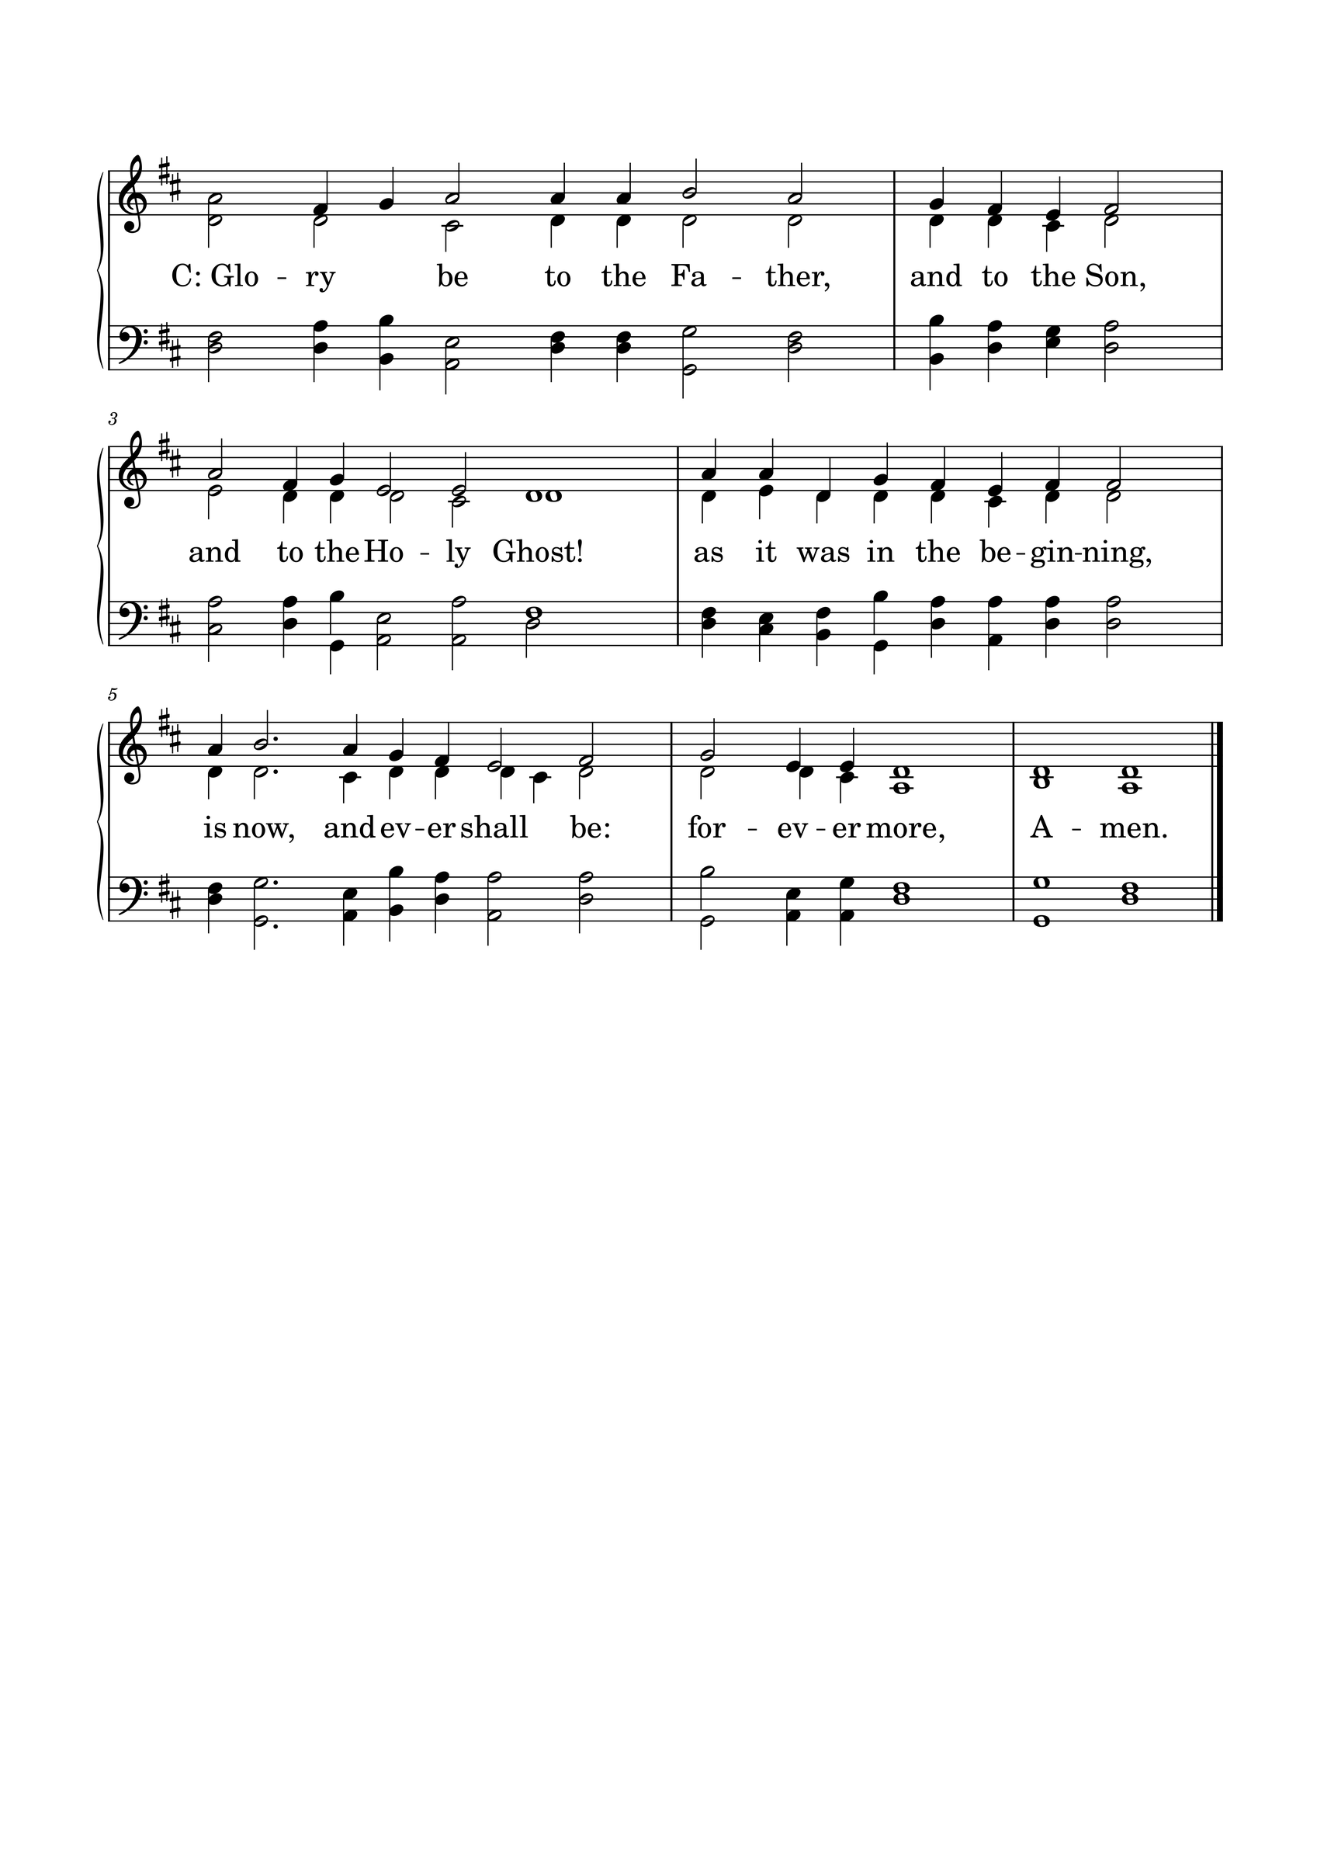

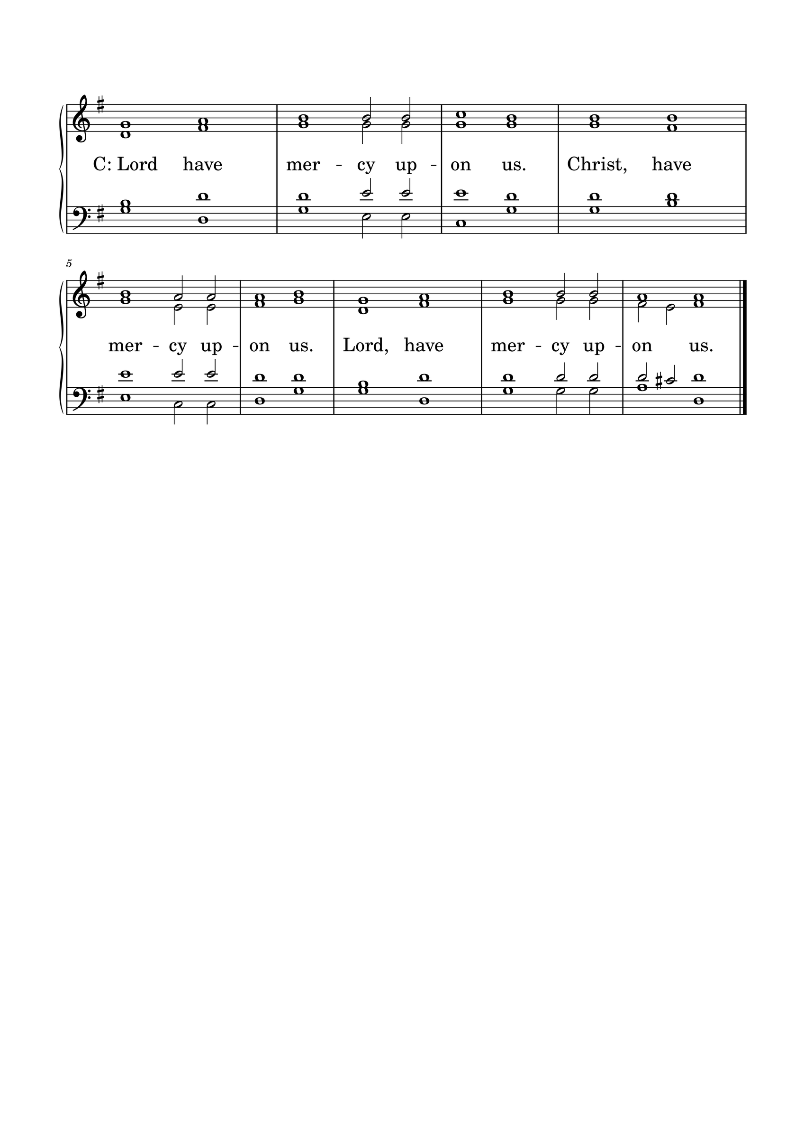KYRIE

GLORIA
The Lutheran Hymnal hymn 244 Verses 1 & 2
C: 1. Glory be to God the Father,
Glory be to God the Son,
Glory be to God the Spirit:
Great Jehovah, Three in One!
Glory, glory,
While eternal ages run!

2. Glory be to Him who loved us,
Washed us from each spot and stain;
Glory be to Him who bought us,
Made us kings with Him to reign!
Glory, glory,
To the Lamb that once was slain!

THE COLLECT
L : Let us pray.
L :
Almighty God, You never cease to uphold Your creation and work for our good. Grant us faith to rest in Your gracious care and to trust in the saving work of Your Son, Jesus Christ, our Lord. Amen.
C: Amen.

FIRST SCRIPTURE READING
L: (The congregation may be seated.) The First Scripture Reading for 16th Sunday of Trinity is written in the 3rd chapter of Ephesians, beginning at verse 13.
[13] Therefore I ask that you do not lose heart at my tribulations for you, which is your glory.
[14] For this reason I bow my knees to the Father of our Lord Jesus Christ, [15] from whom the whole family in heaven and earth is named, [16] that He would grant you, according to the riches of His glory, to be strengthened with might through His Spirit in the inner man, [17] that Christ may dwell in your hearts through faith; that you, being rooted and grounded in love, [18] may be able to comprehend with all the saints what is the width and length and depth and height— [19] to know the love of Christ which passes knowledge; that you may be filled with all the fullness of God.
[20] Now to Him who is able to do exceedingly abundantly above all that we ask or think, according to the power that works in us, [21] to Him be glory in the church by Christ Jesus to all generations, forever and ever. Amen.
L: Here ends the First Scripture Reading.

SECOND SCRIPTURE READING
L: The Second Scripture Reading is written in the 7th chapter of Luke, beginning at verse 11.
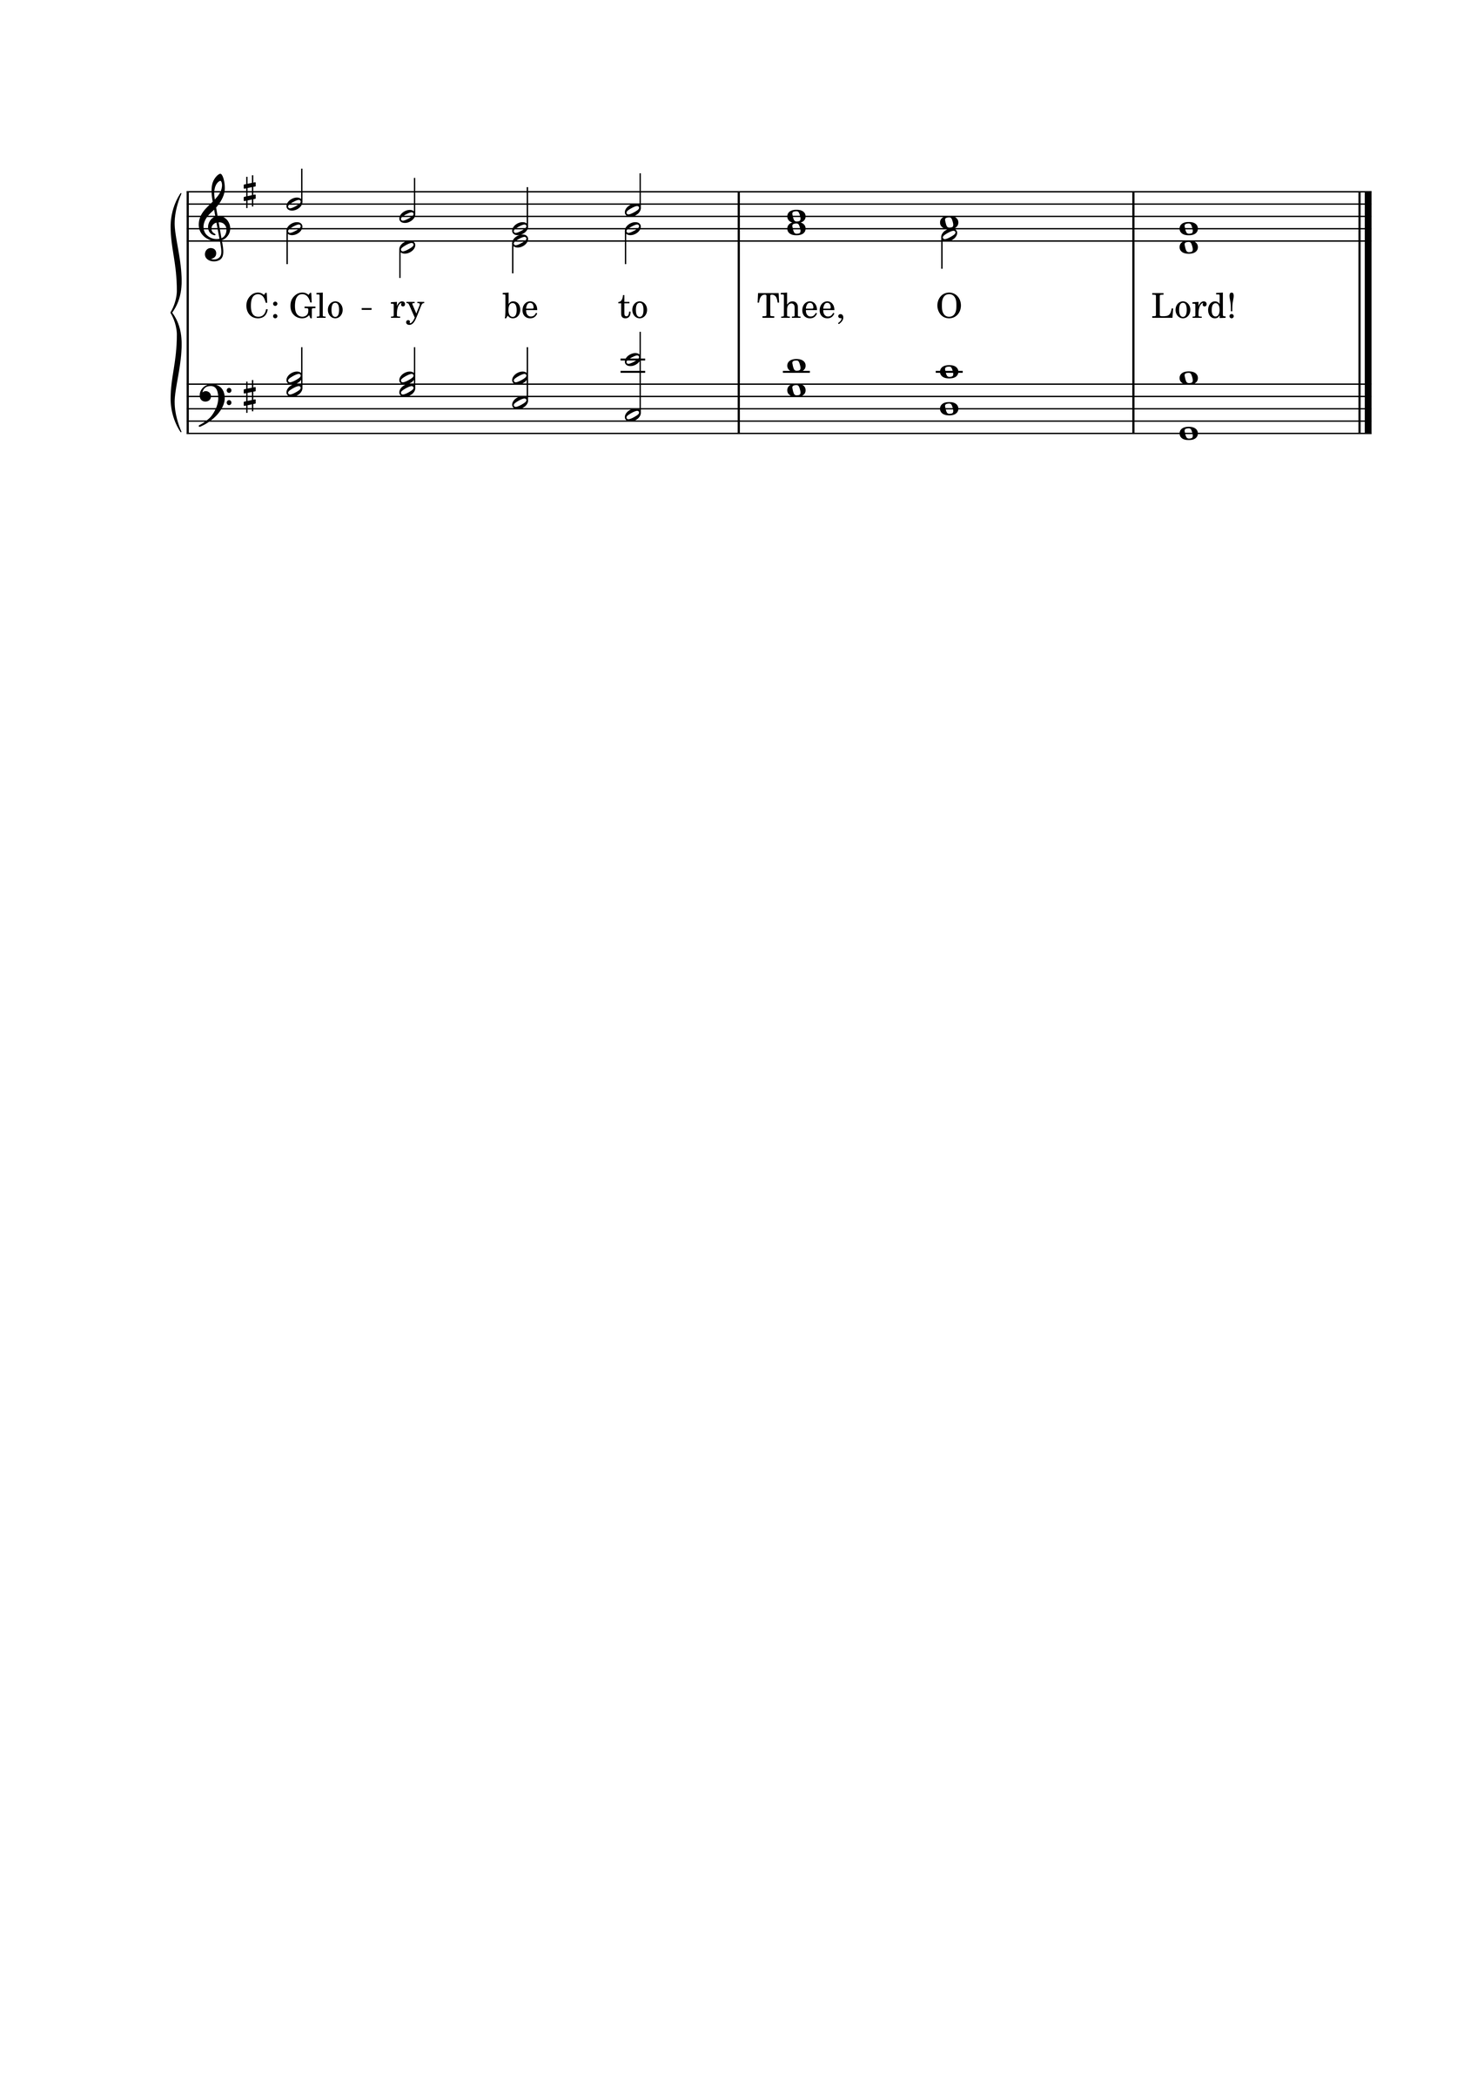

[11] Now it happened, the day after, that He went into a city called Nain; and many of His disciples went with Him, and a large crowd. [12] And when He came near the gate of the city, behold, a dead man was being carried out, the only son of his mother; and she was a widow. And a large crowd from the city was with her. [13] When the Lord saw her, He had compassion on her and said to her, “Do not weep.” [14] Then He came and touched the open coffin, and those who carried him stood still. And He said, “Young man, I say to you, arise.” [15] So he who was dead sat up and began to speak. And He presented him to his mother.
[16] Then fear came upon all, and they glorified God, saying, “A great prophet has risen up among us”; and, “God has visited His people.” [17] And this report about Him went throughout all Judea and all the surrounding region.

L: Here ends the Second Scripture Reading.

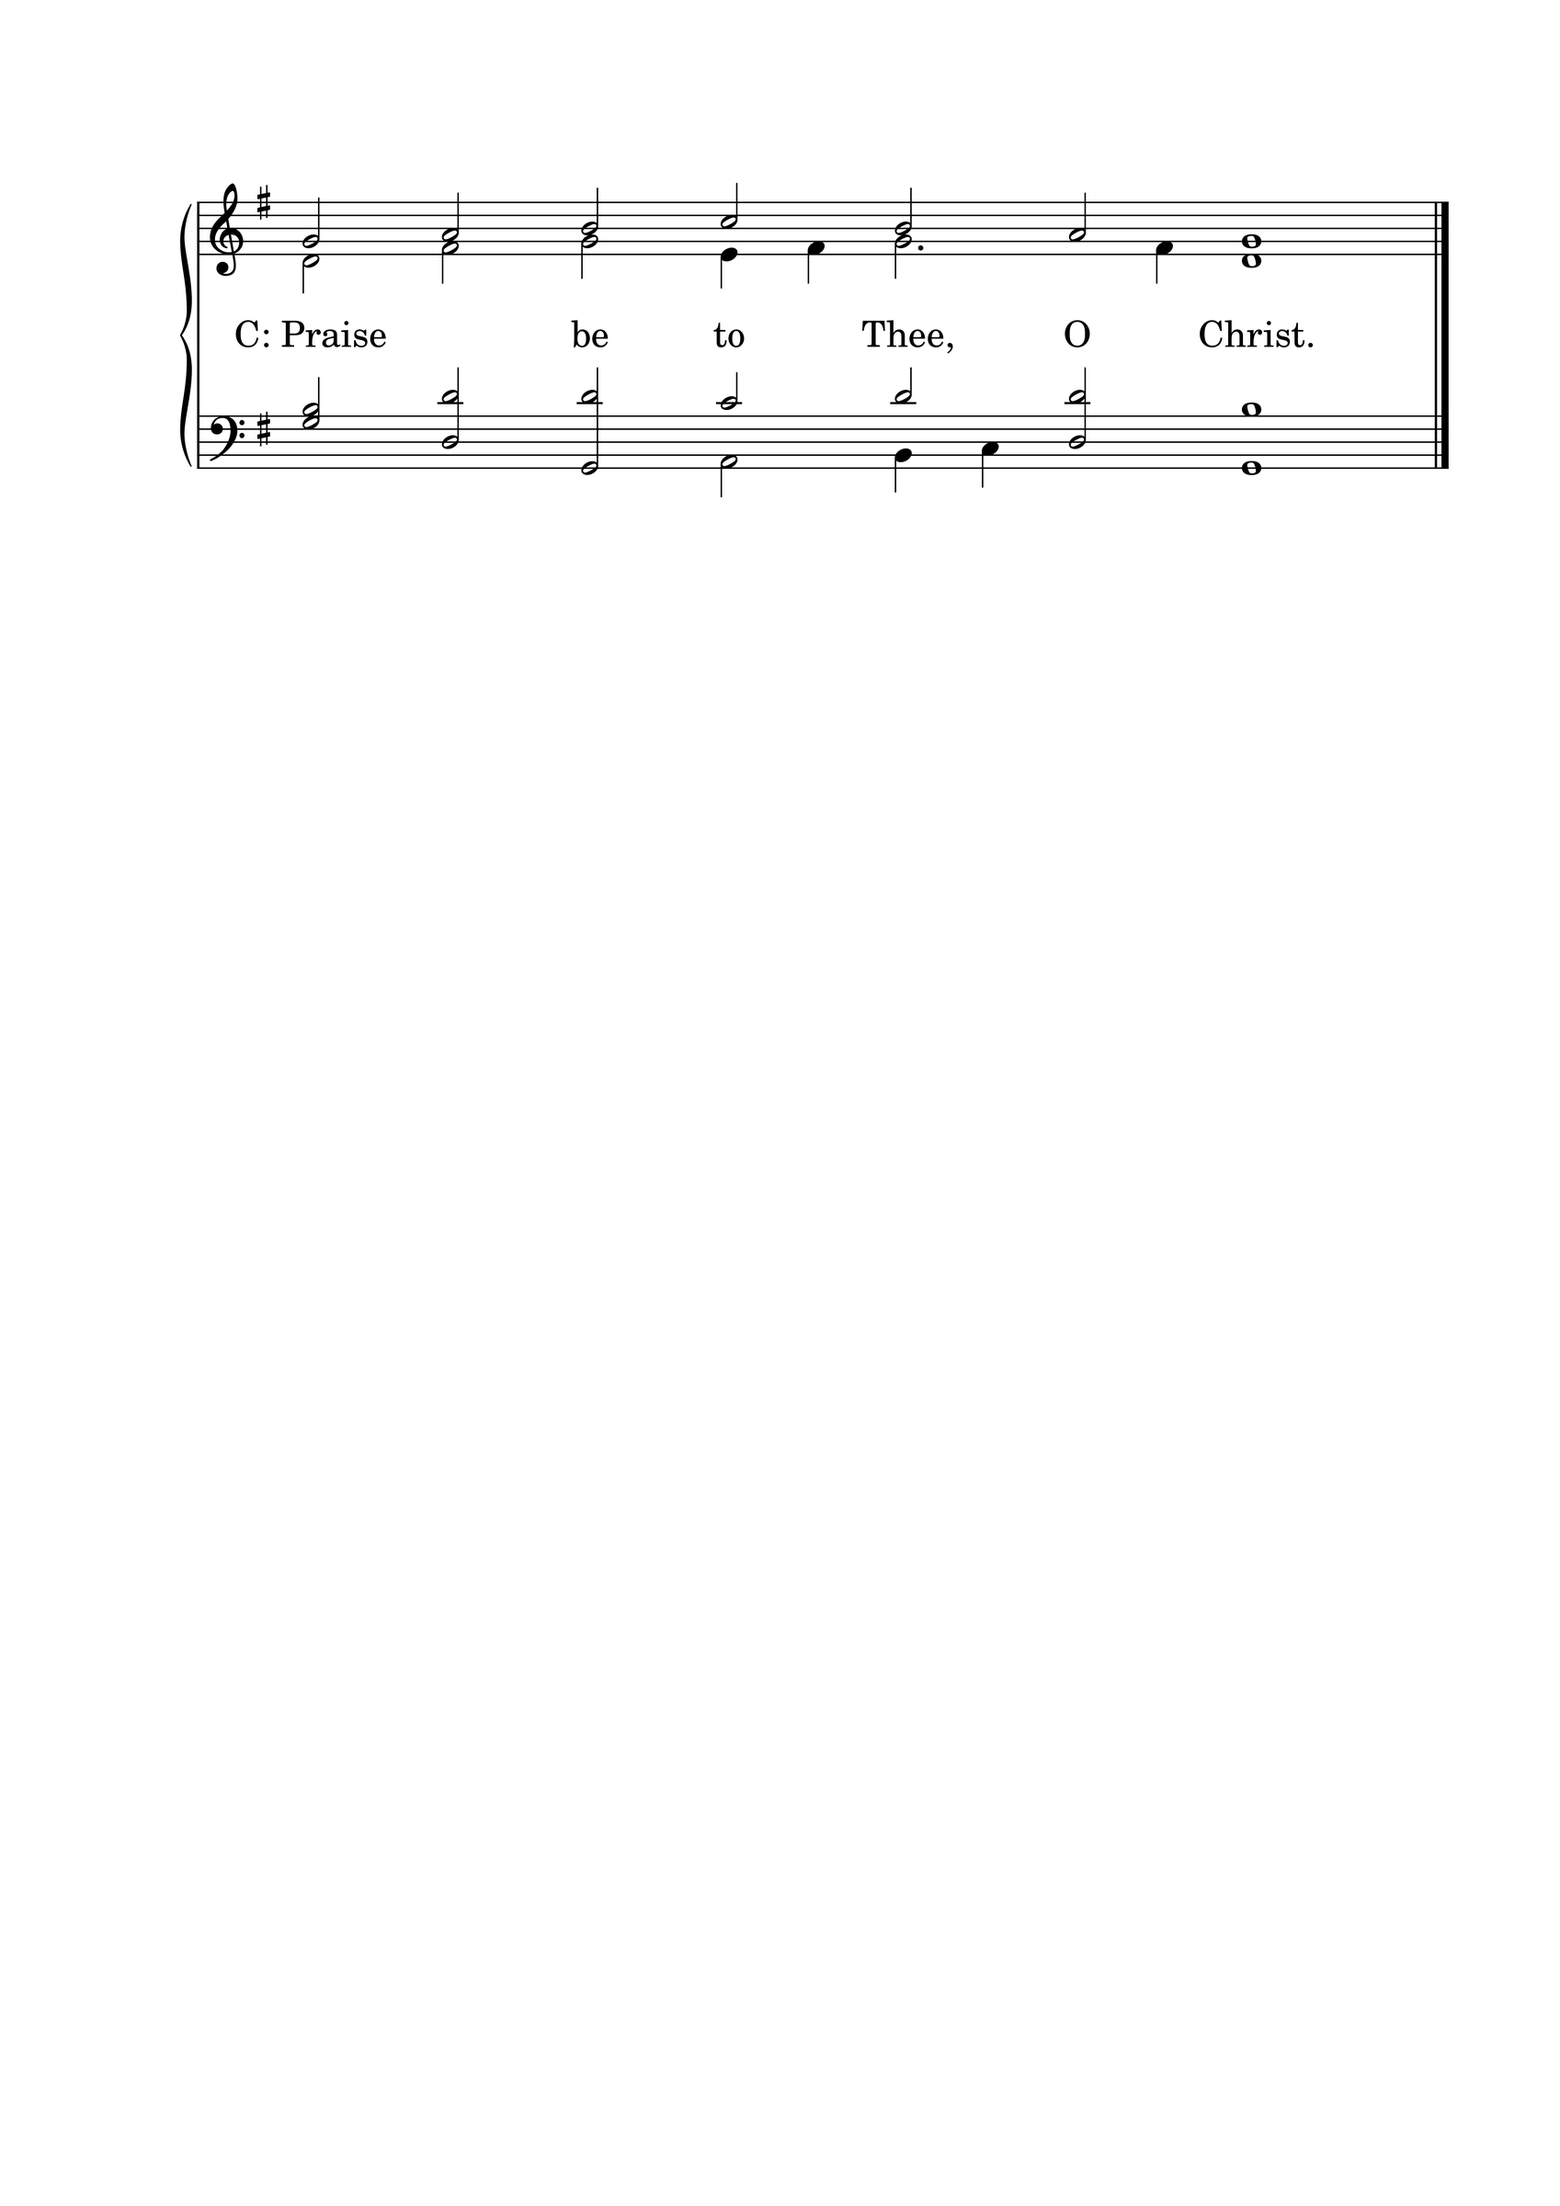

THE APOSTLES' CREED
C: I believe in God the Father almighty, maker of heaven and earth. And in Jesus Christ, His only Son, our Lord, who was conceived by the Holy Spirit, born of the Virgin Mary; suffered under Pontius Pilate, was crucified, died, and was buried. He descended into hell. The third day He rose again from the dead. He ascended into heaven and is seated at the right hand of God the Father almighty. From there He will come to judge the living and the dead. I believe in the Holy Spirit; the holy Christian Church, the communion of saints; the forgiveness of sins; the resurrection of the body; and the life everlasting. Amen.

HYMN 27

THE SERMON
Sermon Text: John 5:5-18 NKJ
"Now a certain man was there who had an infirmity thirty-eight years. 6 When Jesus saw him lying there, and knew that he already had been in that condition a long time, He said to him, "Do you want to be made well?" 7 The sick man answered Him, "Sir, I have no man to put me into the pool when the water is stirred up; but while I am coming, another steps down before me." 8 Jesus said to him, "Rise, take up your bed and walk." 9 And immediately the man was made well, took up his bed, and walked. And that day was the Sabbath. 10 The Jews therefore said to him who was cured, "It is the Sabbath; it is not lawful for you to carry your bed." 11 He answered them, "He who made me well said to me,`Take up your bed and walk.'" 12 Then they asked him, "Who is the Man who said to you,`Take up your bed and walk '?" 13 But the one who was healed did not know who it was, for Jesus had withdrawn, a multitude being in that place. 14 Afterward Jesus found him in the temple, and said to him, "See, you have been made well. Sin no more, lest a worse thing come upon you." 15 The man departed and told the Jews that it was Jesus who had made him well. 16 For this reason the Jews persecuted Jesus, and sought to kill Him, because He had done these things on the Sabbath. 17 But Jesus answered them, "My Father has been working until now, and I have been working." 18 Therefore the Jews sought all the more to kill Him, because He not only broke the Sabbath, but also said that God was His Father, making Himself equal with God."

Sermon Theme: OUR GOD NEVER STOPS WORKING

L: (The congregation rises.) And may the peace of God, which surpasses all understanding, guard your hearts and minds through Christ Jesus, amen.

THE OFFERTORY
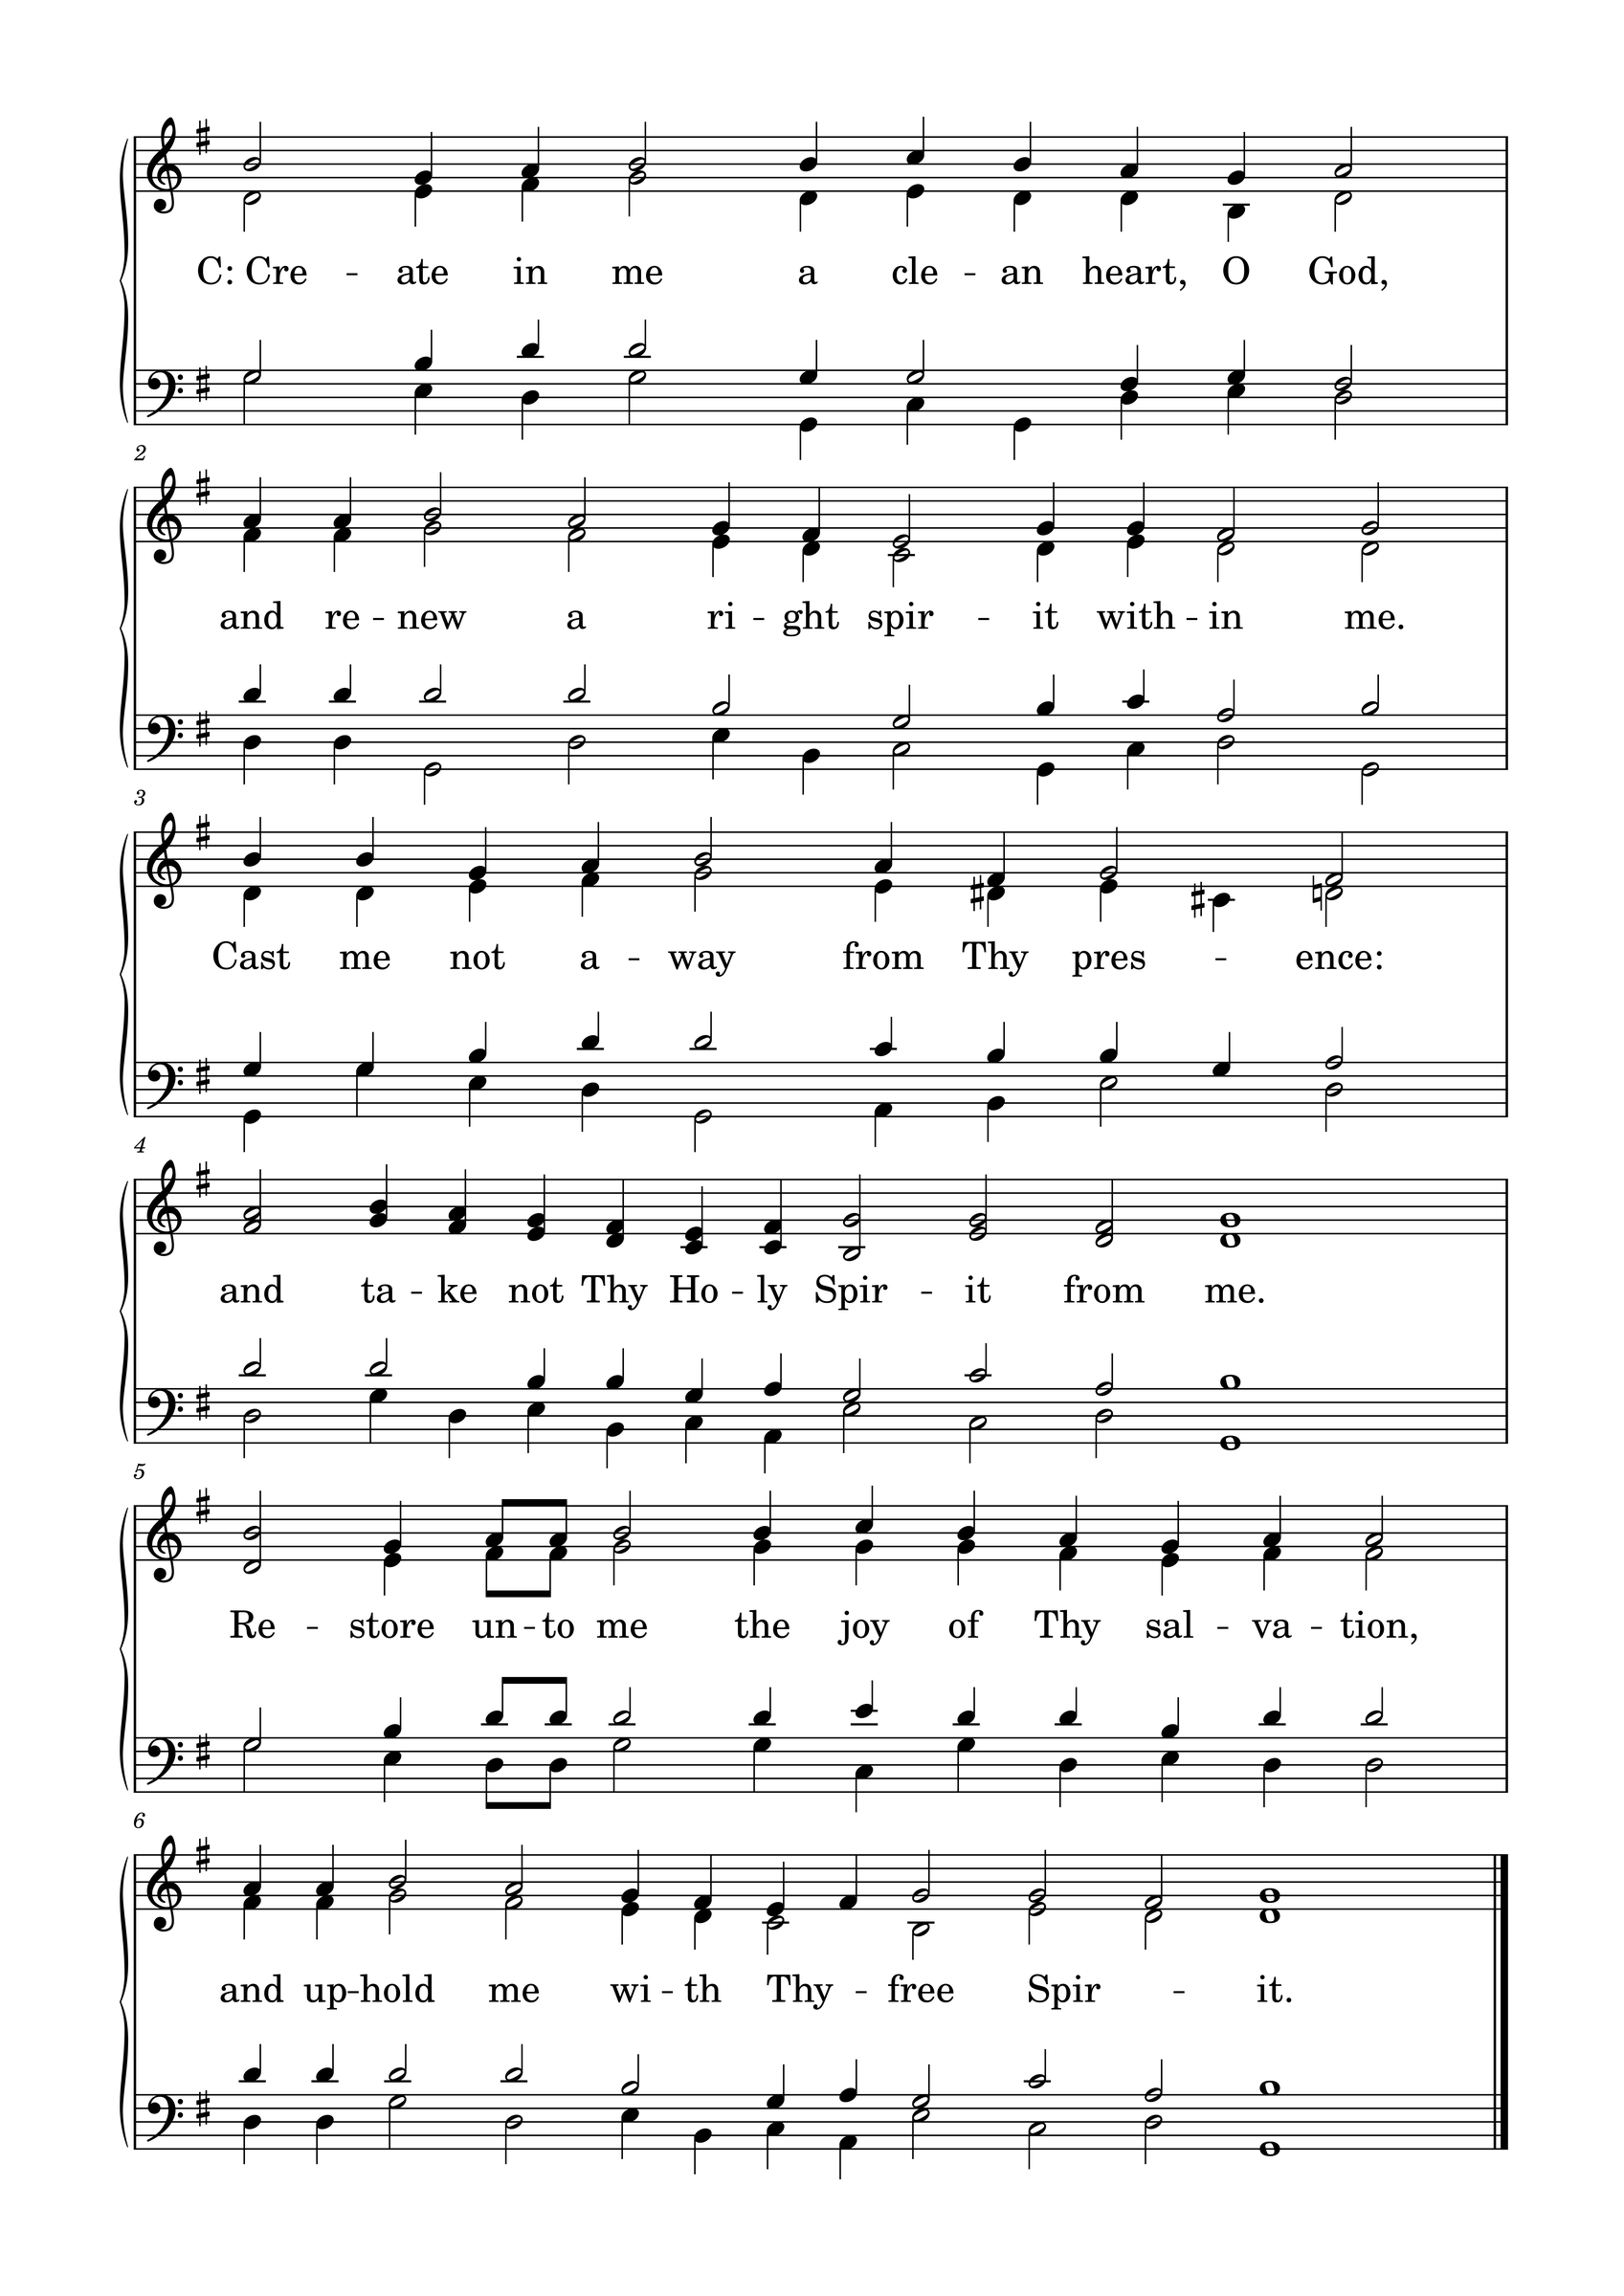

L: Please be seated.

(An offering may be collected at this time, or the congregation may be informed that the offering plate is located at the back of the church.)

HYMN 410

GENERAL PRAYER

THE LORD'S PRAYER
C: Our Father, who art in heaven, hallowed be Your name; Your kingdom come; Your will be done on earth as it is in heaven. Give us this day our daily bread; and forgive us our trespasses, as we forgive those who trespass against us; and lead us not into temptation; but deliver us from evil. For Yours is the kingdom and the power and the glory forever and ever. Amen.

(If Communion is celebrated, refer to the order of Holy Communion.)

FINAL HYMN 47

THE BENEDICTION
L : (The congregation rises.) The Lord bless you and keep you. The Lord make His face shine upon you and be gracious to you. The Lord lift up His countenance upon you and give you peace.
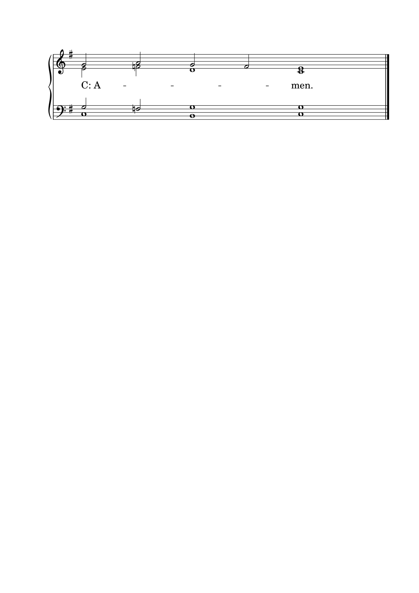

ANNOUNCEMENTS
• CALL NEWS Pastor Chad Seybt of Morning Star Lutheran Church, Fairchild, WI, Peace with God Lutheran Church, Onalaska, WI, St. Paul’s Lutheran Church, Melrose, WI, and Trinity Lutheran Church, Millston, WI, has received the call to Holy Cross Ev. Lutheran Church, Phoenix, AZ. <> Pastor Aaron Ude of Good Shepherd Lutheran Church, Rapid City, SD, has received the call to St. Paul’s Ev. Lutheran Church, Austin, MN. <> Mr. Nick Naumann has received the call to St. Luke’s Ev. Lutheran Church, Lemmon, SD. <> Pastor Joe Naumann of Immanuel Ev. Lutheran Church, Mankato, MN, has returned the call to Mt. Zion Lutheran Church, Madison, Heights, MI.
• ANNIVERSARIES Grace Lutheran School, Fridley, MN, will be celebrating its 50th anniversary on September 13, 2026. Pastor Neal Radichel will be the guest speaker. <> Gethsemane Lutheran Church, Spokane Valley, WA, will be celebrating its 75th anniversary on September 20, 2026. President Michael Wilke will be the guest speaker. <> Ascension Lutheran Church, Batavia, IL, will be celebrating its 60th anniversary on October 11, 2026. Pastor Emeritus David Schierenbeck will be the guest speaker.

“Scripture taken from the New King James Version®. Copyright © 1982 by Thomas Nelson. Used by permission. All rights reserved.”

