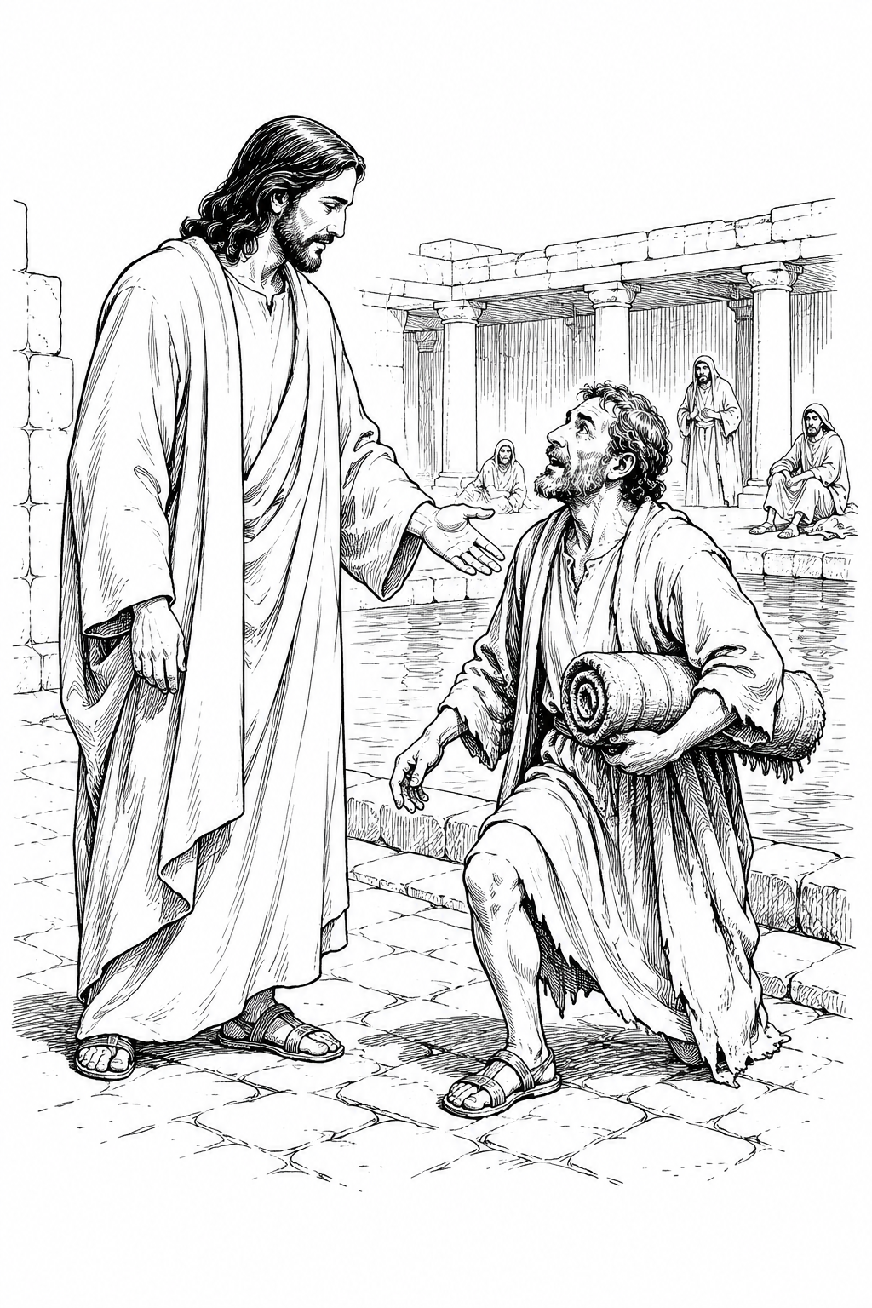
A Church of the Lutheran Confession
September 6, 2026
15th Sunday of Trinity

HYMNS
11; 27; 410; 47

PSALM OF THE DAY
L: I will extol You, O Lord, for You have lifted me up,
C: And have not let my foes rejoice over me.
L: O Lord my God, I cried out to You,
C: And You healed me.
L: O Lord, You brought my soul up from the grave;
C: You have kept me alive, that I should not go down to the pit.
L: Sing praise to the Lord, you saints of His,
C: And give thanks at the remembrance of His holy name.
L: For His anger is but for a moment, His favor is for life;
C: Weeping may endure for a night, But joy comes in the morning.
L: Now in my prosperity I said,
C: “I shall never be moved.”
L: Lord, by Your favor You have made my mountain stand strong;
C: You hid Your face, and I was troubled. (Psalm 30)

THE COLLECT
Almighty God, You never cease to uphold Your creation and work for our good. Grant us faith to rest in Your gracious care and to trust in the saving work of Your Son, Jesus Christ, our Lord. Amen.

FIRST SCRIPTURE READING
Ephesians 3:13-21
[13] Therefore I ask that you do not lose heart at my tribulations for you, which is your glory.
[14] For this reason I bow my knees to the Father of our Lord Jesus Christ, [15] from whom the whole family in heaven and earth is named, [16] that He would grant you, according to the riches of His glory, to be strengthened with might through His Spirit in the inner man, [17] that Christ may dwell in your hearts through faith; that you, being rooted and grounded in love, [18] may be able to comprehend with all the saints what is the width and length and depth and height— [19] to know the love of Christ which passes knowledge; that you may be filled with all the fullness of God.
[20] Now to Him who is able to do exceedingly abundantly above all that we ask or think, according to the power that works in us, [21] to Him be glory in the church by Christ Jesus to all generations, forever and ever. Amen.

SECOND SCRIPTURE READING
Luke 7:11-17
[11] Now it happened, the day after, that He went into a city called Nain; and many of His disciples went with Him, and a large crowd. [12] And when He came near the gate of the city, behold, a dead man was being carried out, the only son of his mother; and she was a widow. And a large crowd from the city was with her. [13] When the Lord saw her, He had compassion on her and said to her, “Do not weep.” [14] Then He came and touched the open coffin, and those who carried him stood still. And He said, “Young man, I say to you, arise.” [15] So he who was dead sat up and began to speak. And He presented him to his mother.
[16] Then fear came upon all, and they glorified God, saying, “A great prophet has risen up among us”; and, “God has visited His people.” [17] And this report about Him went throughout all Judea and all the surrounding region.

THE SERMON
Sermon Text: John 5:5-18 NKJ
"Now a certain man was there who had an infirmity thirty-eight years. 6 When Jesus saw him lying there, and knew that he already had been in that condition a long time, He said to him, "Do you want to be made well?" 7 The sick man answered Him, "Sir, I have no man to put me into the pool when the water is stirred up; but while I am coming, another steps down before me." 8 Jesus said to him, "Rise, take up your bed and walk." 9 And immediately the man was made well, took up his bed, and walked. And that day was the Sabbath. 10 The Jews therefore said to him who was cured, "It is the Sabbath; it is not lawful for you to carry your bed." 11 He answered them, "He who made me well said to me,`Take up your bed and walk.'" 12 Then they asked him, "Who is the Man who said to you,`Take up your bed and walk '?" 13 But the one who was healed did not know who it was, for Jesus had withdrawn, a multitude being in that place. 14 Afterward Jesus found him in the temple, and said to him, "See, you have been made well. Sin no more, lest a worse thing come upon you." 15 The man departed and told the Jews that it was Jesus who had made him well. 16 For this reason the Jews persecuted Jesus, and sought to kill Him, because He had done these things on the Sabbath. 17 But Jesus answered them, "My Father has been working until now, and I have been working." 18 Therefore the Jews sought all the more to kill Him, because He not only broke the Sabbath, but also said that God was His Father, making Himself equal with God."

Sermon Theme: OUR GOD NEVER STOPS WORKING

ANNOUNCEMENTS
• CALL NEWS Pastor Chad Seybt of Morning Star Lutheran Church, Fairchild, WI, Peace with God Lutheran Church, Onalaska, WI, St. Paul’s Lutheran Church, Melrose, WI, and Trinity Lutheran Church, Millston, WI, has received the call to Holy Cross Ev. Lutheran Church, Phoenix, AZ. <> Pastor Aaron Ude of Good Shepherd Lutheran Church, Rapid City, SD, has received the call to St. Paul’s Ev. Lutheran Church, Austin, MN. <> Mr. Nick Naumann has received the call to St. Luke’s Ev. Lutheran Church, Lemmon, SD. <> Pastor Joe Naumann of Immanuel Ev. Lutheran Church, Mankato, MN, has returned the call to Mt. Zion Lutheran Church, Madison, Heights, MI.
• ANNIVERSARIES Grace Lutheran School, Fridley, MN, will be celebrating its 50th anniversary on September 13, 2026. Pastor Neal Radichel will be the guest speaker. <> Gethsemane Lutheran Church, Spokane Valley, WA, will be celebrating its 75th anniversary on September 20, 2026. President Michael Wilke will be the guest speaker. <> Ascension Lutheran Church, Batavia, IL, will be celebrating its 60th anniversary on October 11, 2026. Pastor Emeritus David Schierenbeck will be the guest speaker.

“Scripture taken from the New King James Version®. Copyright © 1982 by Thomas Nelson. Used by permission. All rights reserved.”

